Penhallow Class - Home Learning Curriculum Grid: Wednesday 21st July – Friday 23rd July

Can you find out about the Olympics?  Watch this video - https://www.youtube.com/watch?v=xBsRx4wN_v4  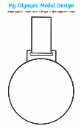  Can you design your own medal? | London 2012  Watch this video of the opening ceremony of London 2012 - https://www.youtube.com/watch?v=7QL_uG2GSZo  Can you choose a suitable piece of music and create a dance for an opening ceremony.  You can try using props, such as ribbons to enhance the performance | Olympic Athletes  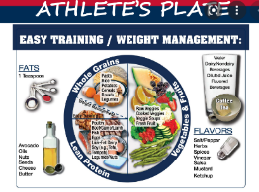  Can you design a healthy plate of food for an athlete?  Maybe you could use a paper plate and divide it into sections. There is a plate template at the bottom of the blog.
End of the year  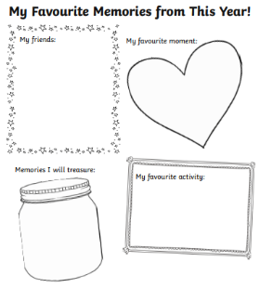  This week is our last week of being Penhallow Class.  Think about your memories, use the template at the bottom of the blog to help you. | Summer holidays  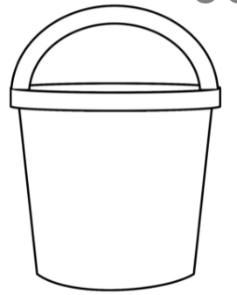  Our summer holidays have nearly begun – fill the bucket with different pictures of things you’d like to do. | Summer Poetry  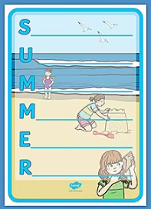  Can you write a poem about the Summer? See the template at the bottom of the blog.  For example –  S…. is for suncream or sand  Please email it to us.
Get Active
Try the activities below, on the next page – Can you carry out the activities for the letters of your name? Roll the dice, what exercises can you do?
https://www.youtube.com/user/GoNoodleGames Here’s the link to the fun GoNoodle dances we do in class.
https://www.youtube.com/watch?v=jYeMpUdufNk Supermovers – Alphabet song
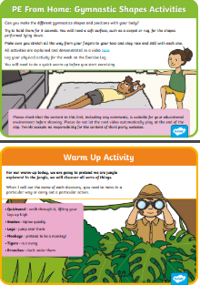
Gymnastics – Have a look at the PE Home learning cards at the bottom of the blog. Here’s a link to a video which may help you. https://youtu.be/4aEaIgDFy3A

Take a photo of some of the shapes you make and email them.

