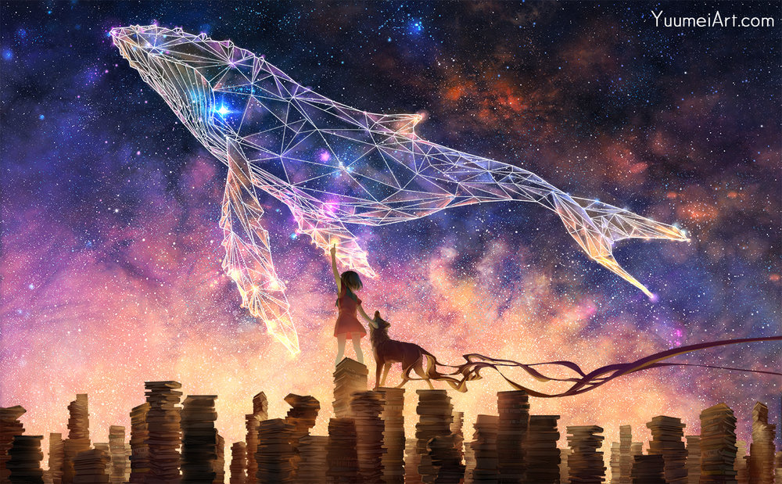  Write your own story inspired by the image below. | Create your own superhero comic strip.  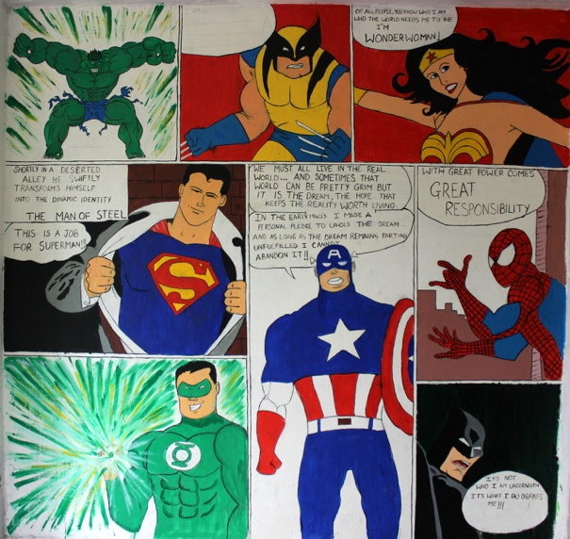
Write a ‘How to…’ guide on a topic of your choice.  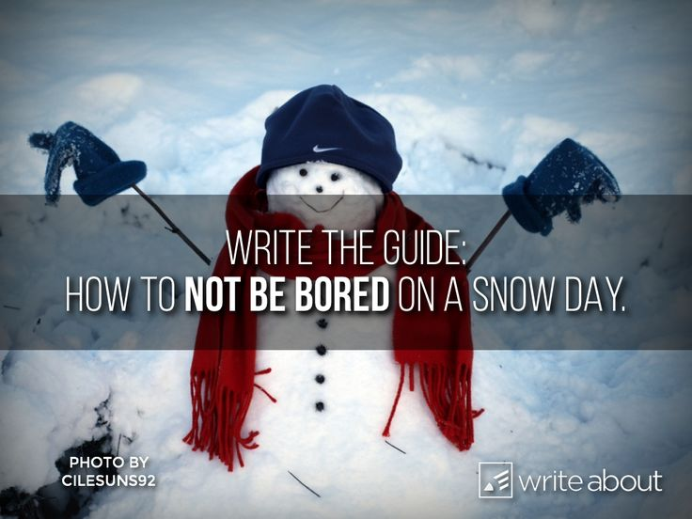 | Invent a new animal. Draw a describe its appearance, what is sounds like, how it moves and what it eats. Would it be a pet or live in the wild?  