Monday 19th July – Home Learning Grid

If you can, please send any work highlighted in yellow to afernie@polperroprimary.co.uk
 | Reception | Year 1
AM | Start your day today with some PE with Joe Wicks  https://www.youtube.com/watch?v=4hdR8Mlib3M
 | 10.30 - Phonics – Online session with Mrs Fernie.  Please log on to teams for our Phonics session.  Please bring –  - A piece or paper or something to write on.  - A pencil or something to write with  - Your thinking hats as we will be going on a bit of a scavenger hunt around your house!  There are a couple of optional Phonics activities you could do in your own time attached to the class blog. | 9.30 - Phonics – Online session with Mrs Fernie.  Please log on to teams for our Phonics session.  Please bring –  - A piece or paper or something to write on.  - A pencil or something to write with
 | Maths –  Learning Challenge: I can make a magic maths pot.  Can you make your own magic maths pot? Find an old empty container, pot or bowl which you can add some decoration to. Maybe you could draw, cut out and stick on some numbers and or shapes? Can you collect 20 small objects which can all fit inside your pot?  Please bring the pots and your objects to our teams meeting tomorrow morning for some amazing Magic Maths! | Maths –  Learning Challenge: I can count fluently in 2s  Can you have a go at 2 of the 3 activities.  - Make a hopscotch with chalk and count in 2s.  - Make a washing line with pairs of socks or shoes and number each one.  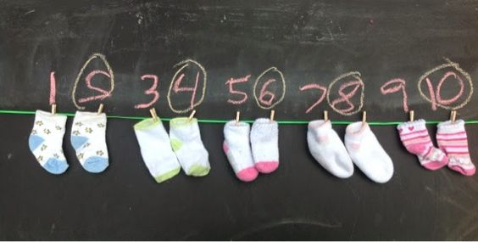  - Counting in 2s rote chanting. Work with an older siblings or parents. This works best when there are 3 or more of you, the first person shouts 2 followed by someone else shouting 4 and so on in 2s. You could start by taking it in turns then go randomly, you can only say one number at a time, if 2 of you shout the same number you have to start back at the beginning. What is the highest number you can get to?  Please email me a photo of your work. I would love to see it.
 | English –  Learning Challenge: I can write a sentence using my phonics to help me sound out.  Attached are some pictures of the day we made dams and did some colour mixing. Can you write a sentence or two about what you discovered or found out for the first time. This might be to do with how you made the dam and what worked well or maybe the colours you made. Surprise me with what you learnt.  Please email me a photo of your writing I would love to see it. | English-  Learning Challenge: I can complete the treasure hunt based on my previous learning.  For today’s English task you will be sent on a treasure hunt! Ask your parents to cut up the clues and hide these around your home and/or garden. You will need a pen and paper and a clipboard to record your answers. We have learnt all of these skills in class so think carefully about the answers.  Please email me a photo of you on your treasure hunt.
PM | Enquiry – How is our World filled with colour?  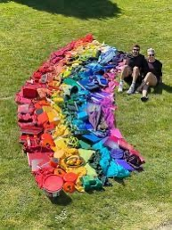  As the weather is due to be so beautiful I have set you 2 outdoor learning sessions to do this week.  Last week we made a rainbow by melting wax crayons. This week I would like you to go out into your gardens and see if you can make a rainbow using things you can see, it might me natural things such as flowers or grass or maybe it will be some toys you have in your garden such as cars or spades or even washing from your line! Have a go at creating a rainbow and listen to the song to help you remember how it goes.  https://www.youtube.com/watch?v=4g0NbaukkQc  OR…  Have a go at one of these colour changing experiments.  https://funlearningforkids.com/rainbow-walking-water-science-experiment-kids/  https://funlearningforkids.com/easy-science-experiments-for-kids/  https://funlearningforkids.com/color-changing-flowers-science-experiment/?utm_medium=social&amp=&utm_source=pinterest&amp=&utm_campaign=tailwind_tribes&amp=&utm_content=tribes&amp=&utm_term=327957678_9926368_112125  PLEASE EMAIL ME a photo of your picture - I’d love to see it!

