Grammar Treasure Hunt- Monday 19th July
For today’s English task you will be sent on a treasure hunt! Ask your parents to cut up the clues and hide these around your home and/or garden. You will need a pen and paper and a clipboard to record your answers. We have learnt all of these skills in class so think carefully about the answers.
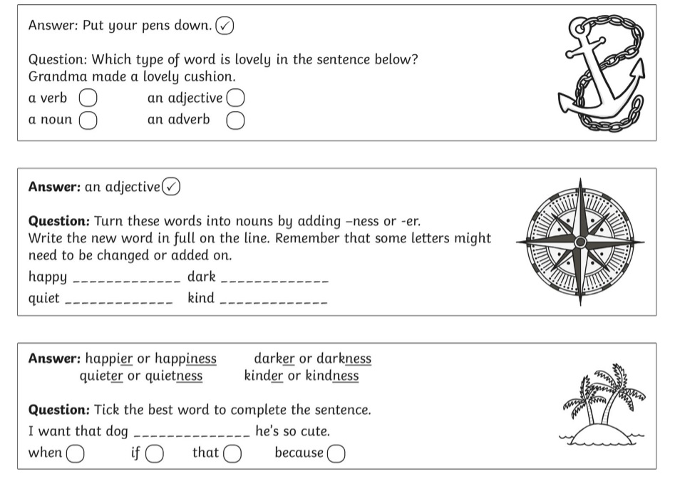

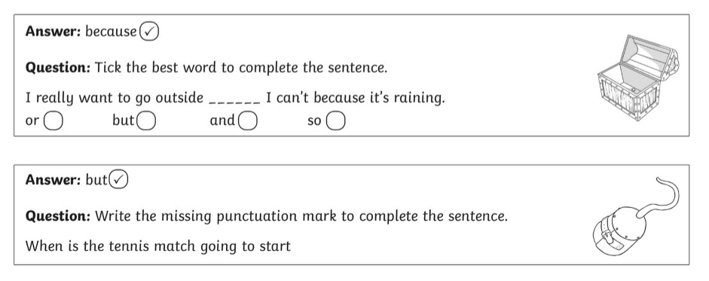
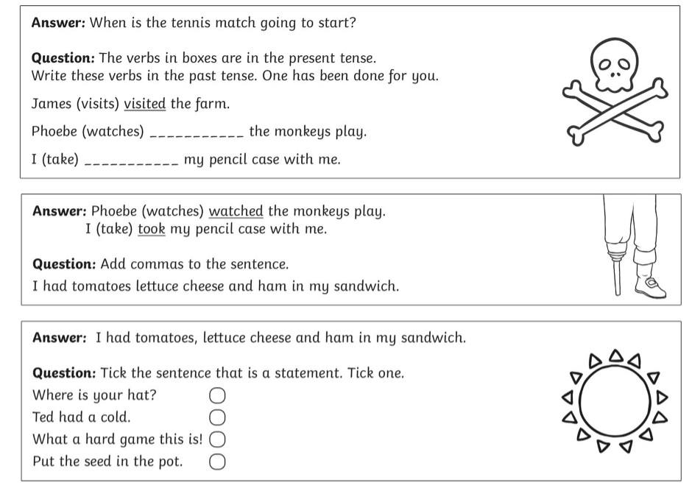

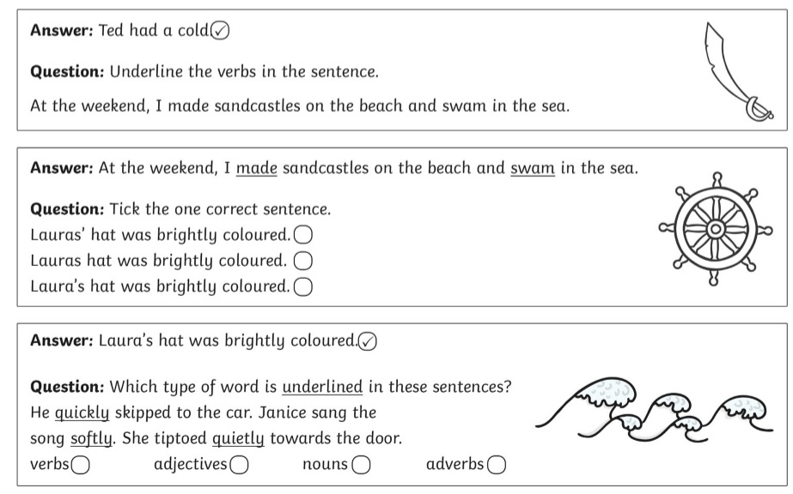

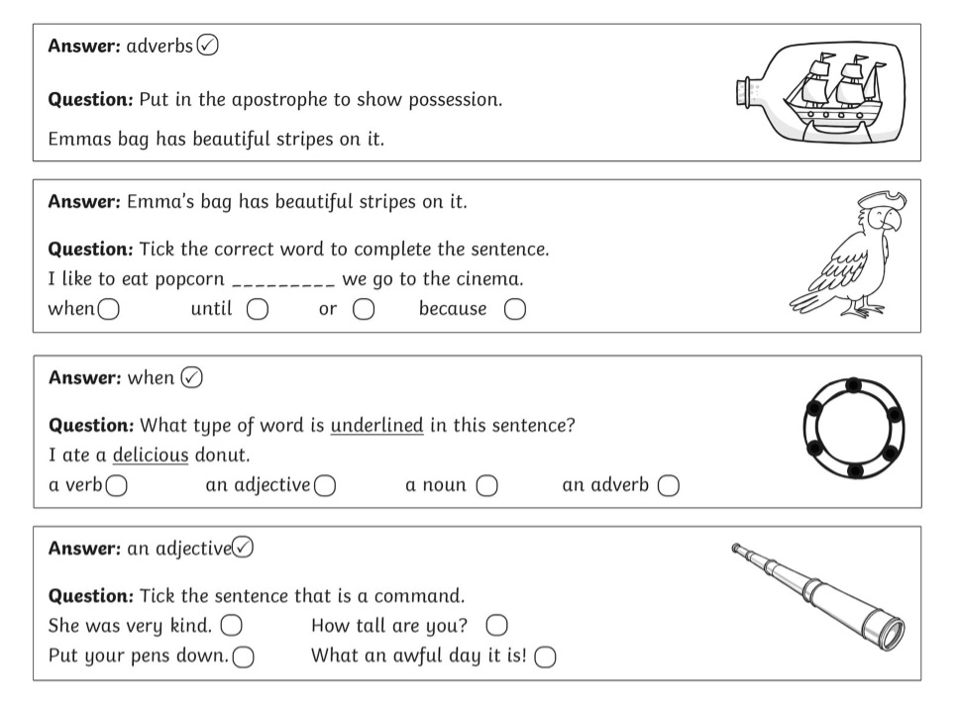

Extra Challenge
Create your own treasure hunt based on something you have learnt recently.
Challenge the people you live with to solve your clues.

