Friday 16th July – Home Learning Grid
If you can, please send any work highlighted in yellow to ecounsell@polperroprimary.co.uk
 | YR |  | Y1
AM | Start your day today with some Cosmic Yoga https://www.youtube.com/user/cosmickidsyoga |  | Start your day today with some Cosmic Yoga https://www.youtube.com/user/cosmickidsyoga
 | Phonics – HOME LEARNING  Starter: practise some fine motor/finger exercises:  https://www.youtube.com/watch?v=-_ukAaO_JDM  Today we are going to practise blending. To help you watch this https://www.youtube.com/watch?v=xG-xKG7I83E.  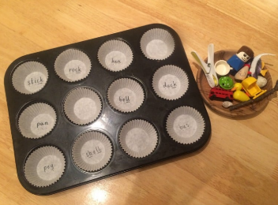  Then  Can you make a blending cake tin like this to play with your adult? |  | 9.30 - Phonics – ONLINE SESSION WITH MRS COUNSELL.  Please bring –  - A piece of paper  - A pencil
Maths – HOME LEARNING
LC: I can explore and compare time using minutes and seconds.
Watch https://vimeo.com/564566890
With a grown up, using a stopwatch, how many can you do of the following things in 20 seconds?
- How many star jumps?
- How many hops on one spot?
- How many times can you write your name?
Did you measure in seconds? Minutes or hours? Can you make a grid to show your results?
Now explore 1 minute -
Can you build a big tower?
How many times can you run up and down the stairs?
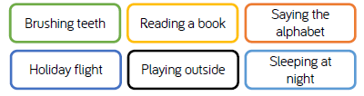
How would you measure these things? Minutes, seconds or hours?

With an adult:
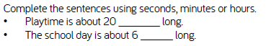
YR – continue to explore seconds and minutes. Can you time your adult to hop a the spot? Wash their hands? Write their name?
Y1 –
Complete the activity on the blog. PLEASE EMAIL WHEN YOU HAVE COMPLETED
 | 11.00 - ONLINE SESSION WITH MRS COUNSELL.  Please bring –  - A piece of paper  - A pencil | English- HOME LEARNING  On Tuesday it will be the Y6s’ leaving assembly  Please can you write a short message to them for Mrs Hillman to share with them from us all. This can be:  - Typed in an email to Mrs Counsell or Mrs Fernie  - On a piece of paper, photographed and emailed to Mrs Counsell or Mrs Fernie.  PLEASE SEND WHEN YOU HAVE COMPLETED
PM | Enquiry – How is our World filled with colour?  Today would usually be your art afternoon with Mrs G.  Art:  Can you create your own pattern using different coloured buttons or anything else you have at home? 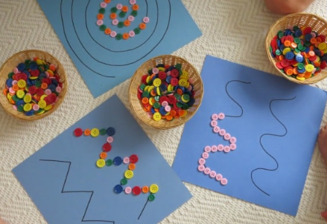  OR…  Create some squiggle art – take your pencil for a walk around an A4 page of paper like this. Draw a controlled squiggle.  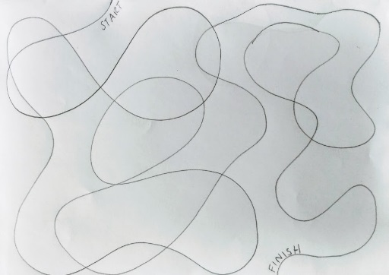  Then… decorate inside of your squiggles in different ways.  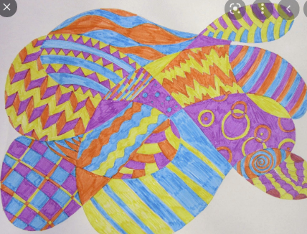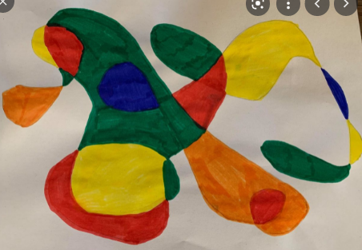  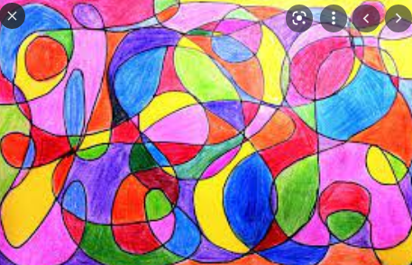  Try using different materials: pencils, pens, crayons, stickers, filling them with things such as; torn up paper strips, buttons, pasta. PLEASE EMAIL ME a photo of your picture - I’d love to see it!

