Thursday 15th July – Home Learning Grid
If you can, please send any work highlighted in yellow to ecounsell@polperroprimary.co.uk
before 3pm
 | YR | Y1
AM | Start your day today with some Cosmic Yoga – we are going on a bear hunt this morning  https://youtu.be/KAT5NiWHFIU  Phonics – watch this Alphablocks video on blending. https://www.youtube.com/watch?v=BxtUFEFkSas  Once you have watched it – please have a try at the blending activity at the bottom of the blog.  Maths –  Yesterday we looked at telling the time to the hour.  Look at the powerpoint ‘Talk about time’ at the bottom of the blog – with an adult talk about the different pictures and language being used  Can you make your own clock?  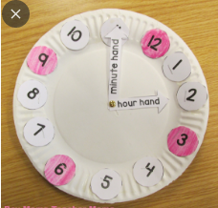  Can you make 1 o’clock? Can you make 3 o’clock?  (PLEASE POST A PHOTO ONTO TAPESTRY OF YOUR CLOCK) | Start your day today with some Cosmic Yoga – we are going on a bear hunt this morning  https://youtu.be/KAT5NiWHFIU  Phonics – consonant blendings.  In phonics yesterday we looked at consonant blends. Watch our friend – Jack Harman to remind yourself. https://www.youtube.com/watch?v=QZ1Uu2MRXTY  Then complete the activity at the bottom of the blog.  Maths –  Learning Challenge: I can tell the time to the half hour.  In maths yesterday – we were learning to tell the time to the hour. Can you remember the language we used to name the clock hands? Can you remember the language we used to name the type of clock we were using?  Watch - https://vimeo.com/566056276  Make your own clock –  Don’t forget – the hour hand is always slightly shorter than the minute hand.  Complete the activity - at the bottom of the blog (PLEASE EMAIL TO MRS COUNSELL before 3pm)
PM | This afternoon we were going to start learning this song – Here comes the sun by The Beatles  https://www.youtube.com/watch?v=mc1ta1UMGeo  Can you practise it and find a way to perform it to your adults/ others in your household?  Can you make a sunny picture to go with the song? Here’s some ideas:  https://creativefamilyfun.net/10-ways-to-play-this-weekend-week-42/  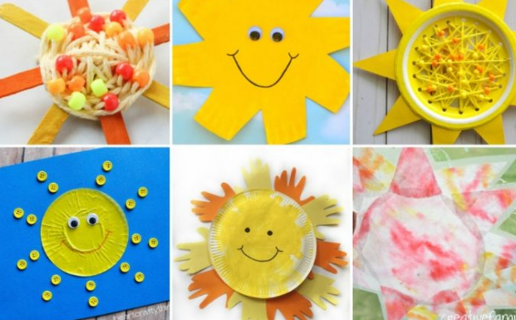  Have a good day

