 | READING | 10.00 – 10:30  MATHS | 10.45 – 11:00  SPELLINGS | 11:00  ENGLISH | AFTERNOON  ENQUIRY/RE/PSHE | ACTIVE  AFTERNOON
T  H  U  R  S  D  A  Y | Please spend 20 minutes reading a book of your choice.  OR  Log on to Get Epic via the link below, using the class code: jam9567 and read a book of your choice.  https://www.getepic.com/sign-in/educator | LC: Year 2: I can measure and compare mass.  LC: Year 3: I can measure the mass of an object.  This will be a live session delivered by Miss Gibbings via TEAMS.  Please log on 5 minutes prior to the session starting. Make sure that you mute your microphone but have your camera on before joining the session.  Year 3 will be asked to watch a video during the lesson via the following link: https://vimeo.com/556159306  You will need:  - Year 2 Worksheet (if able to print)  - Year 2 Maths Challenge (if able to print)  - Year 3 Worksheet (if able to print)  - Year 3 Maths Challenge (if able to print)  - Paper  - Pencil | Year 2  This week we have been looking at the phoneme ‘u’ spelt as ‘o’.  Use the spelling strategy cards to practice spelling the following words:  Other  Mother  Cover  Loved  Someone  Brother  Smothering  Brother  Where is the ‘u’ sound positioned in each word?  Year 3  This week we have been looking at homophones.  How many homophones can you think of in 1 minute?  Use the spelling strategy cards to practice spelling the following homophones:  there / their / they’re  threw / through  heard / herd  weight / wait  Can you put these into a sentence? | LC: I can create my own fact file about the Olympic Games.  This will be a live session delivered by Miss Gibbings via TEAMS.  Please log on 5 minutes prior to the session starting. Make sure that you mute your microphone but have your camera on before joining the session.  You will need:  - Paper  - Pencil  - Colouring pencils or pens | Art  LC: I can design my own Olympic ring artwork.  ACTIVITY  Create your own piece of artwork inspired by the Olympic rings. See the images for inspiration below.  What household objects could you use to create the circular outlines for the rings? How can you include patterns in your design? What colours are the rings?  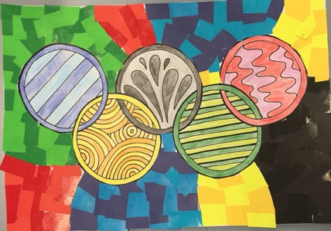  You will need:  - 2-D circle (E.g. Sellotape, circular coaster, rim of a mug/glass).  - Paper  - Pencil  - Colouring pencils, pens, paint, pastels etc. | You can choose from:  GoNoodle https://www.gonoodle.com/  Supermovers https://www.bbc.co.uk/teach/supermovers/pshe-super-mood-movers/zm2gydm  or Cosmic Kids Yoga  https://www.youtube.com/user/CosmicKidsYoga

