Penhallow Class ~ Supporting Learning at Home Grid
Our Enquiry: What’s it made of?

Enjoy reading with other people in your home. Can you find unusual places to read?  What texts can you find about materials?  Remember to log all of your reading on your SeeSaw account. | What every day materials can you find in your home?  Can you have a go at sorting the materials?  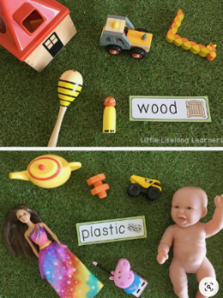  What can you find that is bumpy, smooth, hard, soft? | Listen to the story of ‘Aliens love Underpants’  https://www.youtube.com/watch?v=ADnAGBWlzqE  Can you create a spaceship for an alien? 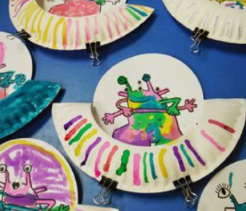 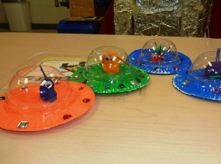  What materials can you use in your home to make it? - Plastic, wood, paper, card?
Aliens love wacky underpants  Using as many different textures as you can find (recycling bins can be helpful) –create a collage of the wackiest pair of pants you can think of. | Year 1 Maths:  Measuring addition and subtraction  Blog is 12cm and Glob is 8cm. How tall are they altogether?  Can you write 5 more maths challenges similar to this, to challenge your parents…the harder the better!  Reception Maths  Go on a material hunt around your house. How many things can you find? Count how many you have found, can you sort them into metal, plastic, wood, fabric? Can you create a grid to show your results? | Get active!  Have a look at the GoNoodle active dances to get moving.  https://www.youtube.com/user/GoNoodleGames  Cosmic Yoga  https://www.youtube.com/user/CosmicKidsYoga

