Chaipel homework grid
Science  Recipe for a hurricane.  You will need:  1 large jug  Water  Spoon  Put water into the jug (about ¾)  Stir the water with a spoon  Watch the hurricane.  If you stir a jug of water very quickly then take your spoon out to watch it spin, you will see fast moving particles moving around a central point. The hurricane winds work in the same way, but their central point is still and expanding. | Art  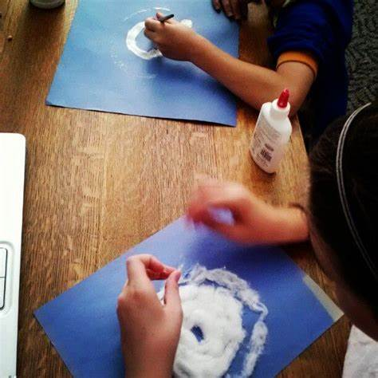  Make your own 3D model of a hurricane, use cotton wool and stick making sure you swirl it around. Don’t forget to leave the eye of the storm! | Maths  Gather data of hurricanes wind speed, you will need about 7 – 10 different storms.  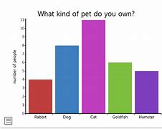  Draw a bar graph to show the data, remember your scale, titles and rulers!
Design and technology  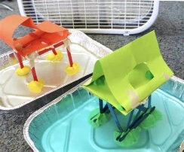  Design your own building that can withstand a hurricane.  What materials are you going to use?  Will it withstand floods, winds and rain?  Use a hairdryer to replicate the hurricane. Does your building survive? | English  Design a poster that will tell people what to do in the event of a hurricane.  Make it clear and simple to follow.  Keep your writing neat and tidy, add diagrams to show your meaning. | Music or PE  Music – make your own song or poem about a hurricane. You could make a rap song or a pop song it’s up to you.  PE – Make a dance about a hurricane, you could use music to dance to or just make a routine up that demonstrate a hurricane.

