Landaviddy’s Homework Grid – Summer Term 1
Enquiry Question: Does Polperro always stay the same?

Go for a walk with your family in the local area.  Create a tally chart to record the different plants and animals you spot.  Does your tally chart look the same on different day?  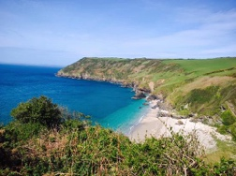 | What is plastic pollution?  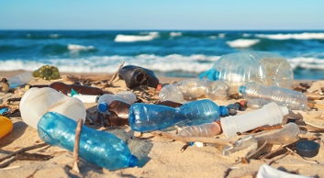  Is plastic a problem in Polperro? What would the future look like without plastic? Create a poster to raise awareness of plastic pollution in the local area. | Fantastic Fossils  What might have lived in Polperro millions of years ago? Pretend you are a news reporter breaking a news story of a never-seen-before fossil found in Polperro. Could you plan/write a script? Could you film your news report?  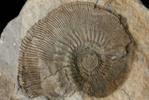
What did Polperro look like in the past?  Create a 3D model of Polperro, showing what you think it looked like in the past. Could you use recyclable materials?  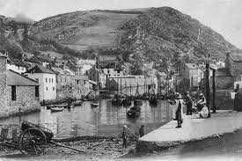 | Create a piece of landscape art inspired by Polperro.  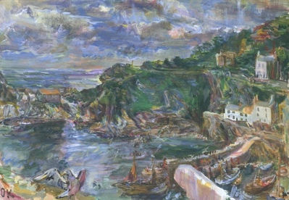  How will you add texture to your artwork? What will you need to include? | Ready. Set. Go!  Create your own obstacle course in your garden. How fast can you complete the circuit? Could you challenge a family member to compete against you?  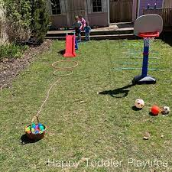
If you would like to share your learning at home with Miss Gibbings, please take a photo and email agibbings@polperroprimary.co.uk.

