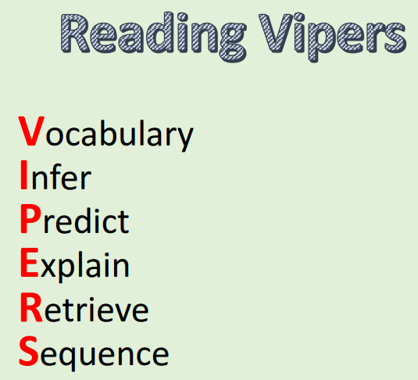
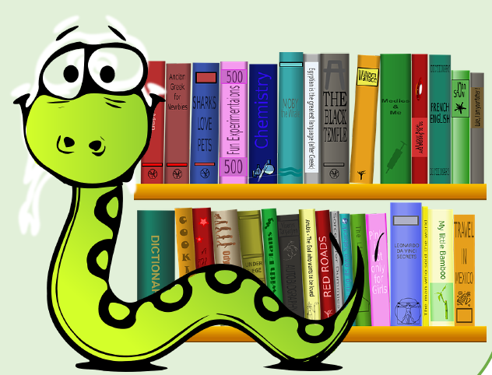
Key Stage One Reading Skills
VIPERS stands for the key reading skills that we teach the children in school. Please find a list of questions below that you can use to prompt discussions and to help your child develop the reading skills. You may wish to link your comments (when recording reading sessions in your child’s reading record) to the reading skills. For example, “Ben explained who his favourite character was and why. He summarised the story after reading.”


