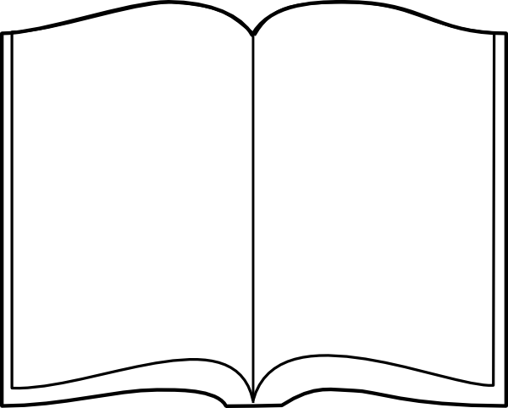**Learning Challenge:** I can write a book review. (Year One)

About the illustrations (tick)

I liked them

They were ok

They were dull

I enjoyed it with…

My favourite bit was…

The stars give my rating out of 5



Title of the book ________________________

_____________________________________

Author _______________________________

_____________________________________

About the story

_______________________________________________________

_______________________________________________________

______________________________________________________

______________________________________________________

______________________________________________________

______________________________________________________