How do flowering plants grow?
Title

Introduction
Did you know…
Have you ever wondered
Read on to find out more…

Exciting Interesting Intriguing Colourful Pretty
Spectacular Amazing Fascinating Awesome

Germination | First,  The seed in the soil grows deep roots.  Water and warmth.  Sunlight and nutrients.  Tiny, miniature, small, miniscule shoot pushes to find carefully light.
Growing and Flowering | Next,  Shoot grows taller, bigger, stronger – produces green leaves.  Leaves help to create food – Photosynthesis  Mature plants grow colourful, beautiful, bright, vibrant, grand, fragrant flowers.  because  As a result,
Pollination | Eventually,  Colourful, fragrant Flowers attract insects – bees, butterflies, ants  Sticky Pollen is collected from anther  Transferred by insects.
Seed Formation | Once,  Sticky, dusty, bright, particles - Pollen mixes with stigma to form a seed.  Seed is created in the ovule of flower.
Seed Dispersal | Finally,  Pollinated flower petals wilt.  Seeds are dispersed – start new plants.  Dispersed – birds eat fruit, travel in the wind, water.  And, because, when

Fun Facts

Did you know…

Some plants are carnivorous and gain nutrients from insects and spiders. E.g. Venus flytraps.

Use this space to draw and label a diagram you will include in your explanation text.

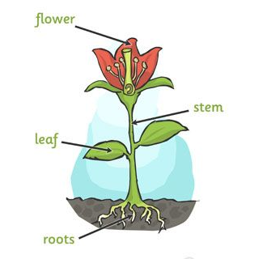

This diagram shows a mature flowering plant.

