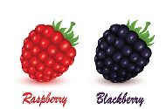
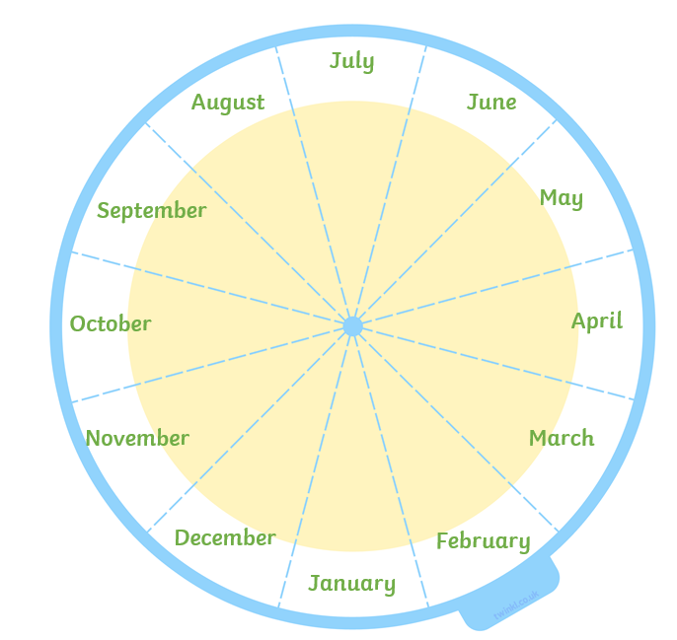
Month Wheel

Fill your wheel with lovely produce which can be grown in the UK (in the month they need to be sown or planted). We might use your ideas for our School Garden!

