 | ACTIVE MORNING  9:00 – 9:20 | 9:30 – 10:30  ENGLISH | 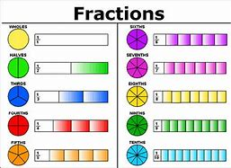  11:00 – 12:00  MATHS | 1PM – 3:15PM  AFTERNOON - Enquiry
THURSDAY | Don’t forget Joe Wicks PE sessions are now back from 9am – 9:20am every Monday, Wednesday and Friday. | Prior to the lesson starting can you please watch this video and complete the tasks To practise and apply knowledge of silent letters, including test (thenational.academy)  After, can you practice your word of the day: Sacrifice  LC:I can use a causal conjunction in my writing.  You will need:  - Paper  - Pencil  - Causal conjunction word mat  - ‘Can you find the causal conjunction?’ text.  This will be a live session delivered by Mrs Visick via TEAMS. Please return 5 minutes prior to the session starting. Make sure that you mute your microphone but have your camera on before joining the session.  Please send me your work today  10:45 AM We will have a 15 minute break and then continue with maths. Please do not leave the session. | LC: I can find a fraction of an amount  You will need:  - paper and worksheets  - Pencil  This will be a live session delivered by Mrs Visick via TEAMS. Please log on 5 minutes prior to the session starting. Make sure that you mute your microphone but have your camera on before joining the session. | 1 – 1:30pm Singing with Mrs Butlin  After singing, can you complete the Fairtrade wordsearch and then complete any work you have outstanding please.  When you have finished your work, I would like you to settle down somewhere comfortable and spend 15 – 20 minutes reading your book.

