 | ACTIVE MORNING  9:00 – 9:20 | 9:30 – 10:30  ENGLISH | 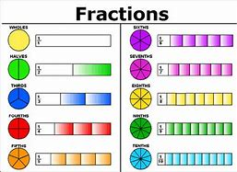  11:00 – 12:00  MATHS | 1PM – 3:15PM  AFTERNOON - Enquiry
WEDNESDAY | Don’t forget Joe Wicks PE sessions are now back from 9am – 9:20am every Monday, Wednesday and Friday. | Prior to the lesson starting can you please watch this video and complete the tasksTo investigate silent letters (thenational.academy)  After, can you practice your word of the day: Rhythm  LC:I can understand how to use a causal conjunction in my writing.  You will need:  - paper  - Pencil  - Causal conjunction word mat  This will be a live session delivered by Mrs Visick via TEAMS. Please return 5 minutes prior to the session starting. Make sure that you mute your microphone but have your camera on before joining the session.  10:45 AM We will have a 15 minute break and then continue with maths. Please do not leave the session. | LC I can find a fraction of an amount  You will need:  - paper and worksheets  - Pencil  This will be a live session delivered by Mrs Visick via TEAMS. Please log on 5 minutes prior to the session starting. Make sure that you mute your microphone but have your camera on before joining the session. | LC: I can use my research to answer questions.  Continuing from yesterday’s research. Please complete the worksheets about where our fruit and vegetables come from.  You will need:  - Map of the world  - Pencil  - Paper  - Worksheets  Please send me your work today  When you have finished your work I would like you to settle down somewhere comfortable and spend 15 – 20 minutes reading your book.

