Editing and Improving Success Criteria:

- Choose a Day to edit
- Check capital letters and full stops
- Check you have a range of sentence openers with a comma!
- 2A sentence
Now check your completed Space Log
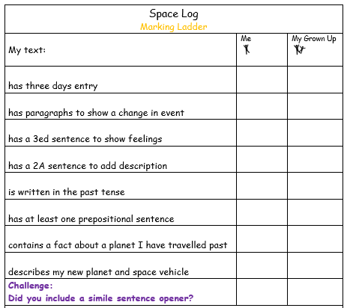
My new writing target is _______________________
______________________________________________.

