 | ACTIVE MORNING  9:00 – 9:20 | 9:30 – 10:30  SCIENCE | 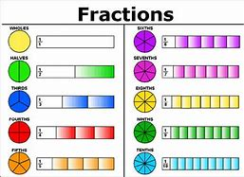  11:00 – 12:00  MATHS | 1PM – 3:15PM  AFTERNOON -
TUESDAY | Don’t forget Joe Wicks PE sessions are now back from 9am – 9:20am every Monday, Wednesday and Friday. | Prior to the lesson starting can you please watch this video and complete the tasks To investigate suffixes: More -er and -est suffixes (thenational.academy)  After, can you practice your word of the day: Sincerely  LC:I can name the different parts of flowering plants and explain their jobs.  You will need:  - paper and worksheets  Pencil  This will be a live session delivered by Mrs Visick via TEAMS. Please return 5 minutes prior to the session starting. Make sure that you mute your microphone but have your camera on before joining the session.  10:45 AM We will have a 15 minute break and then continue with maths. Please do not leave the session. | LC I can find a fraction of an amount  You will need:  - paper and worksheets  - Pencil  This will be a live session delivered by Mrs Visick via TEAMS. Please log on 5 minutes prior to the session starting. Make sure that you mute your microphone but have your camera on before joining the session. | LC: I can research where some fruit and vegetables originate.  You will need:  - Map of the world  - Pencil  - paper  PE:  LC: I can change directions and throw with precision and power.  Changing direction and throwing with power and precision (thenational.academy)  When you have finished your work I would like you to settle down somewhere comfortable and spend 15 – 20 minutes reading your book.

