 | ACTIVE MORNING  9:00 – 9:20 | 9:30 – 10:30  Maths | 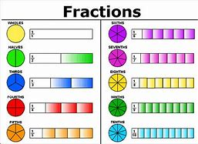  11:00 – 12:00  Guided Reading | 1PM – 3:15PM  AFTERNOON - ART
FRIDAY | Don’t forget Joe Wicks PE sessions are now back from 9am – 9:20am every Monday, Wednesday and Friday. | Prior to the lesson starting can you please watch this video and complete the tasks To practise and apply knowledge of suffixes: More -er and -est, including test (thenational.academy)  After, can you practice your word of the day: Mischievous  LC: I can add fractions within 1. (numerators)  LC: I can find a fraction of an amount. (Denominators)  You will need:  - paper and worksheets  Pencil  This will be a live session delivered by Mrs Visick via TEAMS. Please return 5 minutes prior to the session starting. Make sure that you mute your microphone but have your camera on before joining the session.  10:45 AM We will have a 15 minute break and then continue with maths. Please do not leave the session. | Assembly 11:00am  Please log on to the separate invite on Teams.  LC I can use my VIPER skills to answer questions about a film.  This will be a live session delivered by Mrs Visick via TEAMS. Please log on 5 minutes prior to the session starting. Make sure that you mute your microphone but have your camera on before joining the session.  You will need: | ART  LC:I can create a piece of abstract art in the style of Peter Thorpe.  Look at the pictures below. They are abstract art by Peter Thorpe. I would like you to try and copy one of the pictures yourself. You can either copy it as it is or add your own colour or style as long as it is recognisable as Peter Thorpe. So you may want to change the subject (rocket) for a planet or redesign the rocket to one of your own.  You will need:  - Paper  - Colouring pencils or paint  I would like you to send me pictures of your art work please.  When you have finished your work I would like you to settle down somewhere comfortable and spend 15 – 20 minutes reading your book.

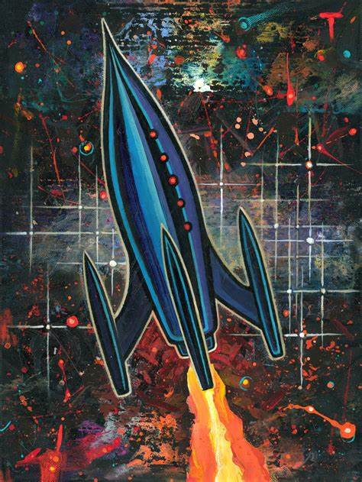
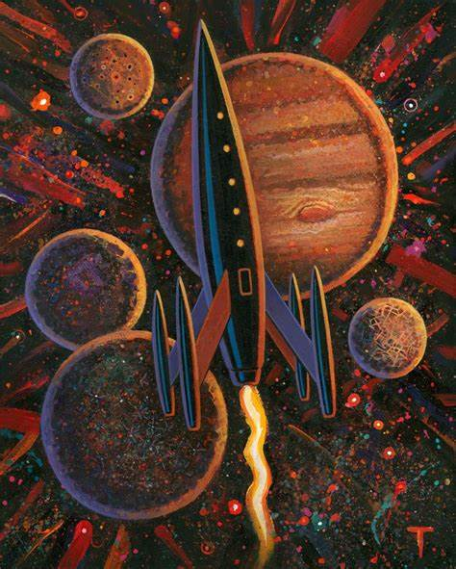
Peter Thorpe Art work

