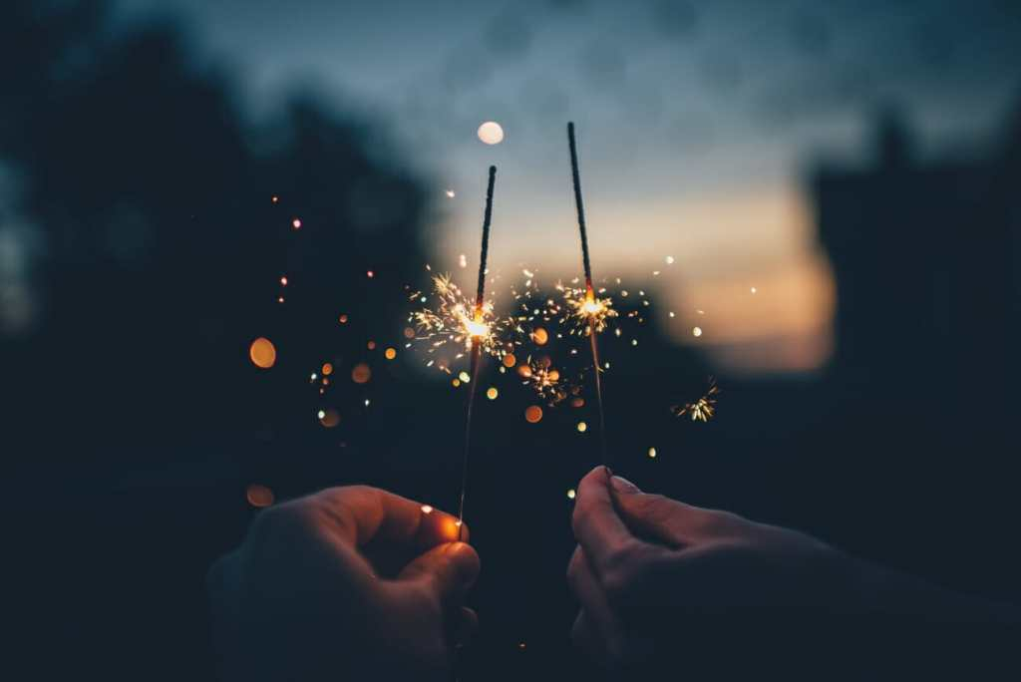

Use the image to inspire a piece of writing. You could write a poem, adventure story, newspaper report, diary entry, anything you want!

Here are some questions to get you thinking and help your ideas flow.

*Who do the hands belong to?*

*What are they holding?*

*When was this photo taken?*

*Where are the people?*

*What time of the day could it be?*