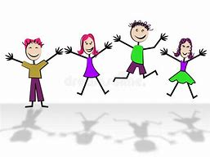
What have you enjoyed learning about this half term?

Please explain why.
What have you found difficult?

Please explain why.

How do you find home learning?
Is there anything school can do to make learning easier for you while you are not in your classroom?
Reflection on my half term learning.

Mrs Counsell and Mrs Batchelor would like to know how you feel about your home learning. Please can you fill this in with a grown up and email it back/or take a photo.

