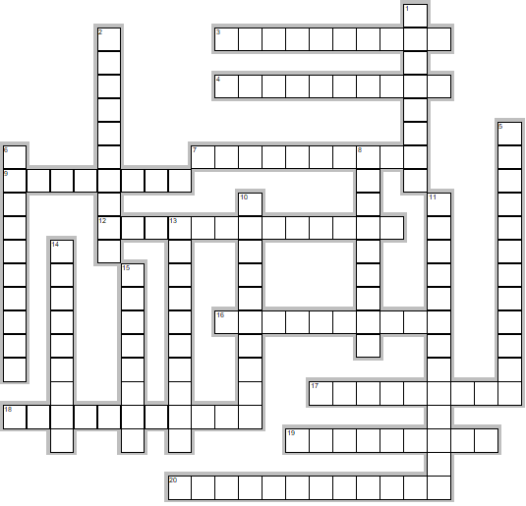
ADDING –SHIP, -NESS & -MENT
New words can be formed by adding
the suffix –ship, -ness or –ment.

Across

3. FRIEND + SHIP =
4. MEMBER + SHIP =
7. LONELY + NESS =
9. MOVE + MENT =
12. NEIGHBOUR + HOOD =
16. WICKED + NESS =
17. SILLY + NESS =
18. FOOLISH + NESS =
19. OWNER + SHIP =
20. CHAMPION + SHIP =

Down

1. TIDY + NESS =
2. MANAGE + MENT =
5. CARELESS + NESS =
6. EMPLOY + MENT =
8. ENJOY + MENT =
10. LOVELY + NESS =
11. CRAFTSMAN + SHIP =
13. GOVERN + MENT =
14. CHILD + HOOD =
15. KIND + NESS =

