**Year 1 and 2 Calculation strategies**

Attached are the different steps to calculation which are taught to your child when they are in year 1 and 2. Children work at different rates and some will work through these methods faster than others – this is ok!

If you are working with your child when they are calculating, please think about;

Can I do this in my head?

Could I do this in my head using drawings or jottings to help me?

Do I need to use a written method?

Which method should I use to help me?

**Also help your child to estimate and then check the answer. Encourage them to ask…Is the answer sensible?**



**Addition** **Mental strategies**

Mental recall of number bonds

6 + 4 = 10 □ + 3 = 10 19 + □ = 20

Use near doubles

6 + 7 = double 6 + 1 = 13

Addition using partitioning and recombining

34 + 45 = (30 + 40) + (4 + 5) = 79

Whole/Part model:

We talk to the children about numbers being part of a whole. This really helps children to find missing numbers and problem solve quite quickly. For example; if the whole number is 5 one part would be 2 and the other would be… The number sentence would be 2 + ? = 5. A practical approach would be taken to teach this method, using counters, buttons etc…

25

5

Counting on from the larger number:

Starting at the larger number and counting on using a number line. The example below would be 5 + 4 = 9

This will be extended to put the larger number in your head and count on using objects.

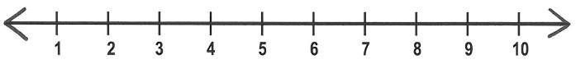

Making 10:

We encourage children to use their number bonds to make 10 and then readjust what they have got left. This allows children to mentally partition numbers, showing that they have got a good grasp of how numbers work.

+1

+4

Making 10 with 3 numbers:

When children are ready, they add 3 numbers together. We get them to become number detectives and spot the number bonds to 10 to help them calculate.

For example:

3 + 5 + 7 =



3 + 7 = 10 + 5

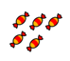

=

+

=

Column method:

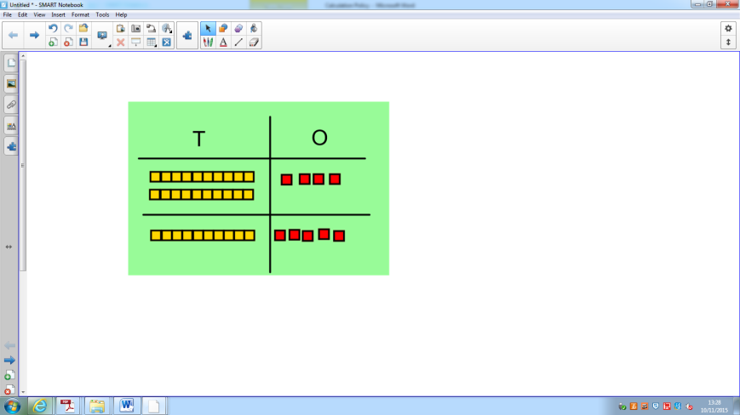

24 + 15 =

Children are able to partition numbers into tens and ones. Through objects, then moving onto using numbers, they can then add the ones and the tens to find the total of the two.

9 = 39

30 +

2 4

+ 1 5

3 9

Once children are confident using apparatus to add in columns, they will be able to move onto just using numbers.

**Subtraction mental strategies:**

Mental recall of addition and subtraction facts

10 – 6 = 4 17 - □ = 11

20 - 17 = 3 10 - □ = 2

Find a small difference by counting up

82 – 79 = 3

Taking away ones:

Children will be given objects or pictures and will physically take the objects away. They will be encouraged to link their learning back to the number bonds they have learnt.

6 – 2 = 4

Whole/part model:

Children will see that the whole number is 6 and that one part of it is 2. They would then use crossing our or physically moving the objects to find the other part.

?



Counting back:

Children will understand by now that subtraction means less than/taking away. We introduce a number line and the children begin to count back on a number line (with the help of a bead string) to find a solution.

9 – 4 =



When children have got a better understanding of place value, they will be able to take away 10’s in 1 jump i.e.:



Some children will move onto more formal ways of subtracting once they have a firm understanding of the numbers they are working with.

**Multiplication mental strategies:**

Doubling – children will be taught that doubling is adding the same again.

Children count in different number patterns from reception onwards.

Times tables are taught from year 1 onwards.

10 times table

5 times table

2 times table

Doubling:

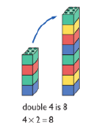Children will be taught that doubling is adding the same again. They will practice this through using physical objects and drawings and will be able to recall doubling facts.

Repeated addition:

Multiplying is adding the same amount a number of times and learning the number patterns, increases the speed at which children learn. When children are first learning about multiplication, they need to see that they are adding the same number multiple times.

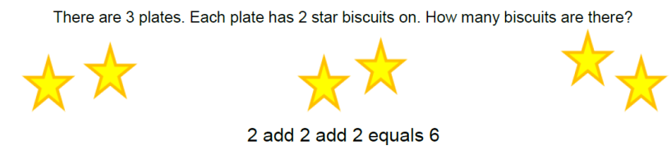

2 + 2 + 2 = 6

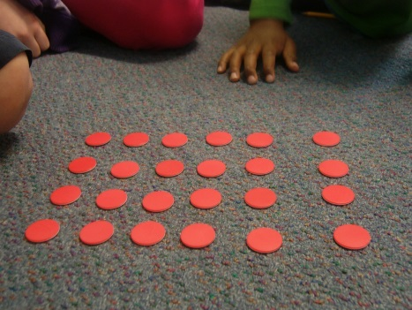Arrays:

When children confident multiplying smaller amounts, they will move on to using arrays to multiply larger amounts (i.e. 4 x 6 as shown in the picture).

From this point onwards, children are encouraged to count in groups (i.e. in 4’s) to find an answer.

**Division mental strategies:**

Halving – children will begin to understand that halving is the opposite of doubling and they will link the facts together (i.e. double 2 is 4 so half of 4 is 2).

Times tables are taught from this year onwards. They will be taught that the division facts can be found within the multiplication facts i.e.

10 x 2 = 20 so 20 ÷ 10 = 2

10 times table

5 times table

2 times table

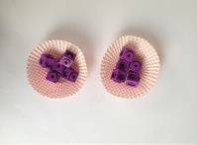Sharing objects into groups:

Children will explore sharing amounts between different groups (they will share them out one at a time). Children will do this with physical objects as well as through drawing pictures to help their understanding.

Can you share 10 objects between 2 groups?

Grouping objects:

Grouping is different to sharing as they are making equal groups rather than handing things out one at a time.

When they are learning to group, they will use numbers that they are familiar with i.e.; how many groups of 2 can I make from 10? When they are becoming more confident with this, they will begin to use a number-line to count back.

5

4

3

2

1



0