Calculation policy:
Subtraction

PROGRESSION THROUGH CALCULATIONS FOR SUBTRACTION

All of the mental methods below need to be taught to the children explicitly. Children will need to see or draw models to show their understanding when they are learning these methods.

Year 1

Mental recall of addition and subtraction facts
10 – 6 = 4 17 - = 11
20 - 17 = 3 10 - = 2

Year 2

Find a small difference by counting up
82 – 79 = 3

Year 3

Counting back in repeated steps of 1, 10, 100, 1000 – This will show children’s understanding of place value very quickly.
86 - 52 = 34 (by counting back in tens and then in ones)
460 - 300 = 160 (by counting back in hundreds)

Year 4

Subtract the nearest multiple of 10, 100 and 1000 and adjust
24 - 19 = 24 - 20 + 1 = 5
458 - 71 = 458 - 70 - 1 = 387

Use the relationship between addition and subtraction
36 + 19 = 55 19 + 36 = 55
55 – 19 = 36 55 – 36 = 19

Many mental calculation strategies will continue to be used. They are not replaced by written methods.

Children should not be made to go onto the next stage if:

- They are not ready.
- They are not confident.

Children should be encouraged to approximate their answers before calculating.
Children should be encouraged to check their answers after the calculation using an appropriate strategy.
Children should be encouraged to consider if a mental calculation would be appropriate before using written methods.

Children should:
- be able to subtract numbers with different numbers of digits;
- be able to subtract two or more decimal fractions with up to three digits and either one or two or three decimal places;
- know that decimal points should line up under each other.

thousand
one
ten
hundred

Year 2
https://mathsframe.co.uk/en/resources/resource/68/itp-difference
Subtracting by finding the difference

Concrete:
This is a concept that children sometimes find challenging but it’s really important when finding the difference between numbers which are close together. The more confident children about their knowledge of number, the greater their fluency will be.
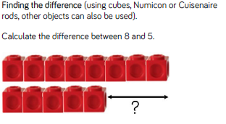

Pictorial:

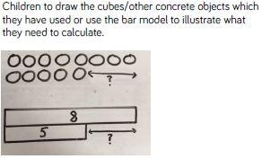

Abstract:
The abstract will come when children increase their fluency and understanding of counting up to find the difference. Ensure children are still encouraged to use pictures until this time. If children are then given ‘near’ numbers, they begin to make connections between ideas.
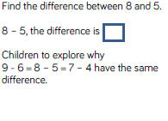

If you have concerns about lower ability of SEN children with this method of calculating, please speak to your maths lead.

Subtraction Year 2
Subtracting by finding 10 (applying use of number bondsof numbers up to 10)

Concrete:

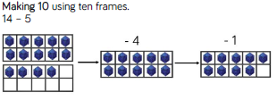
Children will need to use their knowledge of partitioning to be able to do this. This works well when children are going over the 10s boundary.

Pictorial:

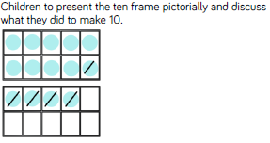
Moving children onto use the number line is really important because they can see where the nearest 10 is and head there and calculate using their number bond knowledge.

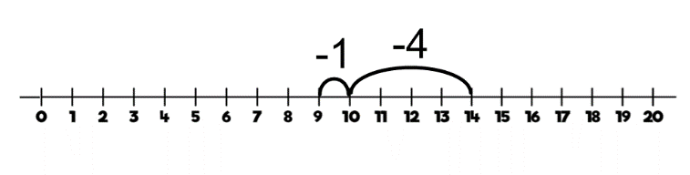

Abstract:
Number which is being subtracted.
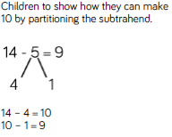
Ensure that children partition before they begin to subtract.

Subtraction – Year 2/3
Subtracting without exchanging

Concrete:

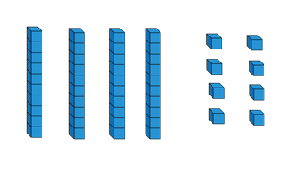
48 – 7 =

Children make the number and take aware the smaller number. This helps children remember that you subtract from the larger number.

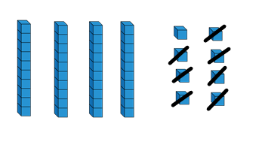

Pictorial:

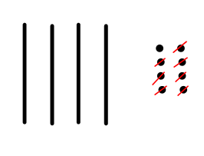
48 – 7 =

Children complete the same process but by drawing a representation of the number using sticks and dots.

Abstract:

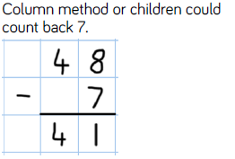
48 – 7 =

Only when children’s knowledge of place value is good enough would you go onto using a more formal written method. Until that time, keep encouraging children to use pictorial representations.

Subtraction – Year 2/3
Key learning for teacher and TA’s to explain when looking at subtraction is ‘Can I do it?’ If the question is 56 – 39 = Look at the ones, 6 – 9 then ask ‘Can I do it?’ Check children’s understanding of number before thinking about exchanging and always begin with concrete objects until children are ready to move on.
Subtracting with exchanging

Concrete:

41 – 26 =
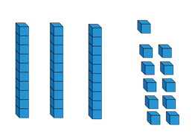
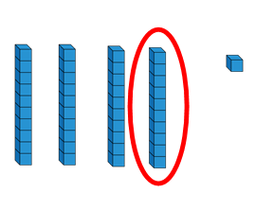
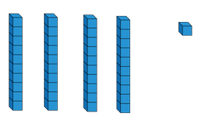

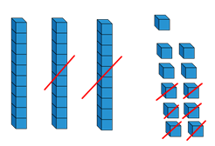
Children need to be able to physically exchange the ten for ten ones to see that they have got the same before they can begin to approach the calculation.

Pictorial:
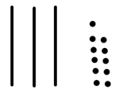
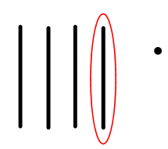
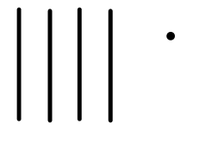

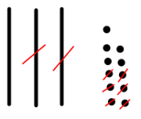
Children need to be able to draw the exchange to consolidate their understanding of 1 ten and ten ones being the same before the attempt to find a solution.

Abstract:
These written calculation will need to be taught alongside the concrete and pictorial representations.
4 0 + 1 3 0 + 1 1

- 2 0 + 6 - 2 0 + 6

Subtraction - Year 3
Subtracting with exchanging

Key learning for teacher and TA’s to explain when looking at subtraction is ‘Can I do it?’ If the question is 56 – 39 = Look at the ones, 6 – 9 then ask ‘Can I do it?’ Check children’s understanding of number before thinking about exchanging and always begin with concrete objects until children are ready to move on.

Concrete:

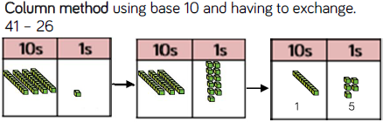

- 2 6

Pictorial:

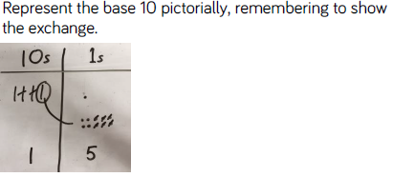

Using the place value grid will help children’s understanding of exchange when they are working with larger numbers.

Abstract:

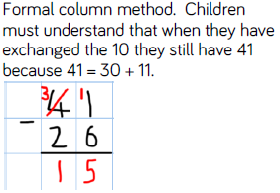
If children are getting confused with a more formal written method, please go back to the more informal way of written subtraction.

