Calculation Policy:
Multiplication

Years 2 and 3

PROGRESSION THROUGH CALCULATIONS FOR MULTIPLICATION

MENTAL CALCULATIONS

These are a selection of mental calculation strategies:
See NNS Framework Section 5, pages 52-57 and Section 6, pages 58-65

Doubling and halving
Applying the knowledge of doubles and halves to known facts.
E.g. 8 x 4 is double 4 x 4
Knowing that doubling is the same as multiplying by 2.

Using multiplication facts

Tables should be taught from Y1 summer term onwards, either as part of the mental oral starter or other times as appropriate within the day.

Year 2 10 times table
5 times table
2 times table

Year 3 4 times table
8 times table
3 times table
6 times table
9 times table

Year 4 7 times table
11times table
12 times table
Derive and recall all multiplication and division facts up to 12 x 12

Years 5 & 6 Derive and recall quickly all multiplication and division facts up to 12 x 12.
Work out products such as 70 X 5, 70 X 50 and 700 X 50 using the related fact 7 X 5 and their knowledge of place value.

Using and applying division facts

Children should be able to utilise their knowledge of multiplication to derive other facts.
E.g. If I know 3 x 7 = 21, what else do I know?
30 x 7 = 210, 300 x 7 = 2100, 3000 x 7 = 21 000, 0.3 x 7 = 2.1 etc

Use closely related facts already known

13 x 11 = (13 x 10) + (13 x 1)
= 130 + 13
= 143

Multiplying by 10 or 100

Knowing that the effect of multiplying by 10 is a shift in the digits one place to the left and the addition of 1 place value holder.
Knowing that the effect of multiplying by 100 is a shift in the digits two places to the left and the addition of 2 place value holders.

Partitioning
23 x 4 = (20 x 4) + (3 x 4)
= 80 + 12
= 102

Use of factors
8 x 12 = 8 x 4 x 3

MANY MENTAL CALCULATION STRATEGIES WILL CONTINUE TO BE USED. THEY ARE NOT REPLACED BY WRITTEN METHODS.

Children should not be made to go onto the next phase if:

1) They are not ready.
2) They are not confident.

Children should be encouraged to approximate their answers before calculating.

Children should be encouraged to consider if a mental calculation would be appropriate before a written method.

Multiplication – Year 2
Using Arrays

Concrete:

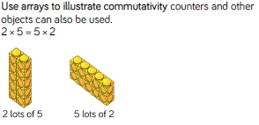
Until children can articulate what multiplication is, it is best not to talk about commutativity so that they don’t get confused.
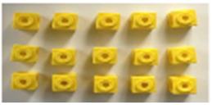
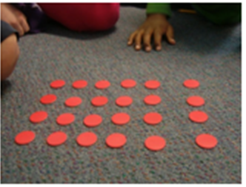
5 x 3

OR

3 x 5
4 x 6

OR

6 x 4

Pictorial:

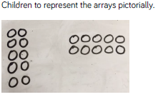
2 x 5

OR

5 x 2

Abstract:

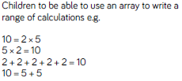
Children will need to complete this activity having made or drawn an array. The more ‘facts’ they can write about an array, he greater their understanding of them.

Multiplication – Year 3
Multiplying by partitioning

Concrete: (15 x 4)

Pictorial:
Using base 10 materials to multiply 15 x 4.

Children multiply the ones and they multiply the 10s and add the two parts together. Using the place value grid helps children when they move onto the pictorial and abstract steps.

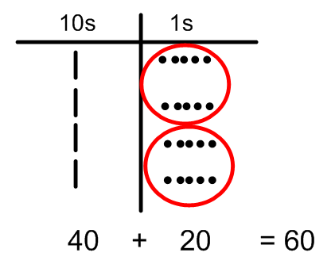

Concrete:

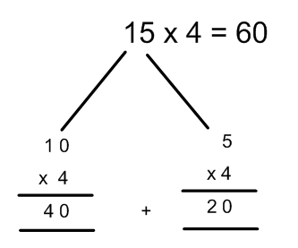
Children need to show all of the steps that they take to be able to find a solution.
Children need to be encouraged to use their times tables facts when working with partitioned numbers where possible.

Multiplication – Year 3

Step 1 – formal multiplication method

Concrete:
23 x 3 =

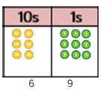
Using base 10 or place value counters (when children’s understanding of place value is good), children partition the number they are multiplying and recombine. Ensure that children are using a place value grid and encourage talk about the value of the digits.

Pictorial:

Children to represent the digits pictorially

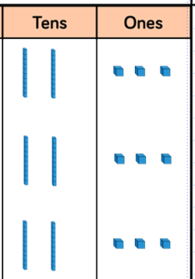
Children can use the base 10 images rather than counters if they prefer. Continue questioning children about the value of the digits they are representing.
9
6

Abstract:

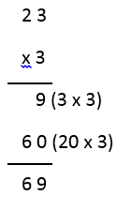
Expanded column multiplication. Ensure that children write down each step of the calculation and continue to talk about the value of each digit. Teach this step alongside the concrete or pictorial step so children can see the size of the numbers they are using.
2 3
x 3
9 (3 x 3)
6 0 (20 x 3)
6 9

Grid Method (to be used as an alternative method)

Concrete

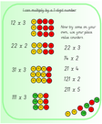
Children use counters first to understand real maths.

Pictorial

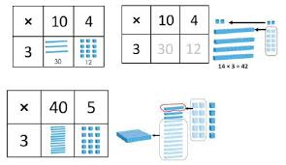
Abstract

