Calculation Policy:
Division

Year 2 and 3

PROGRESSION THROUGH CALCULATIONS FOR DIVISION

MENTAL CALCULATIONS

These are a selection of mental calculation strategies:

Doubling and halving
Knowing that halving is dividing by 2

Deriving and recalling division facts

Tables should be taught everyday from Y2 onwards, either as part of the mental oral starter or other times as appropriate within the day.

Year 2 10 times table
5 times table
2 times table

Year 3 4 times table
8 times table
3 times table
6 times table
9 times table

Year 4 11times table
12 times table
Derive and recall all multiplication facts up to 12 x 12

Year 5 & 6 Derive and recall quickly division facts for all tables up to 10 x 10
Work out products such as: 70 X 5, 70 X 50 and 700 X 50 using the related fact 7 X 5 and their knowledge of place value.

Using and applying division facts
Children should be able to utilise their times table knowledge to derive other facts.
e.g. If I know 21 ÷ 3 = 7, what else do I know?
210 ÷ 70 = 3, 210 ÷ 7 = 30, 210 ÷ 30 = 7, 21 ÷ 30 = 0.7 etc

Dividing by 10 or 100
Knowing that the effect of dividing by 10 is a shift in the digits one place to the right.
Knowing that the effect of dividing by 100 is a shift in the digits two places to the right.

Use related facts
Given that 1.4 x 1.1 = 1.54
What is 1.54 ÷ 1.4, or 1.54 ÷ 1.1?

MANY MENTAL CALCULATION STRATEGIES WILL CONTINUE TO BE USED. THEY ARE NOT REPLACED BY WRITTEN METHODS.

Division – Year 1/ 2
Dividing by sharing

Concrete:

20 ÷ 5 =
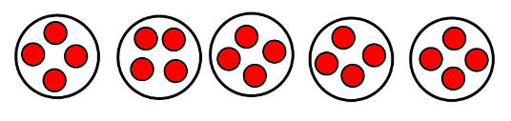

Pictorial:

Leading onto:

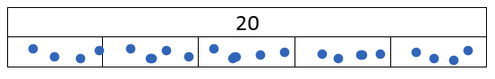

Abstract:

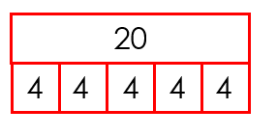
When children are learning to represent their work like this, they will need to be suing concrete objects and pictures alongside the abstract.
Division – Year 1/ 2
Dividing by grouping

Concrete:

8 ÷ 2 =
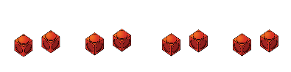
Children need to begin using their knowledge of times tables to count in groups of the divisor, in this case 2.

Develop the use of stem sentences for children to be able to reason their understanding.
There are 4 equal groups.
There are 2 in each group.
There are 8 altogether.

Pictorial:

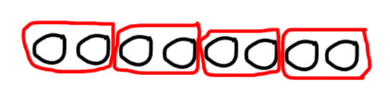
Develop the use of stem sentences for children to be able to reason their understanding.
There are 4 equal groups.
There are 2 in each group.
There are 8 altogether.

Abstract:

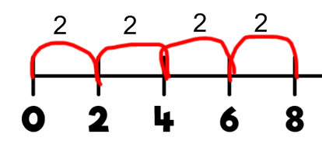
Encourage children to count up in steps of 2.

Division Year 2/3
Dividing using arrays

Concrete:

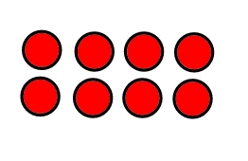
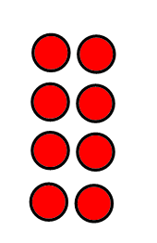
8 ÷ 4 =
8 ÷ 2 =

Refer children back to their understanding of commutativity and building fact families.
Pictorial:
Circle the counters into the groups given to find how many equal groups there would be.
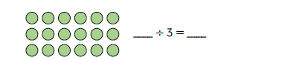

5

Abstract:

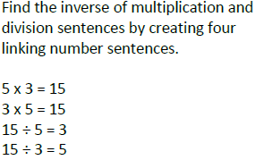

Division – Year 3
Dividing TO by a single digit without exchanging

Concrete:

66 ÷ 3 =
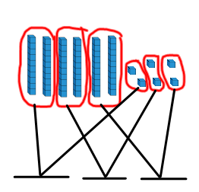
Children need to physically move the pieces into the groups. To begin with, children need to use base 10 but when they have a good understanding of place value, they can move onto place value counters. Children will start with tens and then move onto the ones.

Pictorial:
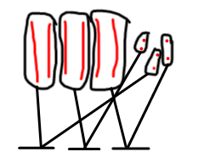
Children need to draw the base 10 representations and then group them together. They might choose to give an answer using base 10 and then write the number that goes with it.

Abstract:
Children have been practising partitioning the tens and ones. When they move onto the abstract method, ensure that they do it alongside a practical/pictorial way too.
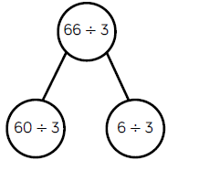

Division – Year 3
Dividing with exchanging

Concrete:

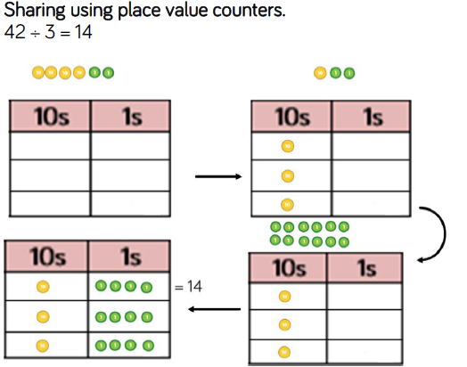

Exchange one 10 for 10 ones!

Pictorial: Children to represent the calcuation pictorially

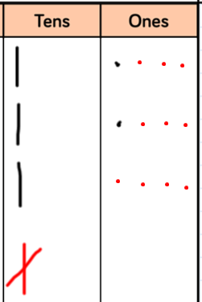
Children could choose to draw using base 10 representations.

Children need to make it clear when they have exchanged – this could be completed in a different colour to begin with.

Abstract:
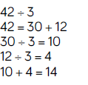
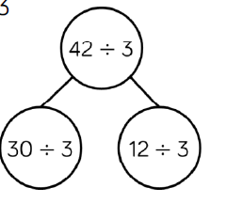
Abstract – children write down what they have done with the counters they have used/drawn.

