Calculation policy: Addition

MENTAL CALCULATIONS

All of the mental methods below need to be taught to the children explicitly. Children will need to see or draw models to show their understanding when they are learning these methods.

Year 1

Mental recall of number bonds
6 + 4 = 10 + 3 = 10
25 + 75 = 100 19 + = 20

Year 2

Use near doubles
6 + 7 = double 6 + 1 = 13

Addition using partitioning and recombining
34 + 45 = (30 + 40) + (4 + 5) = 79

Year 3

Counting on in repeated steps of 1, 10, 100, 1000
86 + 57 = 143 (by counting on in tens and then in ones)

Compensation by adding the nearest multiple of 10, 100 and 1000 and adjust
24 + 19 = 24 + 20 – 1 = 43
458 + 71 = 458 + 70 + 1 = 529

Use the relationship between addition and subtraction
36 + 19 = 55 19 + 36 = 55
55 – 19 = 36 55 – 36 = 19

MANY MENTAL CALCULATION STRATEGIES WILL CONTINUE TO BE USED. THEY ARE NOT REPLACED BY WRITTEN METHODS.

Points to remember:

Children should not be made to go onto the next stage if:
- They are not ready.
- They are not confident.
- They do not understand the value of the numbers they are working with.

Children should be encouraged to approximate their answers before calculating.
Children should be encouraged to check their answers after calculation using an appropriate strategy i.e.; the inverse operation.
Children should be encouraged to consider if a mental calculation would be appropriate before using written methods.

By the end of year 6, children will have a range of calculation methods both mental and written. They will need to select which to use based on the numbers involved.

Addition – Year 2

Addition without exchanging (re-grouping)

Concrete:

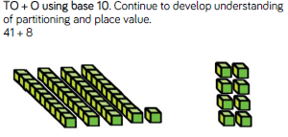
You would move onto using TO + TO ensuring that children were confident about the place value of the numbers they are using.

Pictorial:

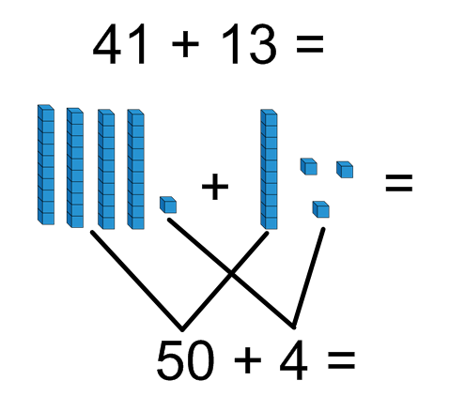
Children should be used to and encouraged to draw the stick and dots in their books to represent the numbers they are using.

When children are secure:
The expanded method should only be used when children are confident with the place value of the numbers they are using. They should still be drawing the sticks and dots to help with their understanding.
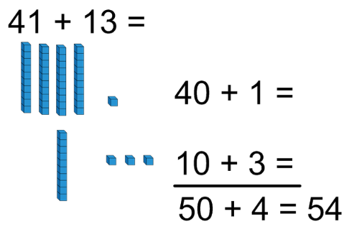

Abstract:

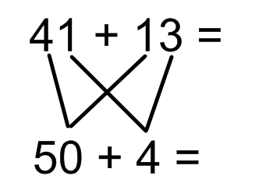
The expanded written method should only be used when children are confident with the place value of the numbers they are using. Some children will need to use sticks and dots to represent the numbers they are using for the whole of KS1 and this is should be encouraged.

For those children who are very confident with number, they could move onto representing their work using the expanded column method.

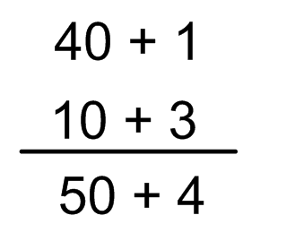

When going from one method to another, teach them side by side so that the children can see they are doing the same but using a different process. Encourage children to use base 10 equipment to support their calculations.

Year 2 – Addition with exchanging

Concrete:
Children need to be encouraged to calculate how many ones there are first and they how many tens.
Children should ‘make’ the 12 (by physically exchanging the 10 ones for a ten) and 50 before finding a solution.
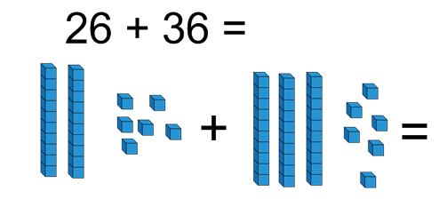
Pictorial:

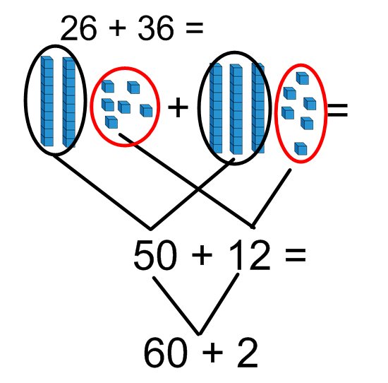
Children need to be encouraged to calculate how many ones there are first and they how many tens.

Abstract:

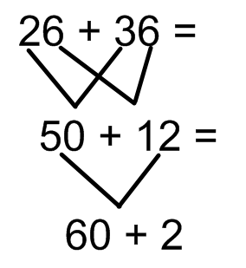
Eventually, children will be able to lose the last step and mentally calculate 50 + 12.

Year 3 – addition without exchanging:

Continue to develop children’s understanding of partitioning and place value to develop fluency. Children need to be able to see this image as both the numbers being partitioned (down the side) and the number being combined (underneath).
Children can begin to use place value counters instead of base 10 when they are confident enough to.

Concrete:

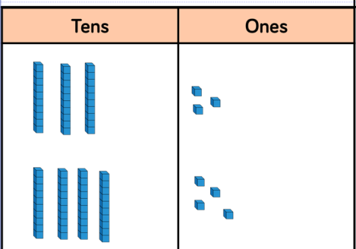

30 + 3 =

40 + 4 =

70 + 7 =

Pictorial:
Children need to be able to see this image as both the numbers being partitioned (down the side) and the number being combined (underneath). Children need to continue to use the images to support their understanding of place value.

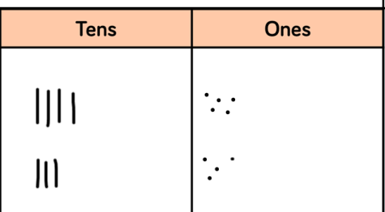

40 + 5 =

30 + 4 =

70 + 9 =

Abstract:

Expanded addition moving onto the compact method

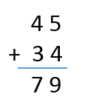
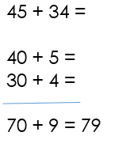

Addition – Year 3
With exchanging (re-grouping)
As previously, children need to physically exchange the 10 ones for a ten if they haven’t grasped the concept of exchanging already.

Concrete:
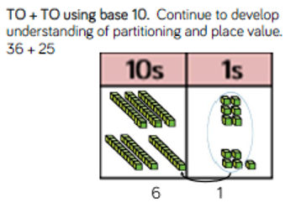

Pictorial:

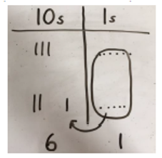
Some children might see this calculation as 20 + 30 + 11, which is good because it shows flexibility in number knowledge. If they need to add the extra step in, that is fine. Encourage children to then add the ones followed by the tens mentally.
30 + 6 =

20 + 5 =

60 + 1 =

Abstract:

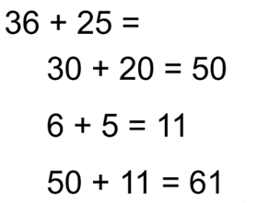
Prior to using the formal written method when exchanging, children should be given the opportunity to continue to partition numbers and re-combine them. This increases mental fluency.

Abstract part 2:

When carrying the tens, ensure as a school you are consistent in where the carried number is placed within the calculation.

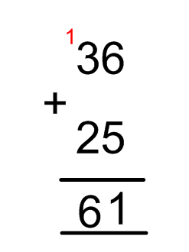

1

