**Year 3 and 4 Calculation strategies**

Attached are the different steps to calculation which are taught to your child when they are in year 3 and 4. Children work at different rates and some will work through these methods faster than others – this is ok!

If you are working with your child when they are calculating, please think about;

Can I do this in my head?

Could I do this in my head using drawings or jottings to help me?

Do I need to use a written method?

Which method should I use to help me?

**Also help your child to estimate and then check the answer. Encourage them to ask…Is the answer sensible?**



**Addition mental strategies:**

**Counting on in repeated steps of 1, 10, 100, 1000**

86 + 57 = 143 (by counting on in tens and then in ones)

**Compensation by adding the nearest multiple of 10, 100 and 1000 and adjust**

24 + 19 = 24 + 20 = 44 – 1 = 43

458 + 71 = 458 + 70 = 528 + 1 = 529

**Use the relationship between addition and subtraction**

36 + 19 = 55 19 + 36 = 55

55 – 19 = 36 55 – 36 = 19

Column method (not going over boundaries):

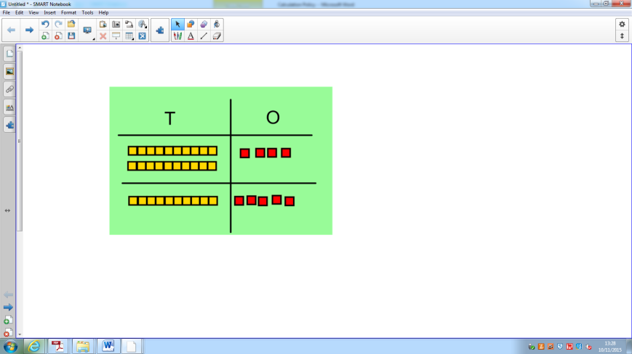

24 + 15 =

Children are able to partition numbers into tens and ones. Through objects, then moving onto using numbers, they can then add the ones and the tens to find the total of the two numbers.

9 = 39

30 +

Column method (going over boundaries):

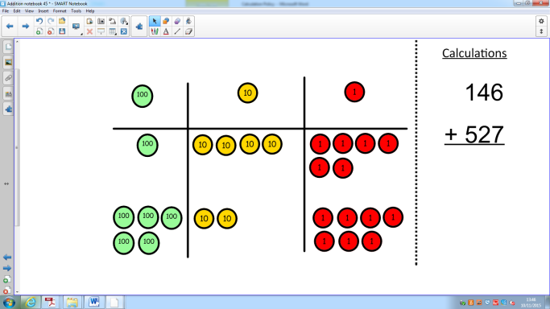

**13**

600

60

Once children are confident at using the column method (without regrouping), they will move onto numbers that cross the ones and tens boundaries. This means that they have to begin carrying over one number into the next. Children need to understand why they need to carry the numbers before they can complete problems like this without using counters and place value grids to help them.

**When regrouped looks like…**

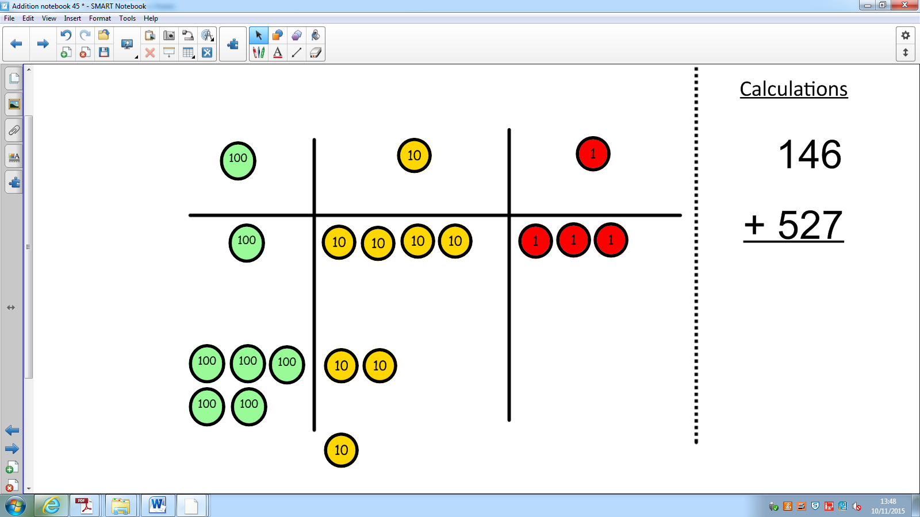

**3**

**70**

600

**Subtraction mental strategies:**

**Counting back in repeated steps of 1, 10, 100, 1000**

86 - 52 = 34 (by counting back in tens and then in ones)

460 - 300 = 160 (by counting back in hundreds)

**Subtract the nearest multiple of 10, 100 and 1000 and adjust**

24 - 19 = 24 - 20 = 4 + 1 = 5

458 - 71 = 458 - 70 = 388 - 1 = 387

**Use the relationship between addition and subtraction**

36 + 19 = 55 19 + 36 = 55

55 – 19 = 36 55 – 36 = 19

Counting back:

Children will still be encouraged to use a number line to support their understanding but will be able to count back in jumps of tens and ones to begin calculating more quickly.

Eventually children will be able to count back in tens and then multiples of one.

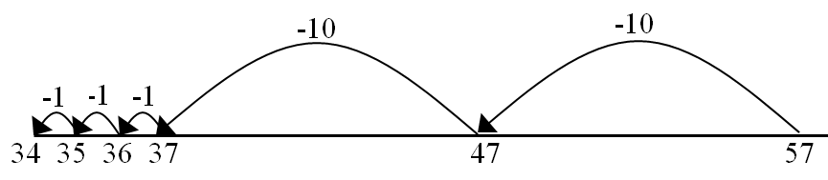

57 – 23 =

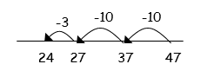

47 – 23 =

Column Subtraction without borrowing:

Children will make the larger number using counters and with a place value grid, they then take the smaller number away. They will also be taught how to draw pictures like this so they can cross out the number they are taking away to find the answer.

75 – 42 =

**When drawn will look like this:**

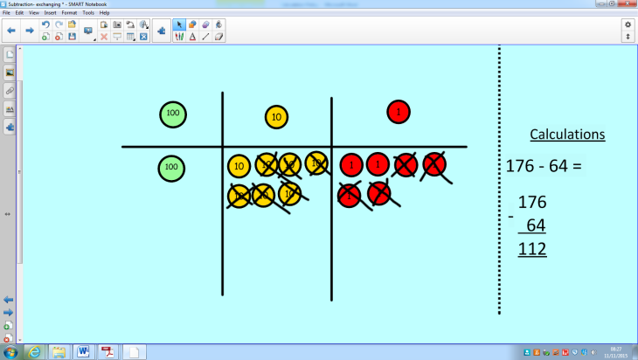

Column Subtraction with borrowing:

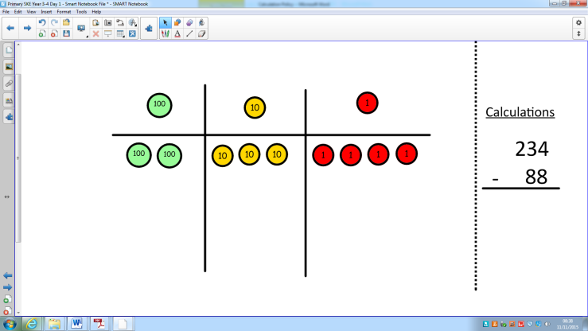Children will again start by making the larger number. Where there is a need to borrow, the children will make the changes physically (either with cubes or by drawing). This will continue until the whole process has been completed.

Eventually, the children will be able to complete the process by just using numbers.

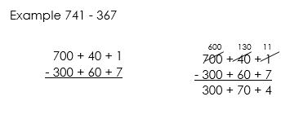

Compact Column subtraction:

Once children are confident with subtraction with borrowing, having gone through all of the processes to show their understanding, they will be able to use compact column subtraction.

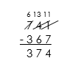

If they don’t get to this stage by the end of year 4, it’s ok – they will still have plenty of opportunity for them to develop this in later year groups. It is more important that they understand what they are doing than move onto a method they don’t understand.

**Multiplication mental methods:**

**Learning all multiplication facts up to 12 x 12**

Arrays:

Children will develop their use of arrays further to ensure they are confident to say what is happening to the numbers when they are multiplied.

Grid Method:

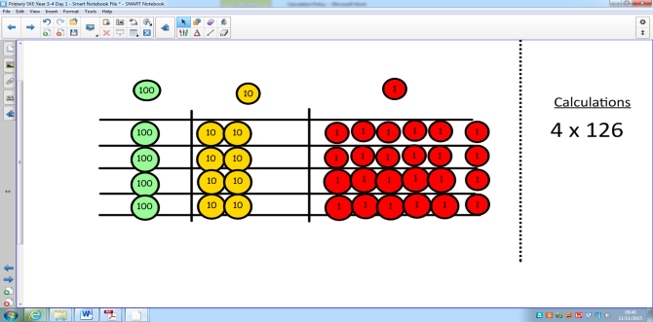Grid method is an extension of arrays but using larger numbers. Children have to, initially, make the number having partitioned them into ones, tens and hundreds and then make it the number of times they multiply it. (See picture). Once they are confident with the numbers they are using, they will begin to just use the numbers.

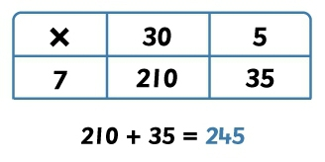

Long column method:

Once children have got an idea of the size of numbers they are working with, they will move onto long multiplication. In year 4, they will only be multiplying by a single digit so will only have

32

X 4

8 (4 x 2)

120 (4 x 30)

128

**Division mental methods:**

**Learning all multiplication facts up to 12 x 12**

Division with remainders:

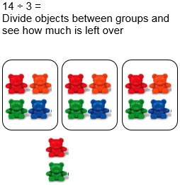The idea of remainders can be quite tricky for a child to grasp. Children will experience grouping objects and having some left over and will be taught that these are called remainders. Once children are happy with this idea, they will be able to divide using a number line and see how many are left over.

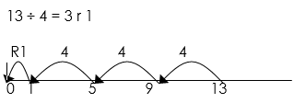

Chunking:

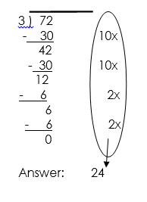Chunking helps children to begin dividing more quickly. They use multiplication facts to find how many lots of the number they are dividing by fits into the larger number. This model means that children are aware of the size of the numbers they are working with. Chunking is also useful because it reaffirms the idea that division is repeated subtraction.