**Division – Year 4**

**Dividing with remainders**

**Concrete:**

94 ÷ 4 =

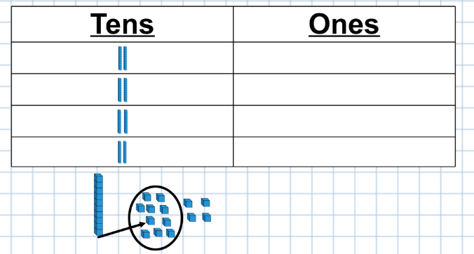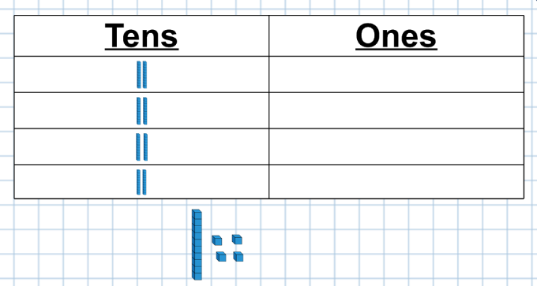

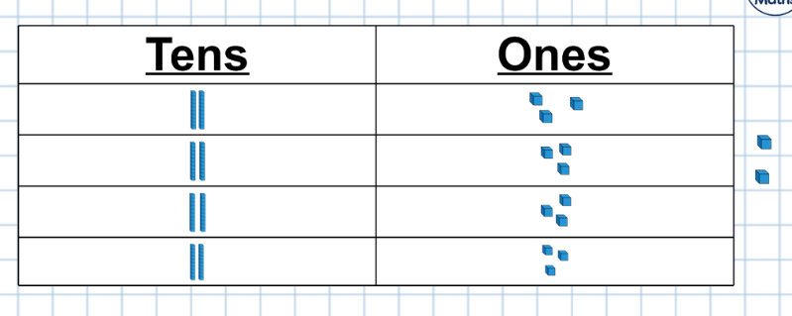

Ensure that children are clear about exchanging and why they have to exchange. Also reinforce the idea that when dividing, you start with the largest valued digit when dividing, rather than the smallest.

**Pictorial:**

Follow the concrete steps but using pictorial representations of base 10.

**Abstract:**

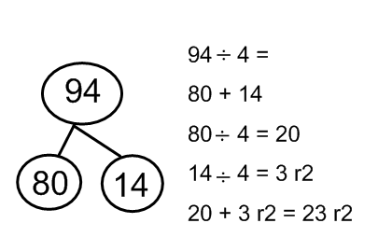

These steps need to be done in conjunction with concrete and pictorial images. Children will need to have a sound understanding of multiplication facts to be able to partition numbers effectively.

**Division – Year 4**

**Dividing 3 digit numbers without exchanging**

**Concrete:**

609 ÷ 3 =

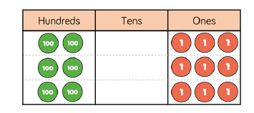

Children can choose between using place value counters and base 10.

**Pictorial:**

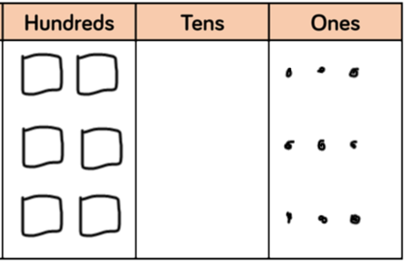

Using the place value grids ensure that children are still thinking about the size of the digits they are using.

**Abstract:**

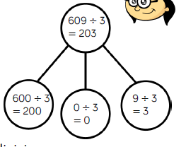

Children will have to use the whole part models alongside concrete and pictorial images.

**Division – Year 4**

**Dividing 3 digits with exchanging and remainders**

**Concrete:**

**981 ÷ 4 =**

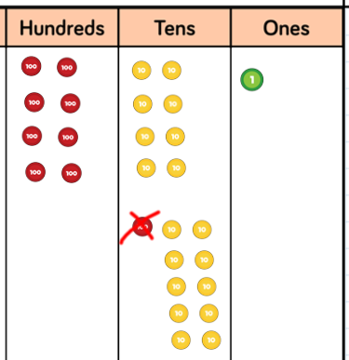

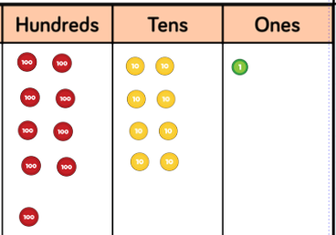

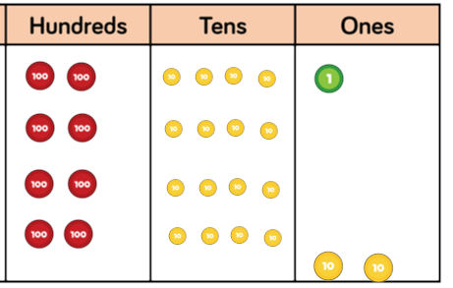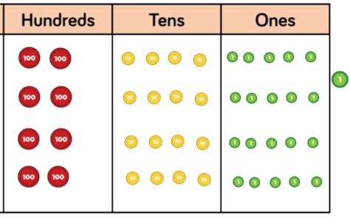

**Pictorial:**

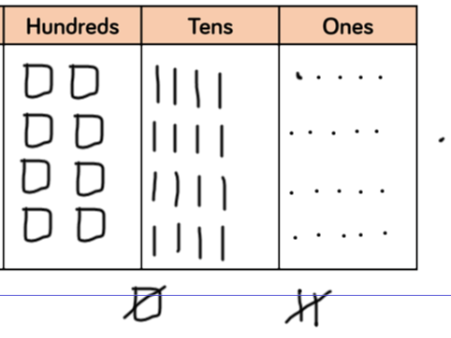

Children need to draw on the base 10/place value counters and then exchange them.

**Abstract:**

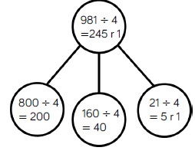

These representations have to be completed alongside images or models that are made.

**Division – Year 4/5**

**Short division**

**Concrete:**

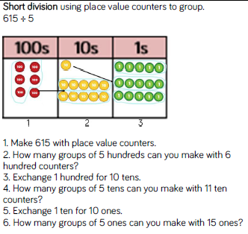

Children need to learn the process but also be able to articulate what they are doing to the digits within the numbers and why.

**Pictorial:**

Represent the digits using pictures.

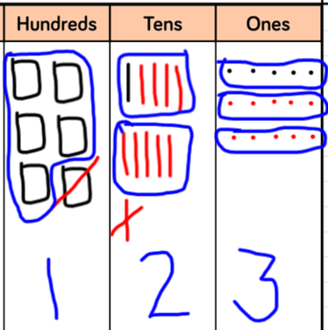

**Abstract:**

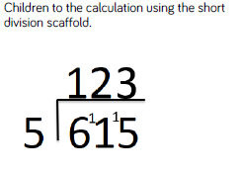

As children become more proficient at dividing larger numbers, encourage children to partition in order to use mental calculations. (600 + 15 ÷ 5 = 123)