Calculation policy:
Subtraction

PROGRESSION THROUGH CALCULATIONS FOR SUBTRACTION

All of the mental methods below need to be taught to the children explicitly. Children will need to see or draw models to show their understanding when they are learning these methods.

Year 1

Mental recall of addition and subtraction facts
10 – 6 = 4 17 - = 11
20 - 17 = 3 10 - = 2

Year 2

Find a small difference by counting up
82 – 79 = 3

Year 3

Counting back in repeated steps of 1, 10, 100, 1000 – This will show children’s understanding of place value very quickly.
86 - 52 = 34 (by counting back in tens and then in ones)
460 - 300 = 160 (by counting back in hundreds)

Year 4

Subtract the nearest multiple of 10, 100 and 1000 and adjust
24 - 19 = 24 - 20 + 1 = 5
458 - 71 = 458 - 70 - 1 = 387

Use the relationship between addition and subtraction
36 + 19 = 55 19 + 36 = 55
55 – 19 = 36 55 – 36 = 19

Many mental calculation strategies will continue to be used. They are not replaced by written methods.

Children should not be made to go onto the next stage if:

- They are not ready.
- They are not confident.

Children should be encouraged to approximate their answers before calculating.
Children should be encouraged to check their answers after the calculation using an appropriate strategy.
Children should be encouraged to consider if a mental calculation would be appropriate before using written methods.

Children should:
- be able to subtract numbers with different numbers of digits;
- be able to subtract two or more decimal fractions with up to three digits and either one or two or three decimal places;
- know that decimal points should line up under each other.

thousand
one
ten
hundred

Subtraction - Year 4
Subtracting with exchange – formal method

Concrete:

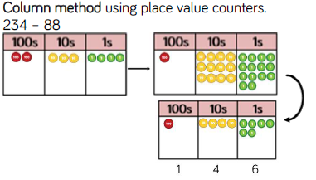
If children’s conceptual understanding of larger numbers isn’t fully developed, please use base 10 before moving onto place value counters.

Pictorial:
Represent the number pictorially remembering to show what has been exchanged.
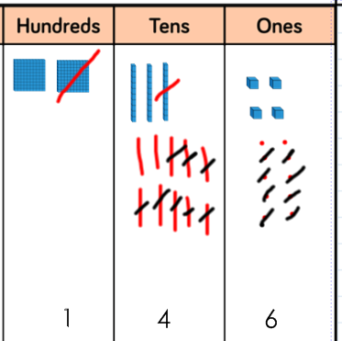
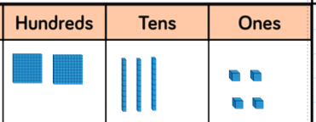

Children could draw base 10 representations instead, but encourage children to move on and use the place value grids and counters to help them.

Abstract:

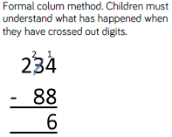
Encourage children to ‘talk the maths’ when they are using formal methods for the first time. This will help them to consolidate their understanding of exchange and why they need to use it.

Subtraction – Year 5/6

Formal methods are to be continued with larger numbers and number that include decimals. Please use previous methods with children if they need to use them to grasp the size of the numbers they are using.

Ensure children are shown subtraction questions using different concepts. Please see below for examples of how to present 391 – 186

Whole/Part model and related bar model.
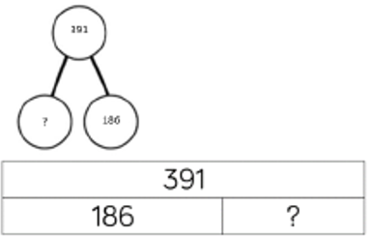

Word problems:

Raj spent £391, Timmy spent £186. How much more did Raj spend?

Calculate the difference between 391 and 186.

Procedural Variation:

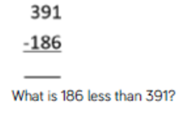
391 - = 186
= 391 - 186
Missing digit calcuations:
