Calculation policy: Addition

MENTAL CALCULATIONS

All of the mental methods below need to be taught to the children explicitly. Children will need to see or draw models to show their understanding when they are learning these methods.

Year 1

Mental recall of number bonds
6 + 4 = 10 + 3 = 10
25 + 75 = 100 19 + = 20

Year 2

Use near doubles
6 + 7 = double 6 + 1 = 13

Addition using partitioning and recombining
34 + 45 = (30 + 40) + (4 + 5) = 79

Year 3

Counting on in repeated steps of 1, 10, 100, 1000
86 + 57 = 143 (by counting on in tens and then in ones)

Compensation by adding the nearest multiple of 10, 100 and 1000 and adjust
24 + 19 = 24 + 20 – 1 = 43
458 + 71 = 458 + 70 + 1 = 529

Use the relationship between addition and subtraction
36 + 19 = 55 19 + 36 = 55
55 – 19 = 36 55 – 36 = 19

MANY MENTAL CALCULATION STRATEGIES WILL CONTINUE TO BE USED. THEY ARE NOT REPLACED BY WRITTEN METHODS.

Points to remember:

Children should not be made to go onto the next stage if:
- They are not ready.
- They are not confident.
- They do not understand the value of the numbers they are working with.

Children should be encouraged to approximate their answers before calculating.
Children should be encouraged to check their answers after calculation using an appropriate strategy i.e.; the inverse operation.
Children should be encouraged to consider if a mental calculation would be appropriate before using written methods.

By the end of year 6, children will have a range of calculation methods both mental and written. They will need to select which to use based on the numbers involved.

Year 4, 5 and 6 – Calculation with larger numbers

Concrete: Calculation shows 243 + 368

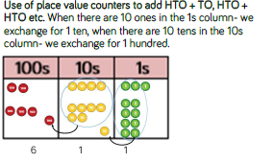

Pictorial: Calculation shows 243 + 368
Children to represent the base 10 in a place value chart crossing out when they make an exchange
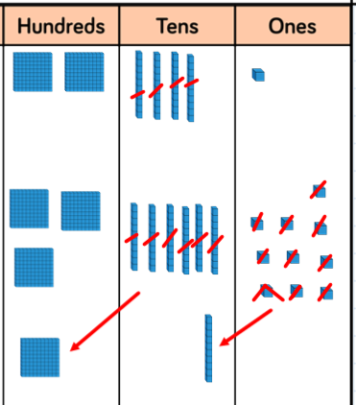
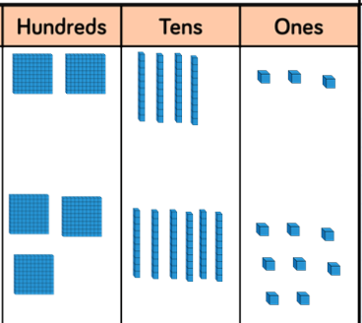

Abstract: Calculation shows 243 + 368

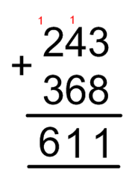

1
1

