Calculation Policy:
Multiplication

Years 5 and 6

PROGRESSION THROUGH CALCULATIONS FOR MULTIPLICATION

MENTAL CALCULATIONS

These are a selection of mental calculation strategies:
See NNS Framework Section 5, pages 52-57 and Section 6, pages 58-65

Doubling and halving
Applying the knowledge of doubles and halves to known facts.
E.g. 8 x 4 is double 4 x 4
Knowing that doubling is the same as multiplying by 2.

Using multiplication facts

Tables should be taught from Y1 summer term onwards, either as part of the mental oral starter or other times as appropriate within the day.

Year 2 10 times table
5 times table
2 times table

Year 3 4 times table
8 times table
3 times table
6 times table
9 times table

Year 4 7 times table
11times table
12 times table
Derive and recall all multiplication and division facts up to 12 x 12

Years 5 & 6 Derive and recall quickly all multiplication and division facts up to 12 x 12.
Work out products such as 70 X 5, 70 X 50 and 700 X 50 using the related fact 7 X 5 and their knowledge of place value.

Using and applying division facts

Children should be able to utilise their knowledge of multiplication to derive other facts.
E.g. If I know 3 x 7 = 21, what else do I know?
30 x 7 = 210, 300 x 7 = 2100, 3000 x 7 = 21 000, 0.3 x 7 = 2.1 etc

Use closely related facts already known

13 x 11 = (13 x 10) + (13 x 1)
= 130 + 13
= 143

Multiplying by 10 or 100

Knowing that the effect of multiplying by 10 is a shift in the digits one place to the left and the addition of 1 place value holder.
Knowing that the effect of multiplying by 100 is a shift in the digits two places to the left and the addition of 2 place value holders.

Partitioning
23 x 4 = (20 x 4) + (3 x 4)
= 80 + 12
= 102

Use of factors
8 x 12 = 8 x 4 x 3

MANY MENTAL CALCULATION STRATEGIES WILL CONTINUE TO BE USED. THEY ARE NOT REPLACED BY WRITTEN METHODS.

Children should not be made to go onto the next phase if:

1) They are not ready.
2) They are not confident.

Children should be encouraged to approximate their answers before calculating.

Children should be encouraged to consider if a mental calculation would be appropriate before a written method.

Multiplication – Year 5 and beyond
Multiplying larger numbers.

Concrete and Pictorial:
Children should be confident enough with the previous steps of multiplication that they don’t need to use concrete or pictorial methods. If they aren’t, please go back a stage until they are.

Abstract:

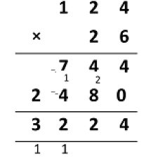
The main piece of learning in this example is where the children put the numbers they are carrying for each step of the calculation. In this example, children only need to carry when multiplying by the 1s. In the example below, they have to carry when multiplying by the 10s as well.
When children are first learning this, they might find it easier to use 2 different colours when multiplying and then add them at the end. Ensure that you are consistent in your approach across your school.

Using Conceptual variation:
Different ways to ask 6 x 23

Bar model:

David earns £23 each day for 6 days. How much does he earn?
23

?

David earns altogether.

Word problems:

Maisy had to swim 23 lengths, 6 times a week. How many lengths did she swim in 1 week?

With counters, prove that 6 x 23 = 138

Procedural variation:

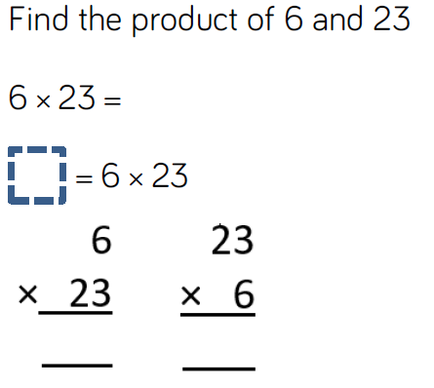

Conceptual variation:
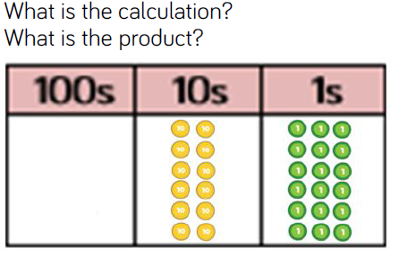
Scaling questions:

