Calculation Policy:
Division
Year 5 and 6

PROGRESSION THROUGH CALCULATIONS FOR DIVISION

MENTAL CALCULATIONS

These are a selection of mental calculation strategies:

Doubling and halving
Knowing that halving is dividing by 2

Deriving and recalling division facts

Tables should be taught everyday from Y2 onwards, either as part of the mental oral starter or other times as appropriate within the day.

Year 2 10 times table
5 times table
2 times table

Year 3 4 times table
8 times table
3 times table
6 times table
9 times table

Year 4 11times table
12 times table
Derive and recall all multiplication facts up to 12 x 12

Year 5 & 6 Derive and recall quickly division facts for all tables up to 10 x 10
Work out products such as: 70 X 5, 70 X 50 and 700 X 50 using the related fact 7 X 5 and their knowledge of place value.

Using and applying division facts
Children should be able to utilise their times table knowledge to derive other facts.
e.g. If I know 21 ÷ 3 = 7, what else do I know?
210 ÷ 70 = 3, 210 ÷ 7 = 30, 210 ÷ 30 = 7, 21 ÷ 30 = 0.7 etc

Dividing by 10 or 100
Knowing that the effect of dividing by 10 is a shift in the digits one place to the right.
Knowing that the effect of dividing by 100 is a shift in the digits two places to the right.

Use related facts
Given that 1.4 x 1.1 = 1.54
What is 1.54 ÷ 1.4, or 1.54 ÷ 1.1?

MANY MENTAL CALCULATION STRATEGIES WILL CONTINUE TO BE USED. THEY ARE NOT REPLACED BY WRITTEN METHODS.

Division – Year 5/6
Short division

Concrete:

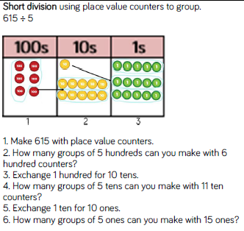
Children need to learn the process but also be able to articulate what they are doing to the digits within the numbers and why.

Pictorial:
Represent the digits using pictures.

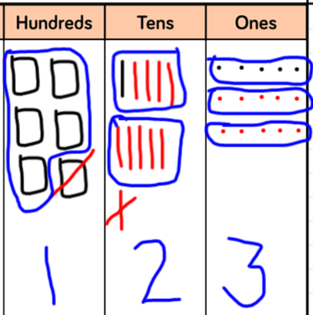

Abstract:

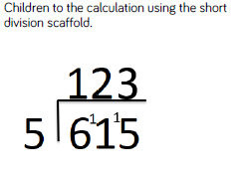
As children become more proficient at dividing larger numbers, encourage children to partition in order to use mental calculations. (600 + 15 ÷ 5 = 123)

Division – Year 6
Long division

There are not concrete or pictorial representations for long division.

Abstract:

Option 1: Option 2:
R 7

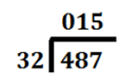
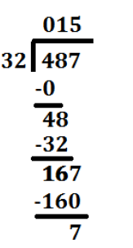
- 3 2 0 (32 x 10 = 320)

1 6 7 +

- 1 6 0 (32 x 5 = 160)

7
R 7

Different ways of asking/representing 615 ÷ 5 =

Part/Whole model:

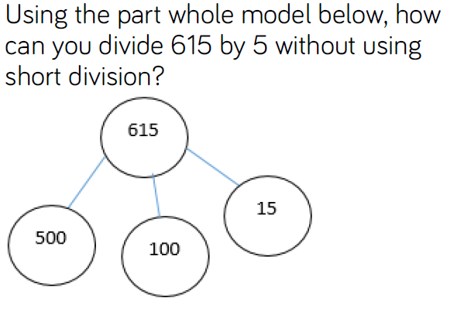

Word problems:

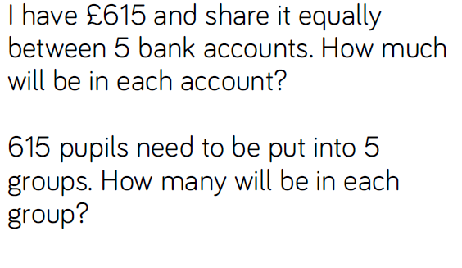

Procedural variation:

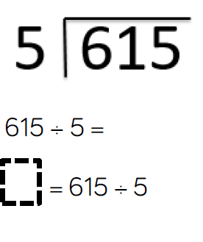

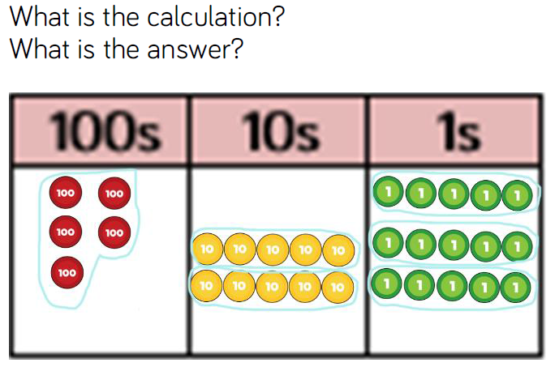
Conceptual variation

