**Year 5 and 6 Calculation strategies**

Attached are the different steps to calculation which are taught to your child when they are in year 5 and 6. Children work at different rates and some will work through these methods faster than others – this is ok!

If you are working with your child when they are calculating, please think about;

Can I do this in my head?

Could I do this in my head using drawings or jottings to help me?

Do I need to use a written method?

Which method should I use to help me?

**Also help your child to estimate and then check the answer. Encourage them to ask…Is the answer sensible?**





**Addition mental strategies:**

**Mental recall of number bonds**

**Use near doubles**

**Addition using partitioning and recombining**

34 + 45 = (30 + 40) + (4 + 5) = 79

**Counting on in repeated steps of 1, 10, 100, 1000**

86 + 57 = 143 (by counting on in tens and then in ones)

**Compensation by adding the nearest multiple of 10, 100 and 1000 and adjust**

24 + 19 = 24 + 20 – 1 = 43

458 + 71 = 458 + 70 + 1 = 529

**Use the relationship between addition and subtraction**

36 + 19 = 55 19 + 36 = 55

55 – 19 = 36 55 – 36 = 19

*(Children should be able to use all of these mental strategies.)*

Column method (going over boundaries):

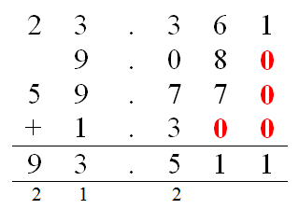Children will be able to use their knowledge of column addition that they have learnt so far and apply it to adding more than 2 numbers, larger numbers and numbers that include decimals.

**Subtraction mental strategies:**

**Mental recall of addition and subtraction facts**

10 – 6 = 4 17 - □ = 11

20 - 17 = 3 10 - □ = 2

**Find a small difference by counting up**

82 – 79 = 3

**Counting back in repeated steps of 1, 10, 100, 1000**

86 - 52 = 34 (by counting back in tens and then in ones)

460 - 300 = 160 (by counting back in hundreds)

**Subtract the nearest multiple of 10, 100 and 1000 and adjust**

24 - 19 = 24 - 20 + 1 = 5

458 - 71 = 458 - 70 - 1 = 387

**Use the relationship between addition and subtraction**

36 + 19 = 55 19 + 36 = 55

55 – 19 = 36 55 – 36 = 19

*(Children should be able to use all of these mental strategies.)*

Column Subtraction with borrowing:

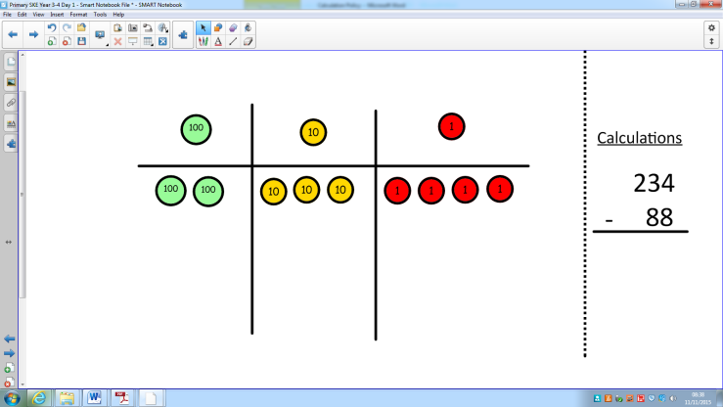Children will again start by making the larger number. Where there is a need to borrow, the children will make the changes physically (either with cubes or by drawing). This will continue until the whole process has been completed.

Eventually, the children will be able to complete the process by just using numbers.

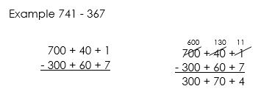

Compact Column subtraction:

Once children are confident with subtraction with borrowing, having gone through all of the processes to show their understanding, they will be able to use compact column subtraction.

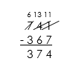

Children will be able to apply their knowledge of subtraction to work with larger numbers and numbers that include decimals.

**Multiplication mental methods:**

**To have instant recall of multiplication facts to 12 x 12**

Compact grid method:

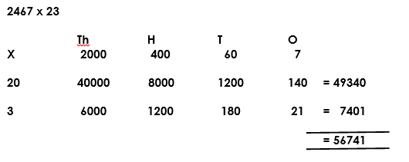Children will be able to use grid method when working with larger numbers. This method helps children understand the size of the numbers they are working with.

Long column method:

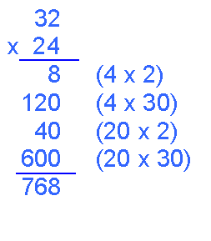Once children have got an idea of the size of numbers they are working with, they will move onto long multiplication.

They work out each step of the multiplication sum individually and then add the steps together to find the total. Some children will stay using this method until they go to secondary school.

Compact column method:

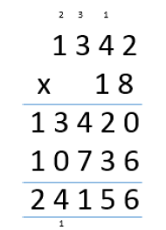Compact column multiplication follows the same pattern as long multiplication but you multiply the whole number rather than partition it. If your child doesn’t multiply like this at the end of primary school, that is ok. They will work towards this when they are at secondary school.

**Division mental methods:**

**Instant recall of multiplication and corresponding division facts up to 12 x 12**

Chunking:

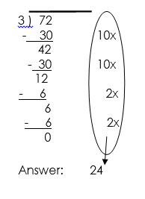Chunking helps children to begin dividing more quickly. They use multiplication facts to find how many lots of the number they are dividing by fits into the larger number. This model means that children are aware of the size of the numbers they are working with. Chunking is also useful because it reaffirms the idea that division is repeated subtraction.

Short division:

When children have shown that they have got a sound understanding of division and the place value of the numbers they are using, they will move onto short division.

So using this example it would be; how many 4’s go into 800? How many 4’s go into 70? How many 4’s go into 2. If a number doesn’t fit exactly, then the remainder gets moved onto the following number. Children can get confused with this method if they don’t have a firm understanding of place value so referring back to the size of the number when you are working it out is really important. Children will be able to apply this method to numbers with remainders and decimals as they become more confident using it.