Calculation Policy:
Division

EYFS and Year 1

PROGRESSION THROUGH CALCULATIONS FOR DIVISION

MENTAL CALCULATIONS

These are a selection of mental calculation strategies:

Doubling and halving
Knowing that halving is dividing by 2

Deriving and recalling division facts

Tables should be taught everyday from Y2 onwards, either as part of the mental oral starter or other times as appropriate within the day.

Year 2 10 times table
5 times table
2 times table

Year 3 4 times table
8 times table
3 times table
6 times table
9 times table

Year 4 11times table
12 times table
Derive and recall all multiplication facts up to 12 x 12

Year 5 & 6 Derive and recall quickly division facts for all tables up to 10 x 10
Work out products such as: 70 X 5, 70 X 50 and 700 X 50 using the related fact 7 X 5 and their knowledge of place value.

Using and applying division facts
Children should be able to utilise their times table knowledge to derive other facts.
e.g. If I know 21 ÷ 3 = 7, what else do I know?
210 ÷ 70 = 3, 210 ÷ 7 = 30, 210 ÷ 30 = 7, 21 ÷ 30 = 0.7 etc

Dividing by 10 or 100
Knowing that the effect of dividing by 10 is a shift in the digits one place to the right.
Knowing that the effect of dividing by 100 is a shift in the digits two places to the right.

Use related facts
Given that 1.4 x 1.1 = 1.54
What is 1.54 ÷ 1.4, or 1.54 ÷ 1.1?

MANY MENTAL CALCULATION STRATEGIES WILL CONTINUE TO BE USED. THEY ARE NOT REPLACED BY WRITTEN METHODS.

Division – Year 1
Dividing by sharing between 2

Concrete:

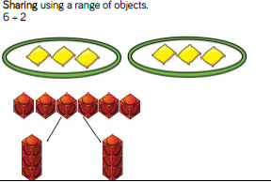
Children need to be able to share. objects by using ‘one for me, one for you’ before they can divide. They need to be able to articulate ‘we have got the same’, ‘we shared them equally’. Putting objects into bowls/containers will make it easier for the children to find out how many are left.

Pictorial:

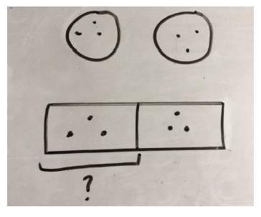
Both images show 6 ÷ 2 =

The top image is more ‘random’ and the bottom image is structured into a bar.
Children might need to be steered into using the more structured image.

Concrete:

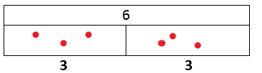
By using and developing the bar idea, children can develop the stem sentences to express what they have found. In this case, 6 shared between 2 is 3.

6 shared between 2 is .

Division – Year 1/ 2
Dividing by sharing

Concrete:

20 ÷ 5 =
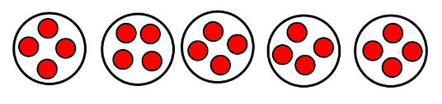

Pictorial:

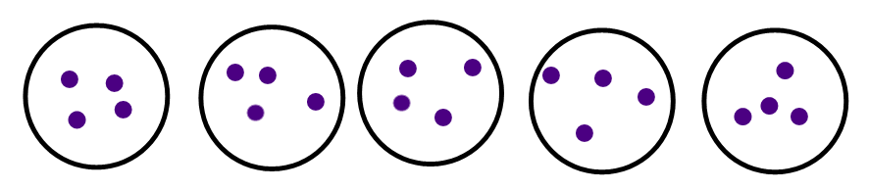
Leading onto:

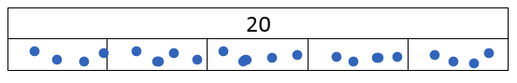

Abstract:

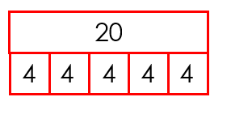
When children are learning to represent their work like this, they will need to be suing concrete objects and pictures alongside the abstract.

Division – Year 1/ 2
Dividing by grouping

Concrete:

8 ÷ 2 =
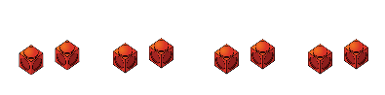
Children need to begin using their knowledge of times tables to count in groups of the divisor, in this case 2.

Develop the use of stem sentences for children to be able to reason their understanding.
There are 4 equal groups.
There are 2 in each group.
There are 8 altogether.

Pictorial:

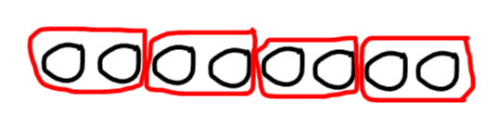
Develop the use of stem sentences for children to be able to reason their understanding.
There are 4 equal groups.
There are 2 in each group.
There are 8 altogether.

Abstract:

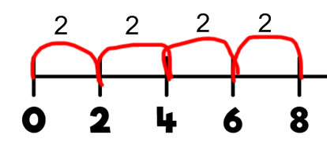
Encourage children to count up in steps of 2.

