 | ENGLISH | MATHS | ENQUIRY | ACTIVE
S  E  S  S  I  O  N  1 | This week you do a range of activities about why you love Cornwall and put all tasks together to show what you have learnt!  ACTIVITY: Today you can make a ‘Thin poem’ about Cornwall. (Include everything you have learnt about our county.)  Each line is made up of a noun/adjective – verb+ing which describes Cornwall.  LOOK AT THIS EXAMPLE  MY TEAM  is a…  hard-shooting  firm-booting  fast-running  smooth-gliding  glory-riding  drama-making  record-breaking  SORT OF TEAM!  (SEE BELOW FOR TEMPLATE) | This week, you will look at a tutorial each day and then begin to identify what an angle means and how to recognise them in a 2D shape.  https://classroom.thenational.academy/lessons/to-identify-and-recognise-angles/activities/2  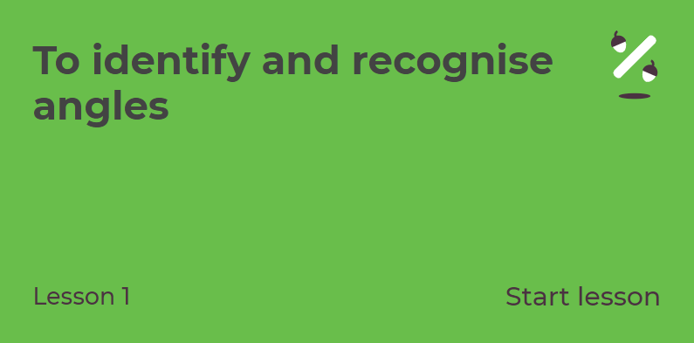 | Research and compile a selection of 5 reasons why you love living in Cornwall. Think about our learning over the past few weeks. It could include;  - Mining  - Smuggling/Wrecking/Piracy  - Tintagel Castle and its links to King Arthur  - Pobel Veans and Giants folktales  - or the amazing food Cornwall has to offer.  ART:  If you like the Cornish links to piracy:  Draw/make your very own pirate or pirate ship! https://www.youtube.com/watch?v=mvYF2qEiNMI  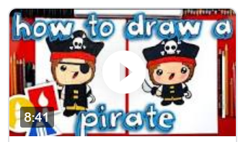  https://www.youtube.com/watch?v=5FZLrWwcCNk  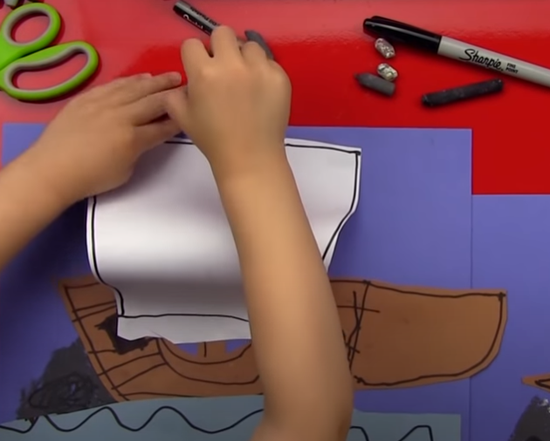 | 60 SECOND WEEKLY CHALLENGE  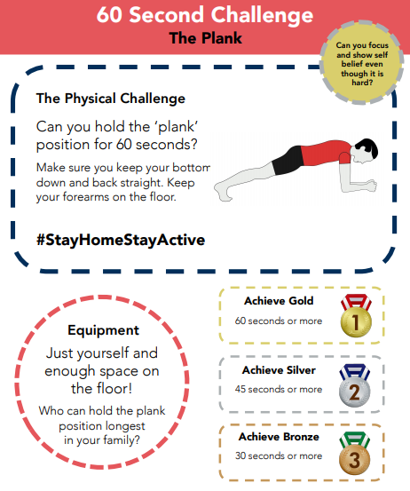  Can you complete  THE PLANK  challenge this week?
S  E  S  S  I  O  N  2 | WRITING  THE BEACH IS A FUN PLACE TO BE BUT CAN ALSO BE DANGEROUS IF YOU DON’T ABIDE BY THE RULES OF SAFETY.  ACTIVITY: Create a leaflet for staying safe on your favourite beach.  Success criteria:  - full, punctuated sentences  - give explanations for your rules  - include sun safety information  - include beach flag information  - include pictures/drawings/diagrams  - make sure you use sub-headings  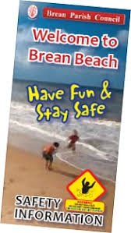 | https://classroom.thenational.academy/lessons/to-identify-angles-inside-2-d-shapes  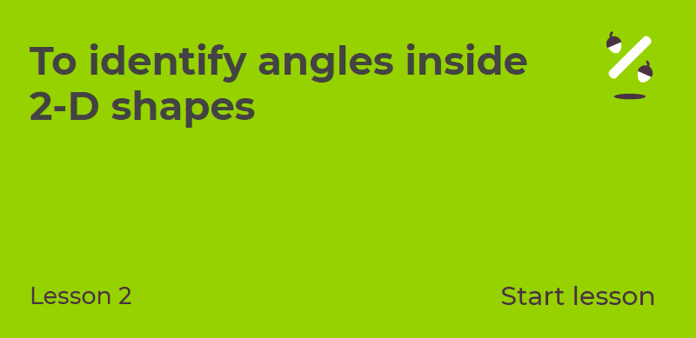 | GEOGRAPHY -  If you love to research:  Go onto GOOGLE MAPS and locate Cornwall.  Find Fistral Beach, Newquay. Drop the yellow man and have a look around. Why would someone visit here?  Find Bodmin Moor, drop the Yellow Man and investigate. Why would you visit there?  Find Land’s End, drop the Yellow Man and investigate. Why would you visit there?  Or  Retell your favourite Pobel Vean/Giant folktale.  Will it be a Knocker, Joan The Wad or Cormoran The Giant?  Don’t forget to draw your creature. | Choose 1 activity:  - Super Movers  - iMovers  PLUS:  Let’s Dance! https://www.youtube.com/playlist?list=PLJnn5H8Y_tYE3LdXoJIG_azMC2l5TjCON
S  E  S  S  I  O  N  3 | MAKE AN ACROSTIC POEM FOR  C  O  R  N  W  A  L  L  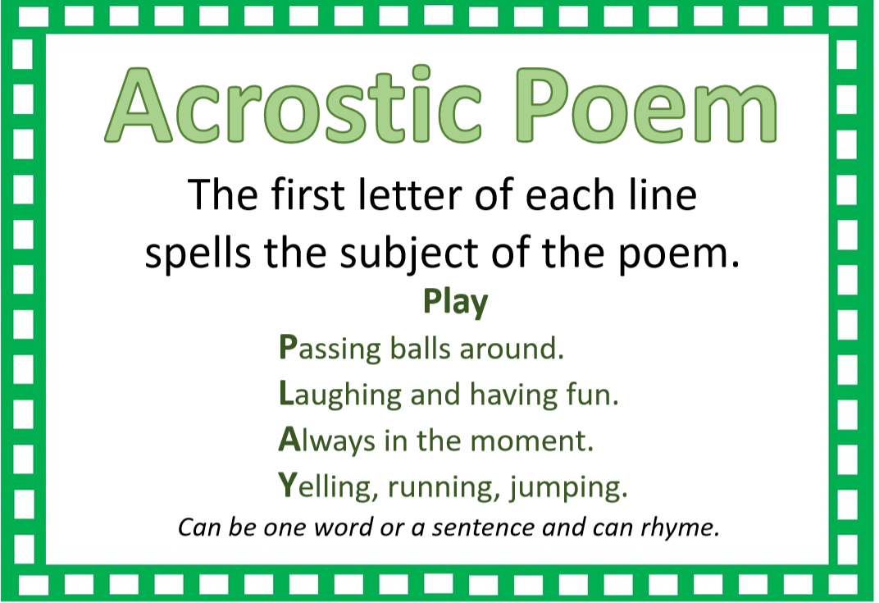 | https://classroom.thenational.academy/lessons/to-recognise-right-angles  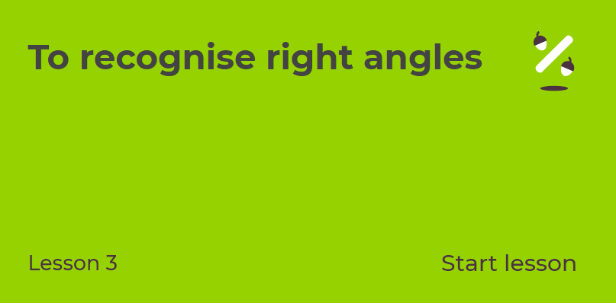 | ART: -  If you enjoy the Cornish food:  Draw your favourite ‘foldable’ ice-cream combo!  https://www.youtube.com/watch?v=vzaUdSnUWS4  OR  Write a recipe for your favourite Cornish treat. Make sure you bake it and add photographs to your work! | Try some activities from  #ThisIsPE  https://www.youtube.com/playlist?list=PLYGRaluWWTojV3An2WEgsQ4qGFy_91jDL  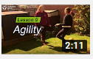  You can choose from lots of different skills. How fast are you at Fast Feet?
S  E  S  S  I  O  N  4 | Use the template attached with the word Cornwall on it.  Now create a picture from the letters to show what you have learnt about Cornwall over this half term.  IDEAS:  C – make into a pasty  o – the face of a Pobel Vean  r – Arrrr make ‘piraty’  n – can be a sandcastle  w – make into Camelot  a – favourite ice-cream  l – make into a Tin mine  l – Excalibur! | https://classroom.thenational.academy/lessons/to-recognise-obtuse-and-acute-angles  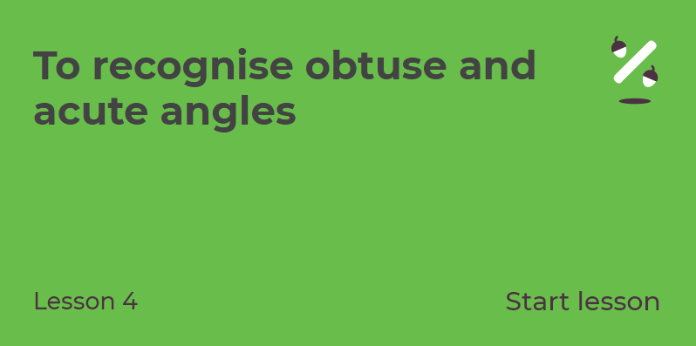 | DT:  If you are proud of our beaches:  Design a personalised beach towel and surf board  (ATTACHED TO BLOG)  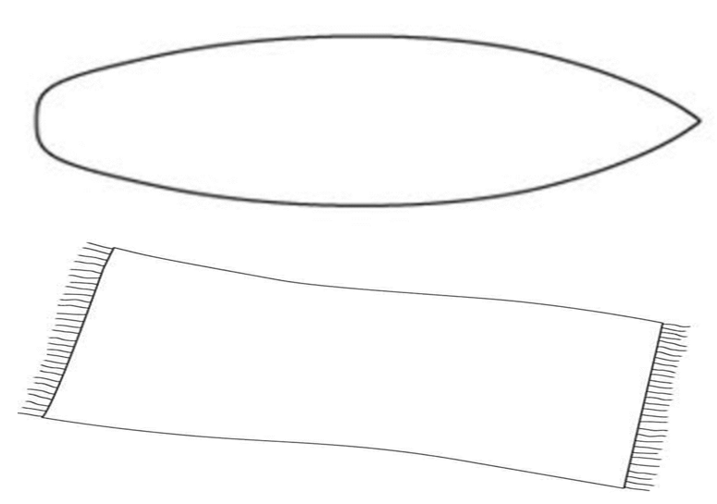 | Choose 1 activity:  - Joe Wicks (The Body Coach TV) Workout  - iMovers  PLUS:  Go Noodle – GoNoodle for Families https://family.gonoodle.com/channels/zumba-kids
S  E  S  S  I  O  N  5 | Take a piece of A4 paper and make 10-15 strips from it.  Write a sentence on each strip with something that you have learnt from this enquiry. It could be to do with King Arthur, mining, Pobel Veans/Giants, pirates or smugglers!  Label an envelope with ‘Things I Know About Cornwall!” and put in your information. | APPLY YOUR UNDERSTANDING  First, use the signs < > = to compare the angles (sheet attached to blog)  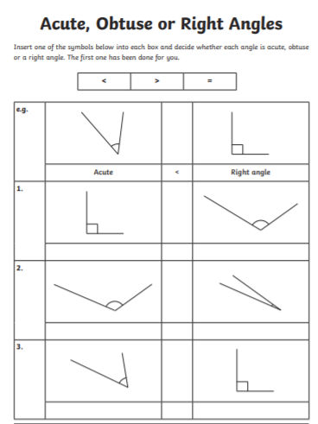  Then,  PLAY TOPMARKS  CHOOSE AN ACTIVITY FOR YOU TO PRACTISE YOUR NEW UNDERSTANDING OF ANGLES.  https://www.topmarks.co.uk/Search.aspx?q=angles | SCIENCE/DT:  If you love the Eden Project:  The Eden Project is a construction of Geodesic domes constructed to withstand considerable weight and stress. Take a look at this clip: https://www.youtube.com/watch?v=f8unx8-pZxg  Make a Geodesic structure https://babbledabbledo.com/stem-kids-straw-geodesic-dome/  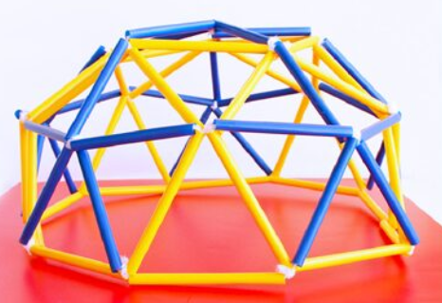  You can use:  Spaghetti and marshmallows straws and pipe cleaners/tape/Blutac | Choose 1 activity:  - Joe Wicks (The Body Coach TV) Workout  - iMovers  PLUS:  https://www.youthsporttrust.org/pe-home-learning  CHOOSE AN ACTIVITY AND DOWNLOAD A CHALLENGE CARD!

SESSION 1 ENGLISH
CORNWALL
Is a…
_______________________________________
_______________________________________
_______________________________________
_______________________________________
_______________________________________
_______________________________________
_______________________________________

PLACE TO LIVE IN!

Session 1 Enquiry
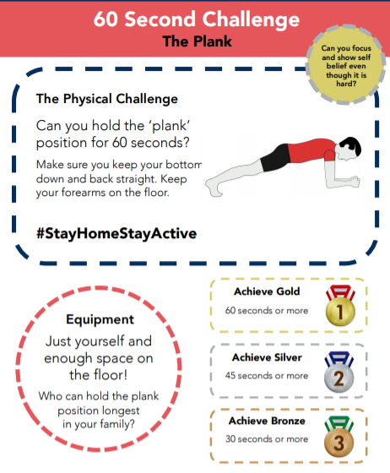

SESSION 4 ENGLISH

C o r n w a l l

