 | ENGLISH | MATHS | ENQUIRY | ACTIVE
S  E  S  S  I  O  N  1 | This week you have a choice of how you would like to represent  5 reasons why I love living in Cornwall  (This task will last you all week!)  Option 1: Create a poster for your bedroom. This needs to show the 5 reasons with images/drawing and annotations explaining why you have chosen these.  Options 2: Create an advert. Write a script for an advert where you talk about your 5 reasons with explanations, then turn the script into an advert with playing the main part.  SUCCESS CRITERIA  - Use our learning about Cornwall  - Say why you have chosen each of the reasons  - Use the activities in the Enquiry to add to your work. | This week, you will be consolidating your learning from the whole year.  There will be a problem of the day for each day.  (Look below the grid for larger versions!)  Day 1:  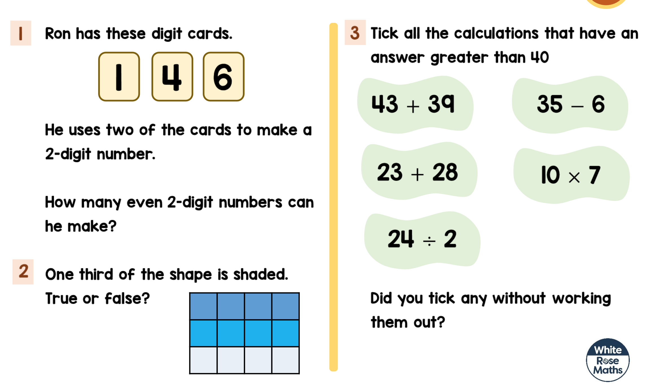  When you have finished, you could play mathletics, Numbots or Karate Cats maths:  https://www.bbc.co.uk/bitesize/topics/zjkphbk/articles/zf4sscw | Research and compile a selection of 5 reasons why you love living in Cornwall. Think about our learning over the past few weeks. It could include;  - Mining  - Smuggling/Wrecking/Piracy  - Tintagel Castle and its links to King Arthur  - Pobel Veans and Giants folktales  - or the amazing food Cornwall has to offer.  ART:  If you like the Cornish links to piracy:  Draw/make your very own pirate or pirate ship! https://www.youtube.com/watch?v=mvYF2qEiNMI  https://www.youtube.com/watch?v=5FZLrWwcCNk  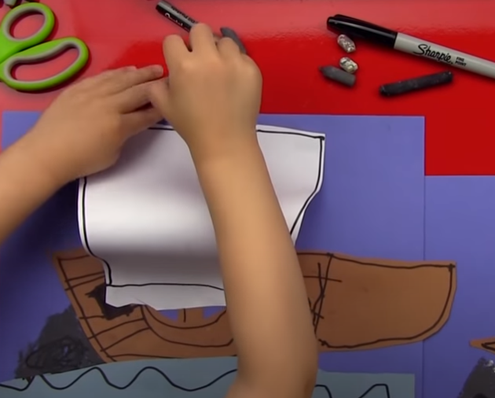 | 60 SECOND WEEKLY CHALLENGE  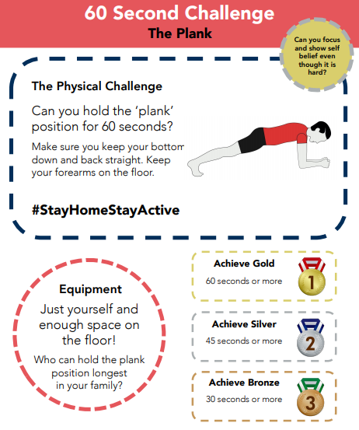  Can you complete  THE PLANK  challenge this week?
S  E  S  S  I  O  N  2 | Inspiration for poster  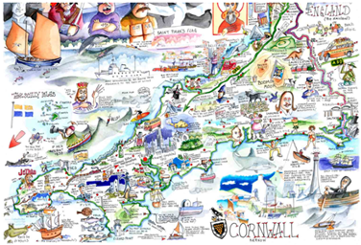  Inspiration for advert  https://www.youtube.com/watch?v=Z0usmMfs5IY | 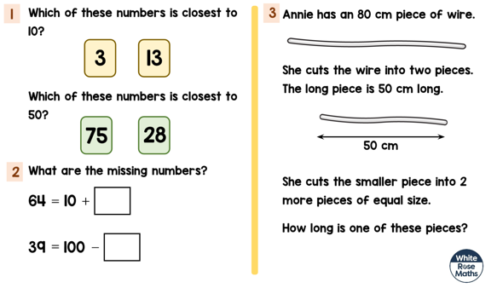  Day 2:  When you have finished, you could play mathletics, Numbots or Karate Cats maths:  https://www.bbc.co.uk/bitesize/topics/zjkphbk/articles/zf4sscw | GEOGRAPHY -  If you love to research:  Go onto GOOGLE MAPS and locate Cornwall.  Find Fistral Beach, Newquay. Drop the yellow man and have a look around. Why would someone visit here?  Find Bodmin Moor, drop the Yellow Man and investigate. Why would you visit there?  Find Land’s End, drop the Yellow Man and investigate. Why would you visit there?  Or  Retell your favourite Pobel Vean/Giant folktale.  Will it be a Knocker, Joan The Wad or Cormoran The Giant?  Don’t forget to draw your creature. | Choose 1 activity:  - Super Movers  - iMovers  PLUS:  Let’s Dance! https://www.youtube.com/playlist?list=PLJnn5H8Y_tYE3LdXoJIG_azMC2l5TjCON
S  E  S  S  I  O  N  3 | MORE INSPIRATION  https://www.visitcornwall.com/content/video  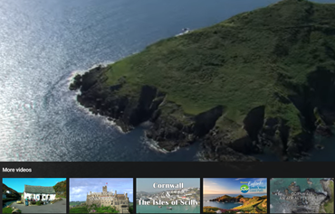 | Day 3:  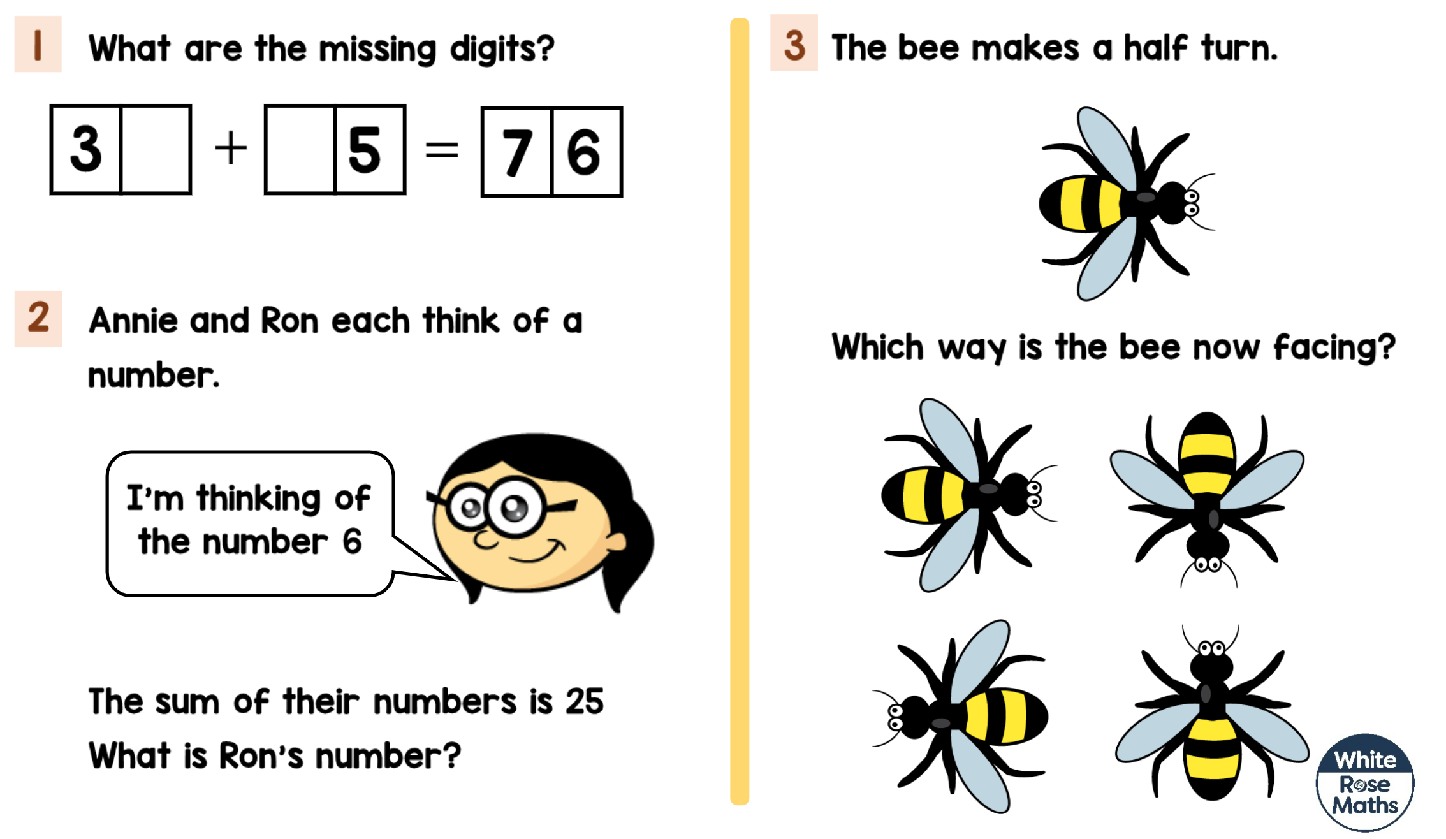  When you have finished, you could play mathletics, Numbots or Karate Cats maths:  https://www.bbc.co.uk/bitesize/topics/zjkphbk/articles/zf4sscw | ART: -  If you enjoy the Cornish food:  Draw your favourite ‘foldable’ ice-cream combo!  https://www.youtube.com/watch?v=vzaUdSnUWS4  OR  Write a recipe for your favourite Cornish treat. Make sure you bake it and add photographs to your work! | Try some activities from  #ThisIsPE  https://www.youtube.com/playlist?list=PLYGRaluWWTojV3An2WEgsQ4qGFy_91jDL  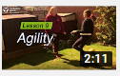  You can choose from lots of different skills. How fast are you at Fast Feet?
S  E  S  S  I  O  N  4 |  | Day 4:  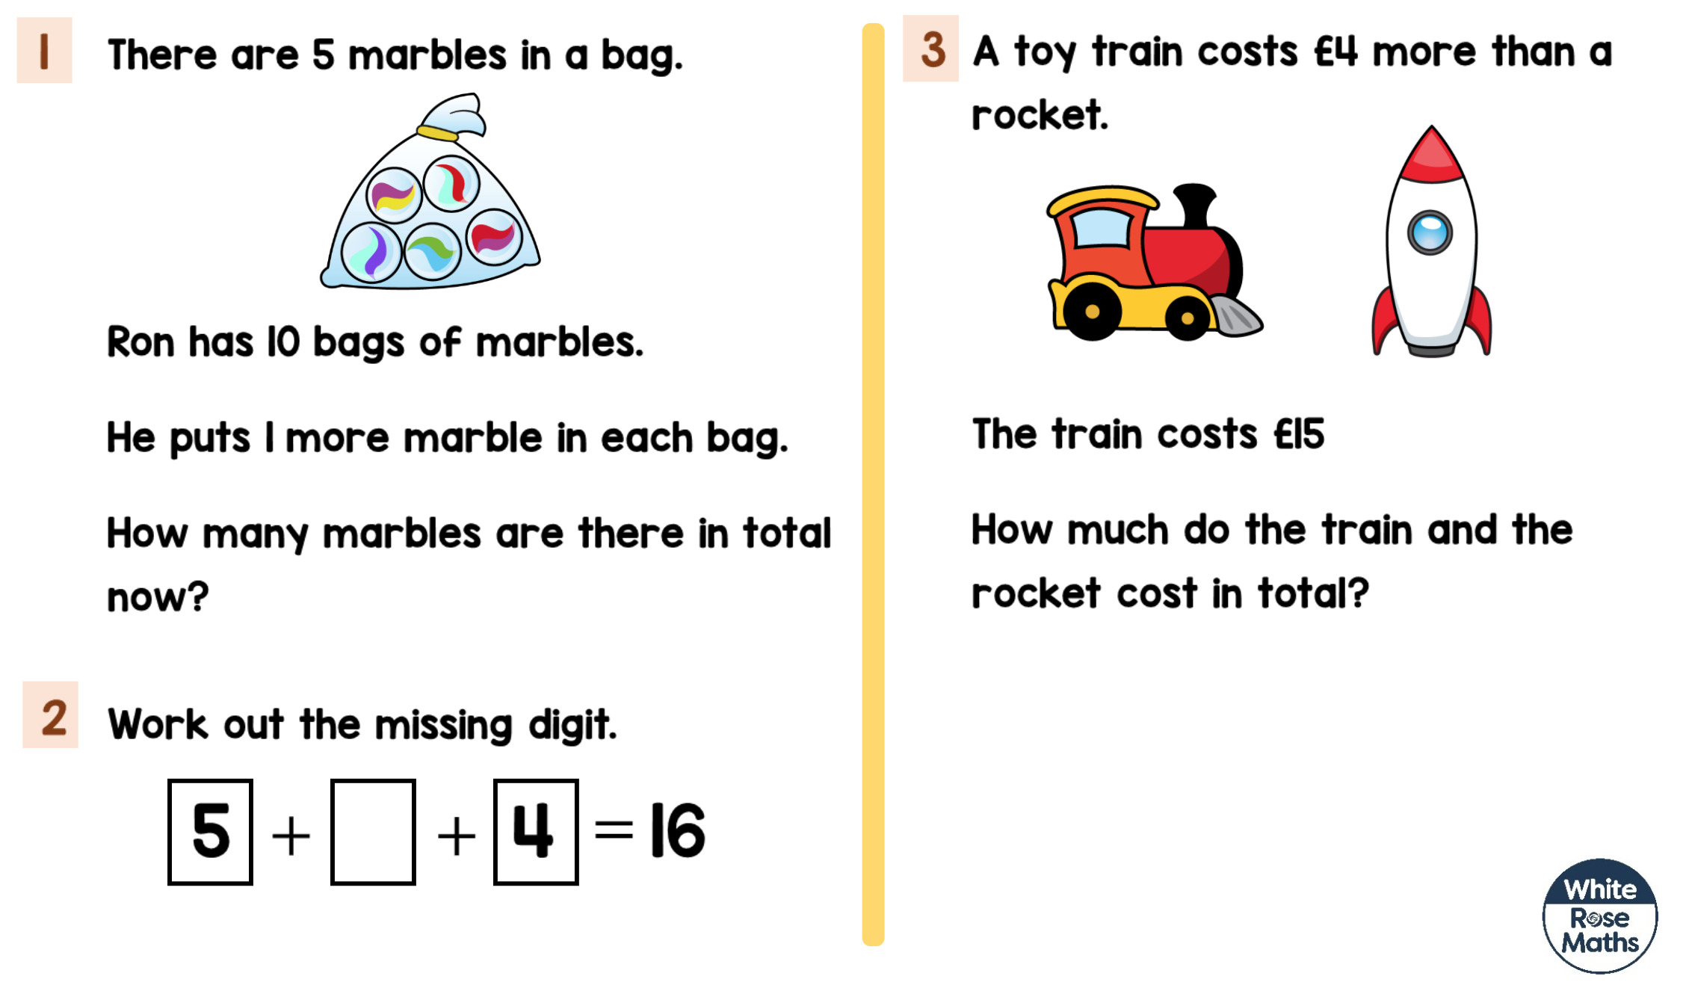  When you have finished, you could play mathletics, Numbots or Karate Cats maths:  https://www.bbc.co.uk/bitesize/topics/zjkphbk/articles/zf4sscw | DT:  If you are proud of our beaches:  Design a personalised beach towel and surf board  (ATTACHED TO BLOG)  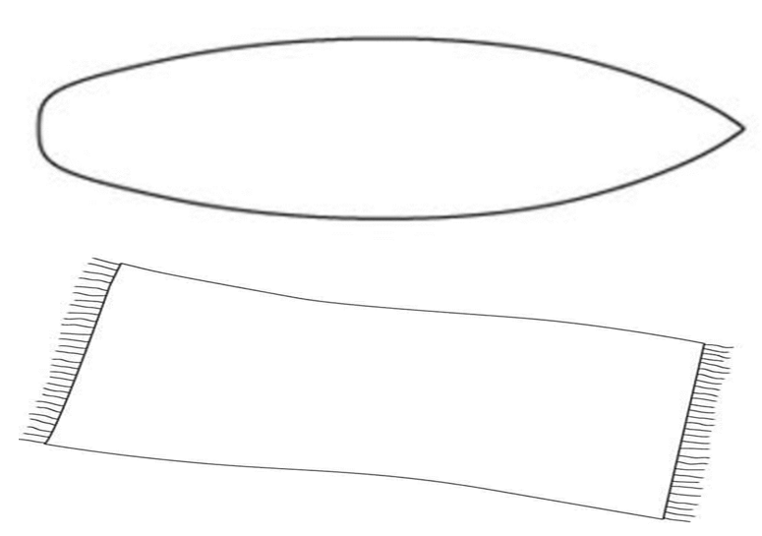 | Choose 1 activity:  - Joe Wicks (The Body Coach TV) Workout  - iMovers  PLUS:  Go Noodle – GoNoodle for Families https://family.gonoodle.com/channels/zumba-kids
S  E  S  S  I  O  N  5 |  | Day 5:  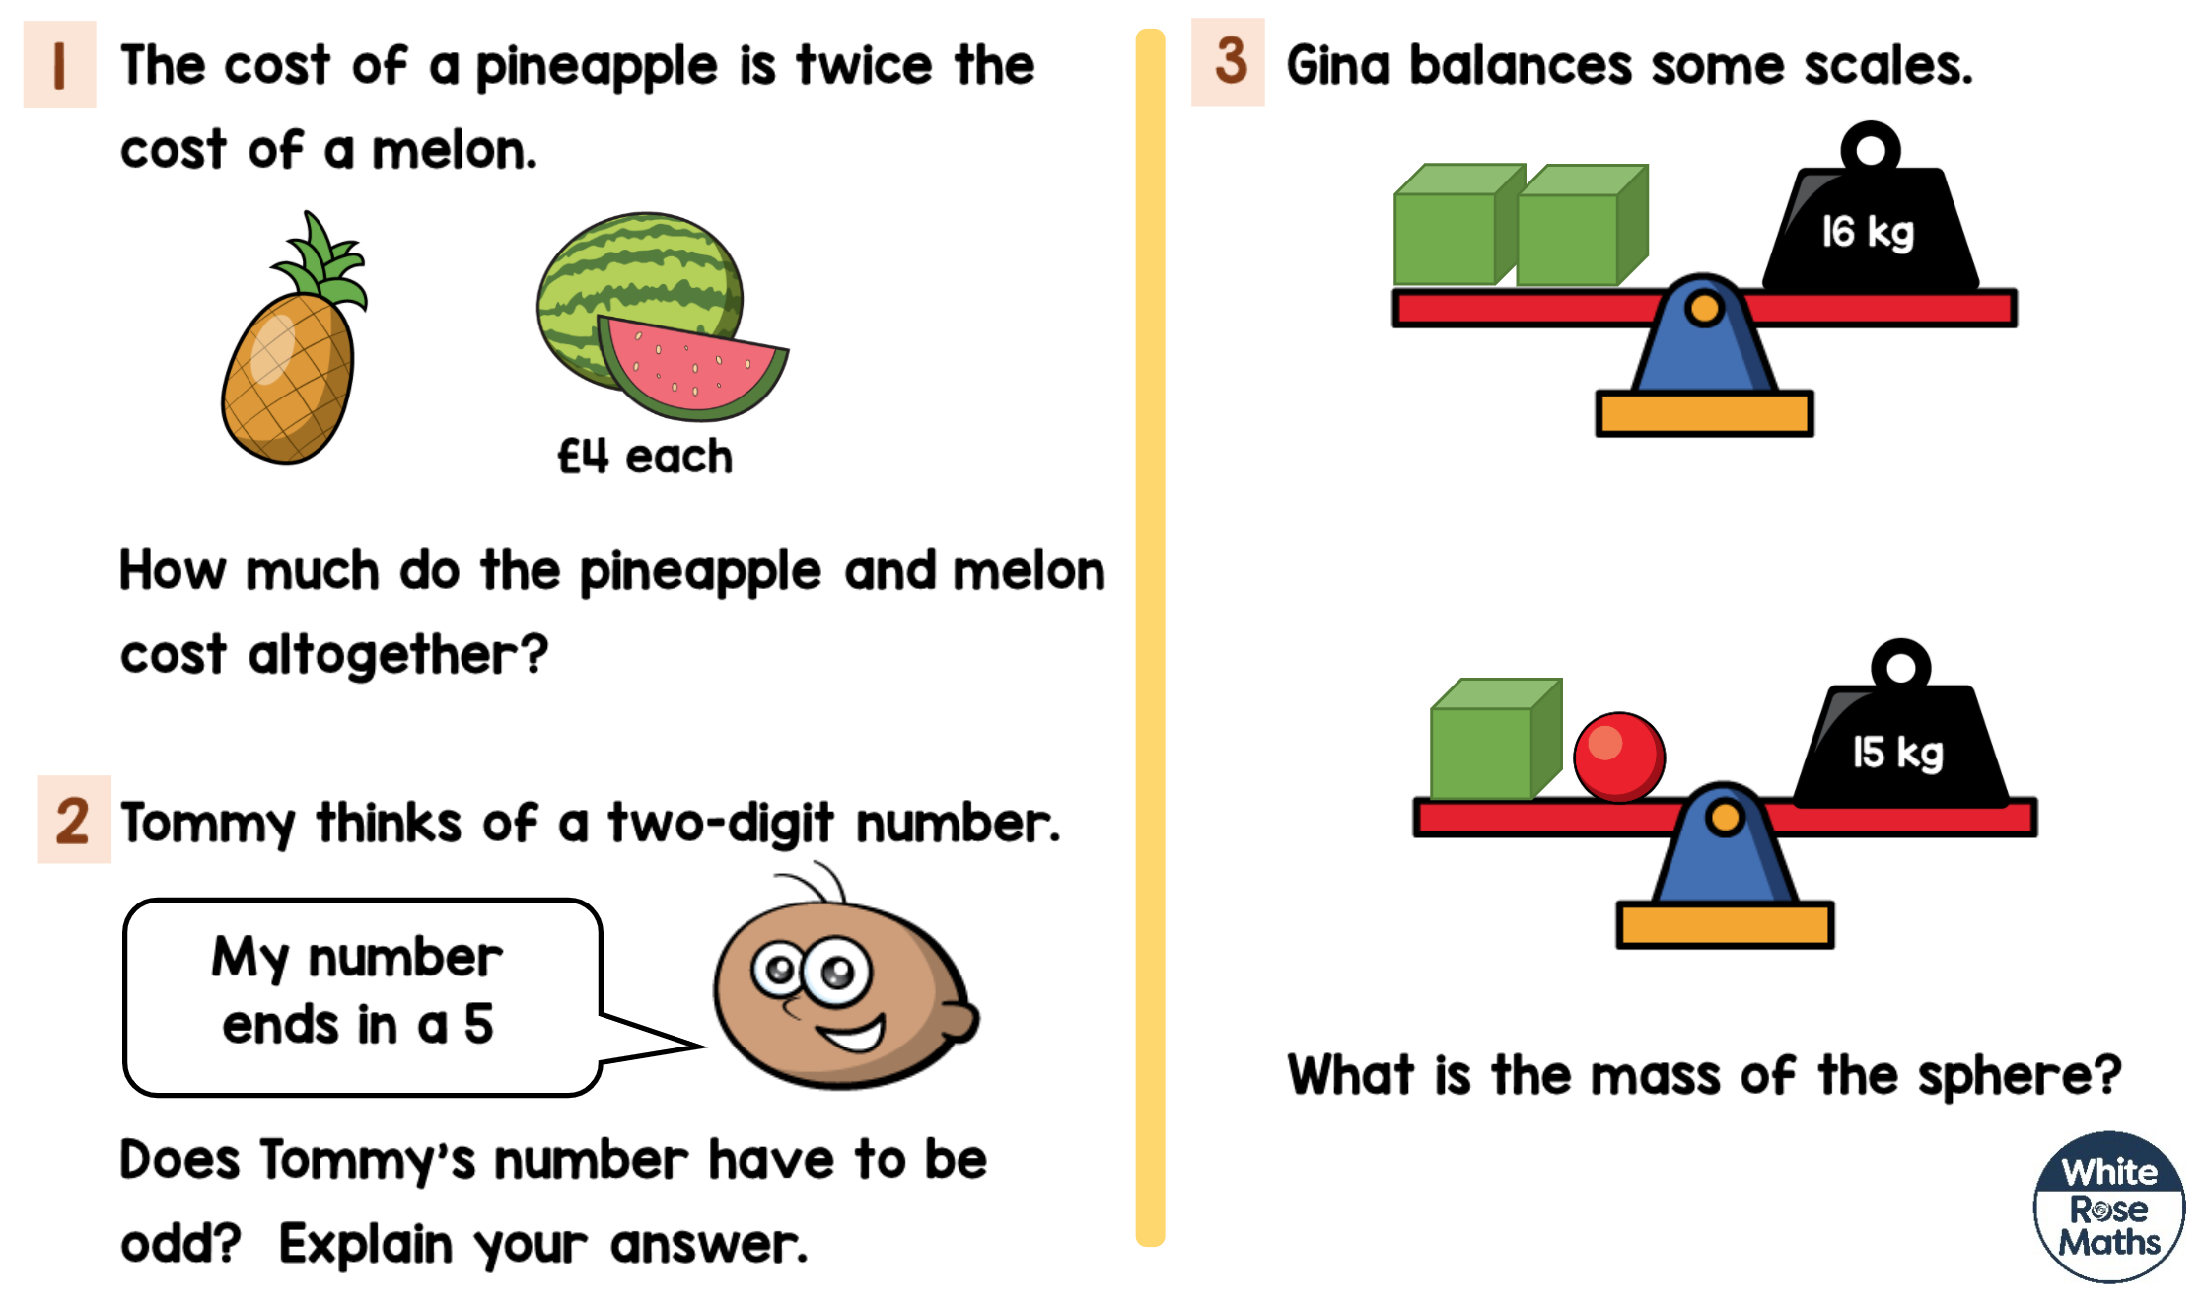  When you have finished, you could play mathletics, Numbots or Karate Cats maths:  https://www.bbc.co.uk/bitesize/topics/zjkphbk/articles/zf4sscw | SCIENCE/DT:  If you love the Eden Project:  The Eden Project is a construction of Geodesic domes constructed to withstand considerable weight and stress. Take a look at this clip: https://www.youtube.com/watch?v=f8unx8-pZxg  Make a Geodesic structure https://babbledabbledo.com/stem-kids-straw-geodesic-dome/  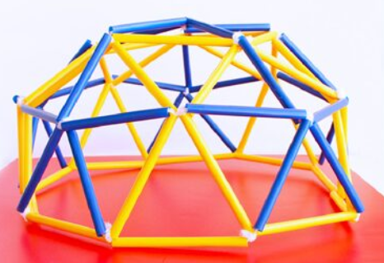  You can use:  Spaghetti and marshmallows straws and pipe cleaners/tape/Bluetac | Choose 1 activity:  - Joe Wicks (The Body Coach TV) Workout  - iMovers  PLUS:  https://www.youthsporttrust.org/pe-home-learning  CHOOSE AN ACTIVITY AND DOWNLOAD A CHALLENGE CARD!
Session 1 PE
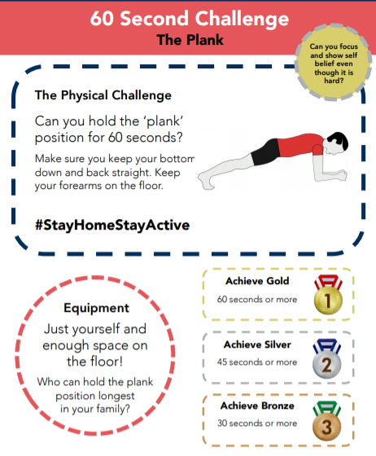

Maths Problem Day 1:

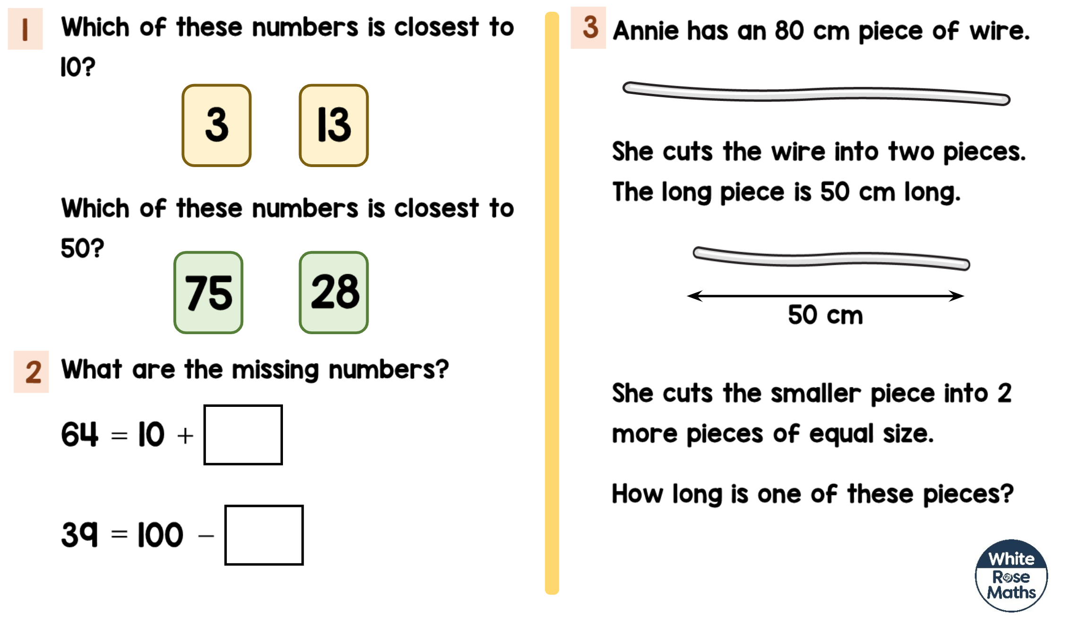
Maths Problem Day 2:

Maths Problem Day 3:
Maths Problem Day 4:
Maths Problem Day 5:

