 | ENGLISH | MATHS | ENQUIRY | ACTIVE
S  E  S  S  I  O  N  1 | Cornwall is known for its tales of smuggling, shipwrecks and piracy. We will be learning about some ‘notorious’ villains this week. So, let’s get our ‘pirate lingo’ on!  Key Vocabulary for the week: “Aye” Jolly Roger  booty “Avast Ye”  grog bounty  cutlass doubloons  scallywag mutiny  ACTIVITY: Look up the meanings for the words above (and any other you like the sound of). https://www.piratevoyages.com/pirate-lingo/  CAN YOU COME UP WITH SOME PHRASES YOU MIGHT SAY IF YOU WERE A PIRATE?  Ext: The right of ‘PARLAY’ is particularly important to a pirate. Can you find out what it means?  ‘SCURVY’ was something a pirate/smuggler did not want to get. Find out what this is. | Your lessons this week are all on Oak Academy. Our focus is addition and subtraction strategies.  Follow this link:  https://classroom.thenational.academy/subjects-by-year  Click ‘Year 1’ or Year 2’ then choose ‘Maths’.  Scroll down until you see ‘Exploring Calculation Strategies’ (Year 2) or ‘Addition and Subtraction’ (Year 1)  Year 1 Lesson 1:  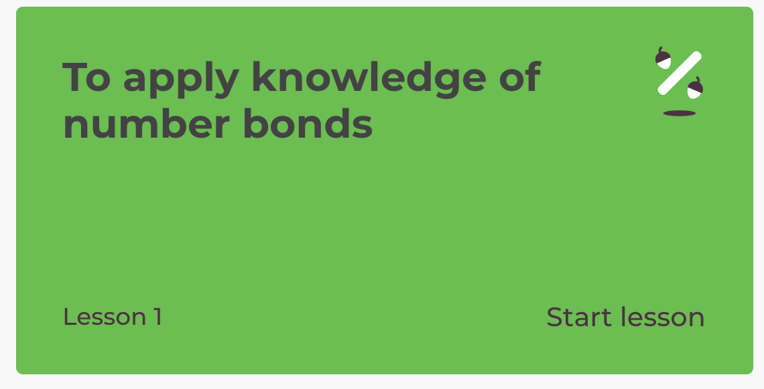  Year 2 Lesson 1:  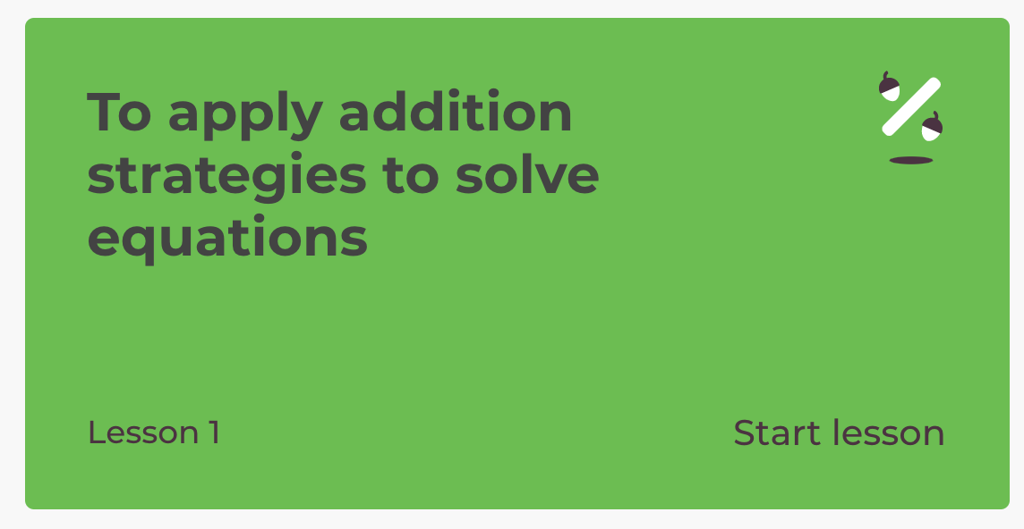  Extension: Choose one of the pirate themed Maths Challenge cards attached to the grid.  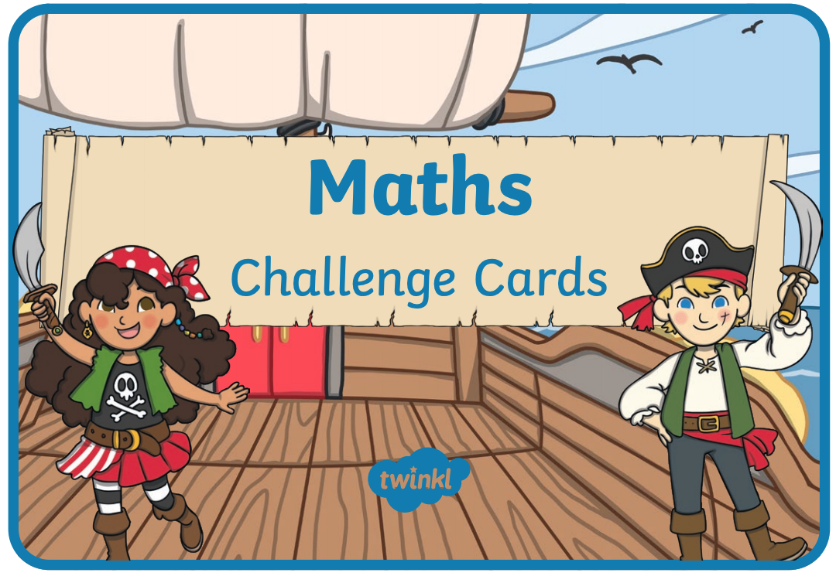 | HISTORY  We are looking into the history of Cornish piracy and smuggling this week. Why do you think people ‘smuggled’ and went ‘treasure seeking?’  Watch this intro: https://www.youtube.com/watch?v=kEMpm053eko  Now let’s read about two of the families mentioned - the aristocratic Killigrew’s and Polperro’s Zephania Job as well as a man nicknamed ‘The King of Prussia’  (SESSION 1 ENQUIRY attached to blog)  ACTIVITY: RESEARCH SOME FACTS AND CREATE A FACT SHEET ABOUT PIRATES AND SMUGGLERS!  https://www.dkfindout.com/uk/history/pirates/  https://www.squizzes.com/pirate-facts/  Listen to a folk song about Polperro’s very own smuggler, Zephaniah Job  https://www.youtube.com/watch?v=1cbBoI2kSuQ  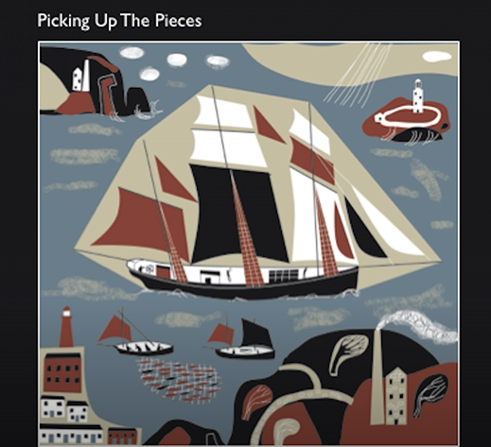 | 60 SECOND WEEKLY CHALLENGE  SOCKS IN A BOX  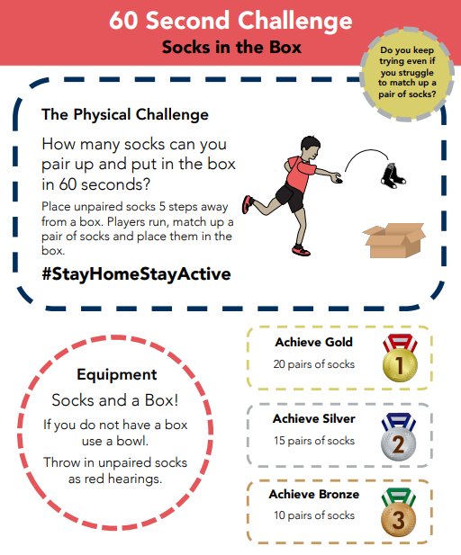
S  E  S  S  I  O  N  2 | COMPREHENSION  Read the Pirate Comprehension attached to the blog and answer the questions.  Year 1:  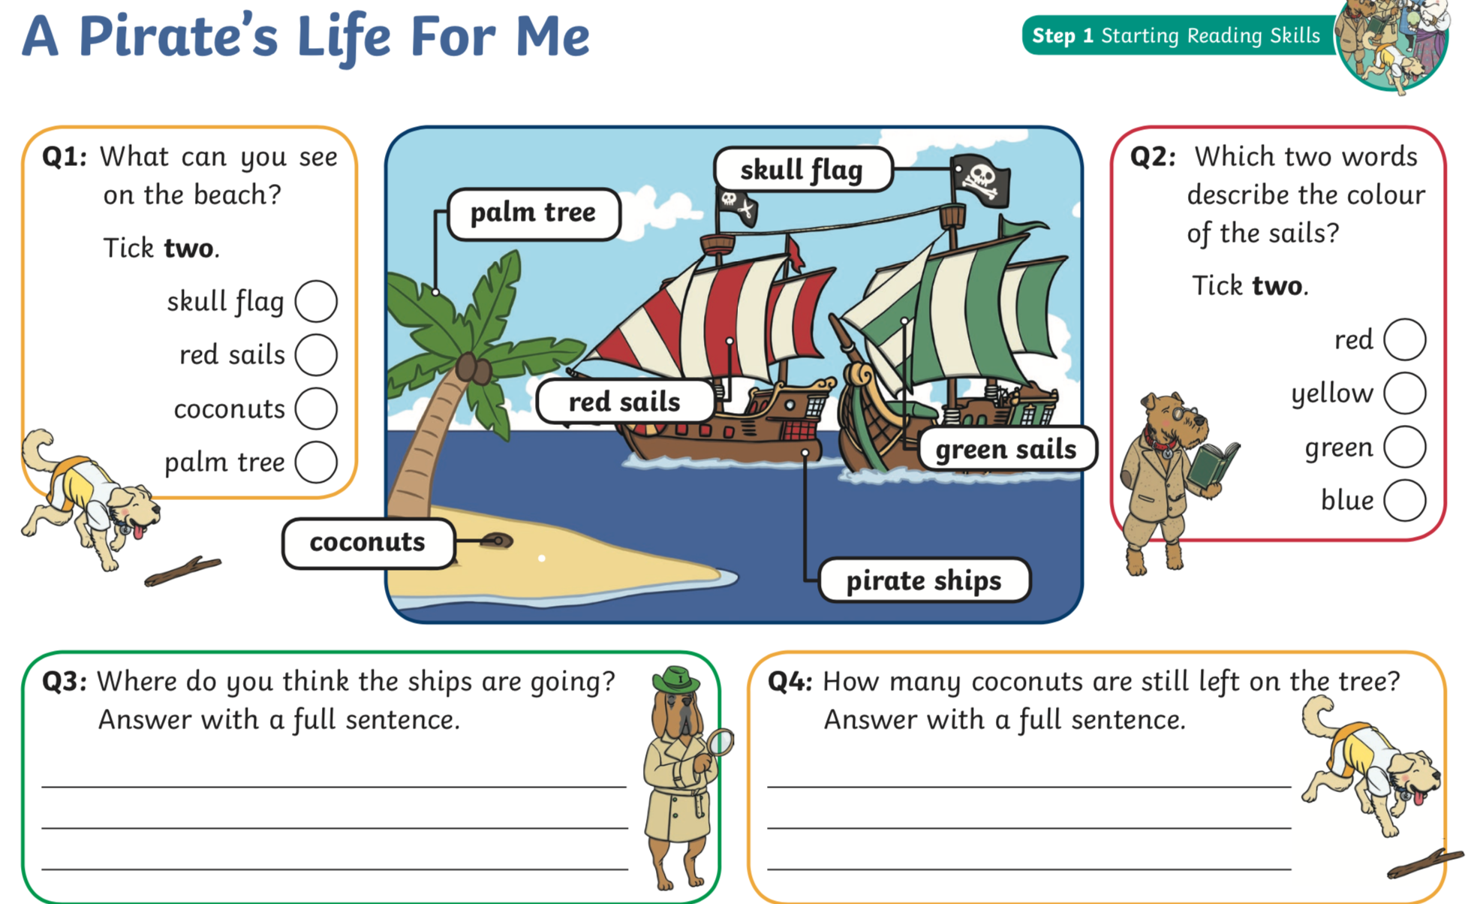  Year 2:  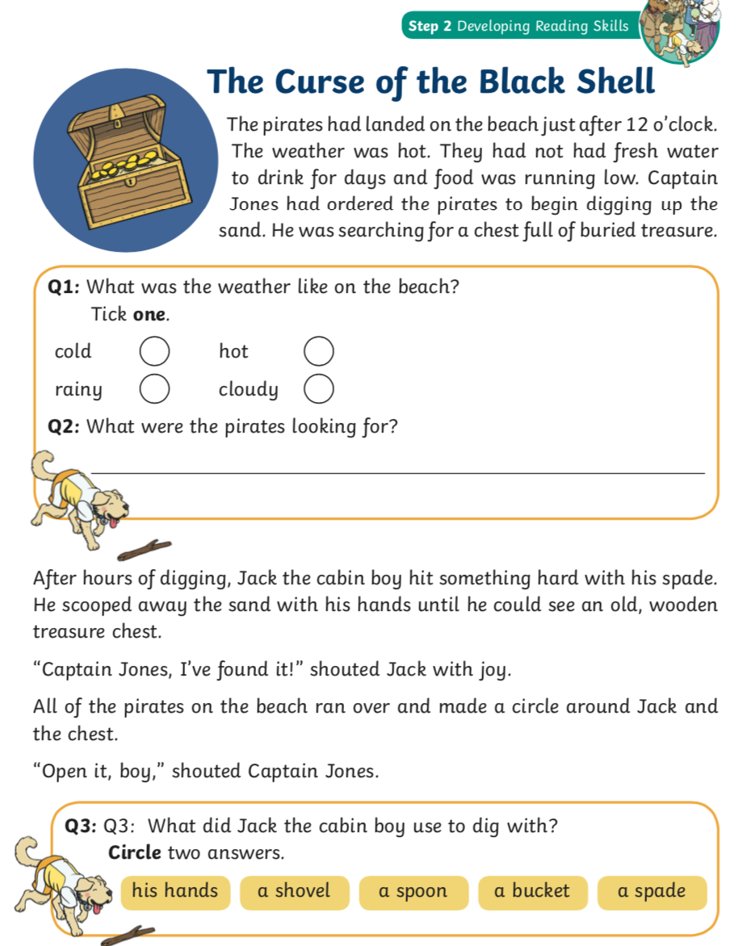 | Year 1 Lesson 2:  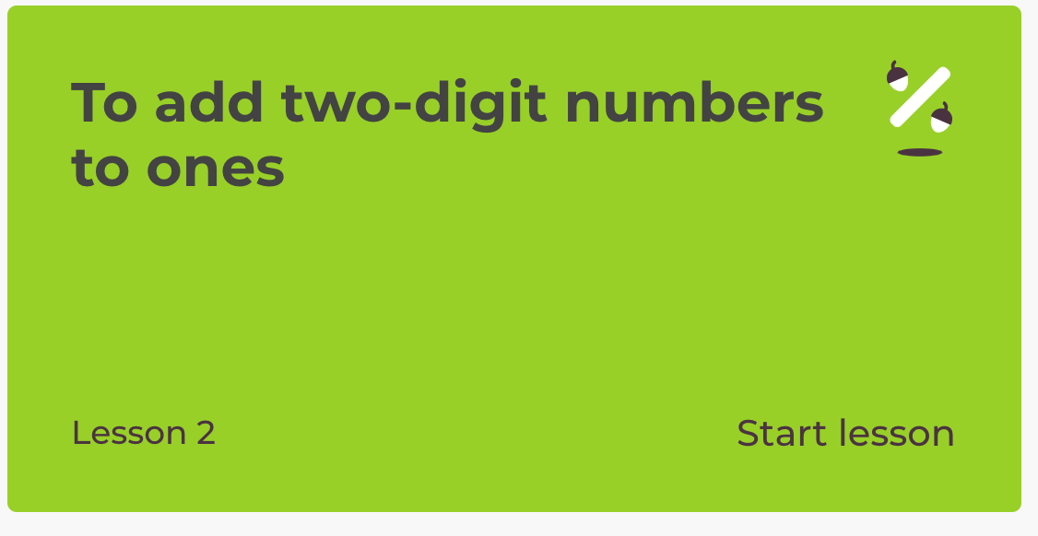  Year 2 Lesson 2:  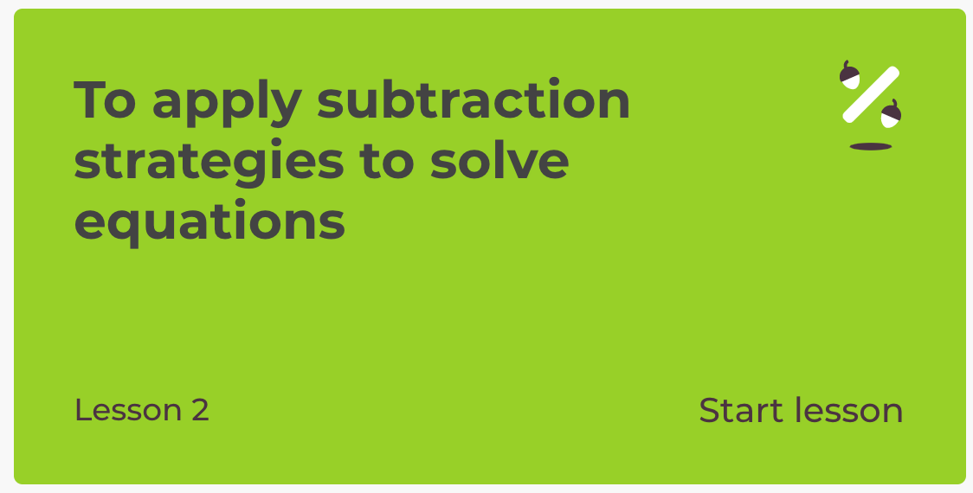  Extension: Choose one of the pirate themed Maths Challenge cards attached to the grid. | SCIENCE - MATERIALS  A PIRATE/SMUGGLER’S SHIP NEEDED TO BE SOLID, WATERTIGHT AND BOUYANT (ABLE TO FLOAT).  Some materials are perfect for the job whilst others do not have the correct properties to keep a vessel afloat.  ACTIVITY: Select various materials around your house (recycling bin is a good place to start) and investigate which would be the best to make a boat. Follow the instructions attached:  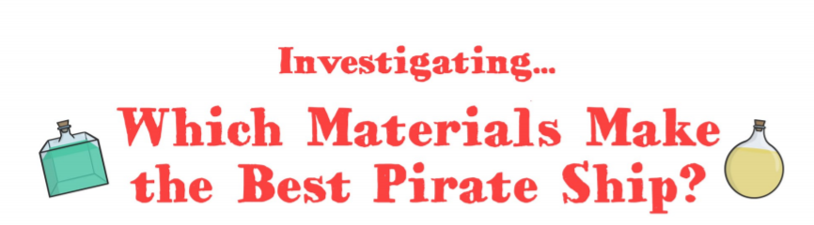  EXTENSION:  WHY NOT MAKE SOME PIRATE DOUBLOONS TO GO ON YOUR SHIP!  (both experiments attached to the blog) | Choose 1 activity:  - Super Movers  - iMovers  PLUS:  Let’s Dance! https://www.youtube.com/playlist?list=PLJnn5H8Y_tYE3LdXoJIG_azMC2l5TjCON
S  E  S  S  I  O  N  3 | COMPREHENSION  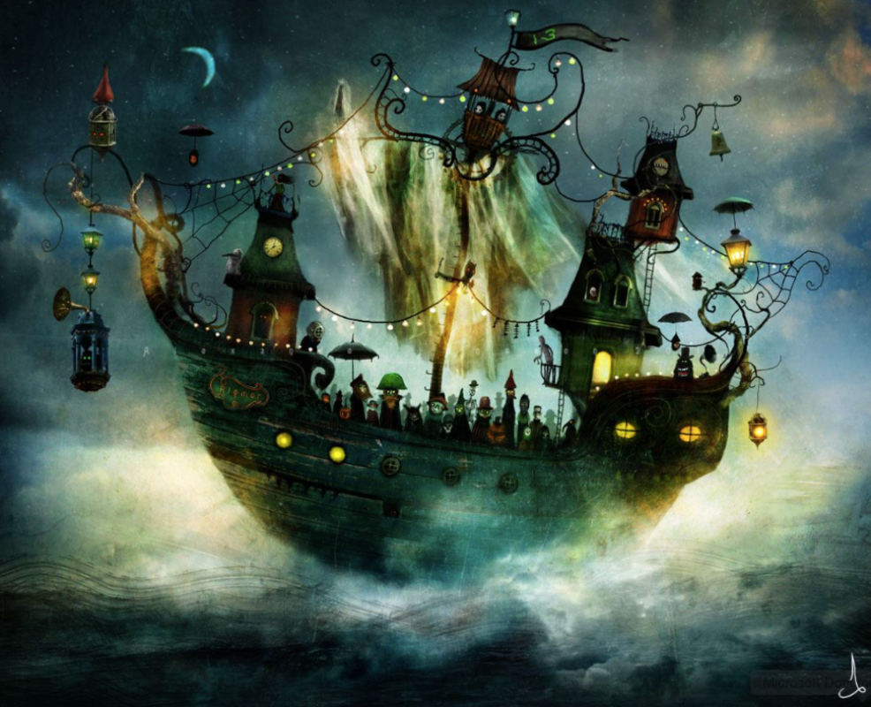  Click the link to Pobble 365 ‘The Strange Ship’  (We have seen this before in our last topic!)  https://www.pobble365.com/the-strange-ship  ACTIVITY: Draw what you think the Captain of the ship looks like.  Ext: Write a sentence to describe your pirate using an expanded noun phrase.  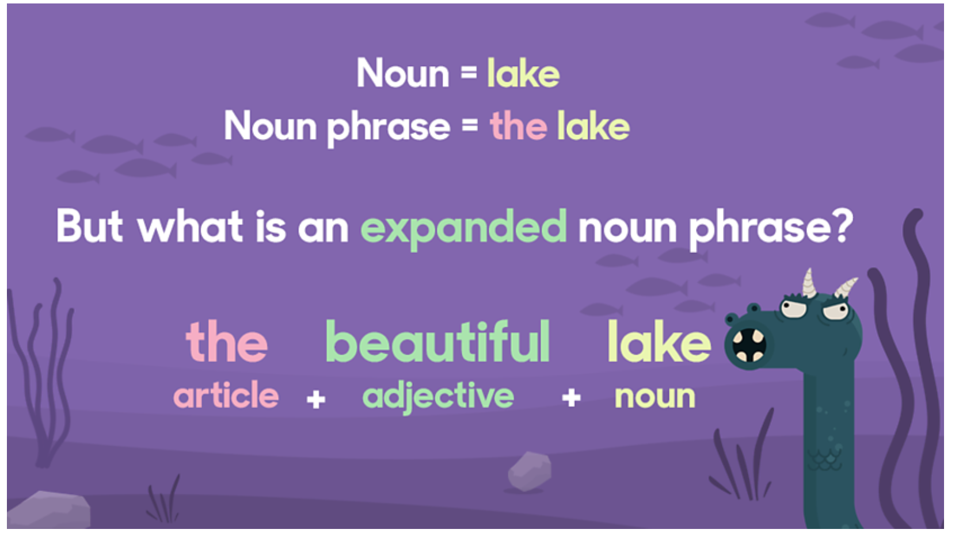 | Year 1 Lesson 3:  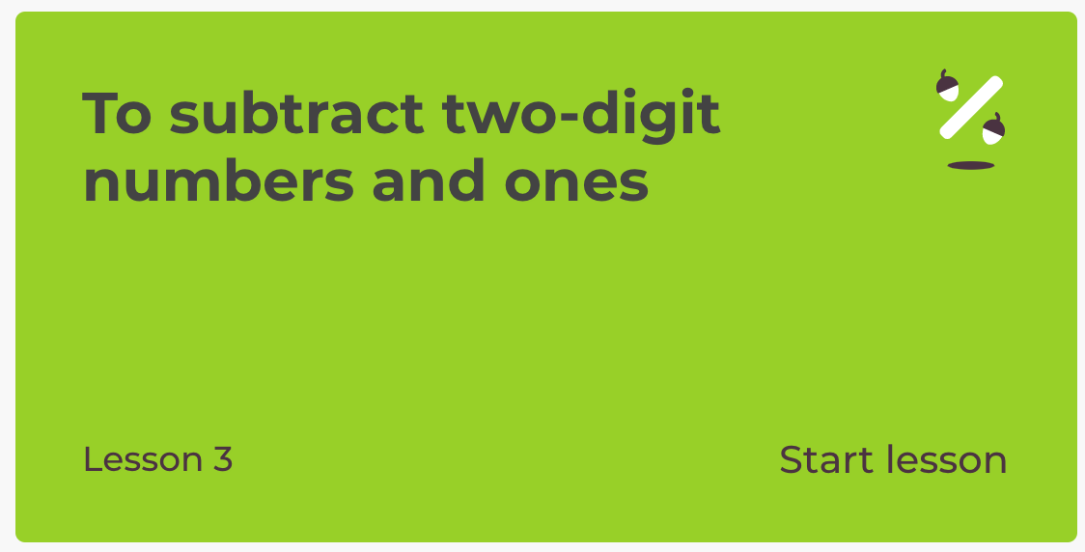  Year 2 Lesson 3:  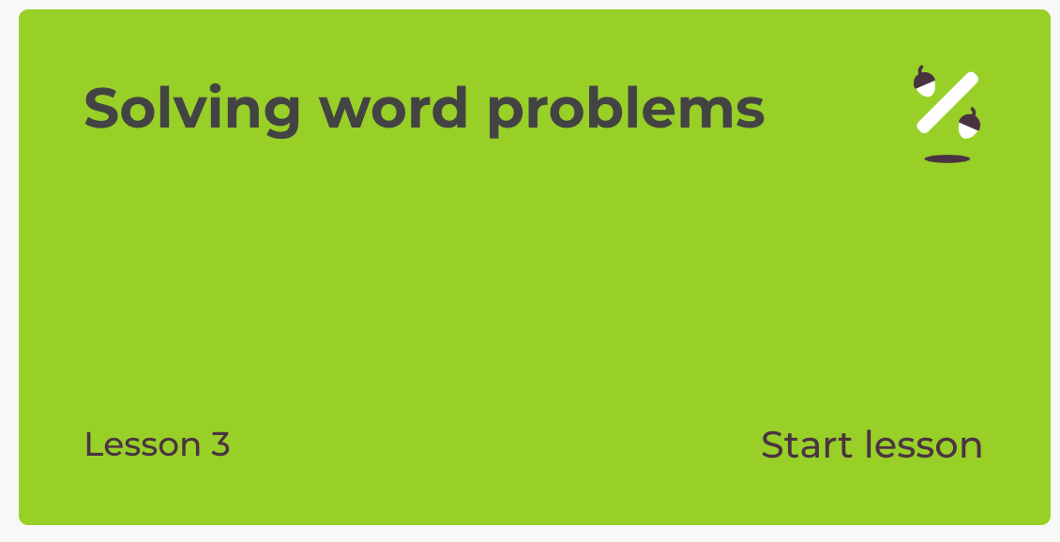  Extension: Choose one of the pirate themed Maths Challenge cards attached to the grid. | ART/DT: The Jamaica Inn is a coaching inn on Bodmin Moor which is associated with smuggling. It is remote, isolated and a perfect hideaway for smugglers to stash their loot and pick up later.  Click on the link to find out more: https://www.jamaicainn.co.uk/history  ACTIVITY: Imagine you are a famous smuggler. Draw/paint a picture of yourself and your crew approaching the mysterious Jamaica Inn with your booty!  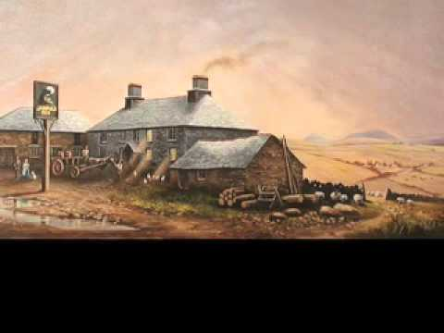 | Try some activities from  #ThisIsPE  https://www.youtube.com/playlist?list=PLYGRaluWWTojV3An2WEgsQ4qGFy_91jDL  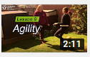  You can choose from lots of different skills. How fast are you at Fast Feet?
S  E  S  S  I  O  N  4 | SPaG  Today we will be learning about possessive apostrophes.  Look at the poster attached to the blog:  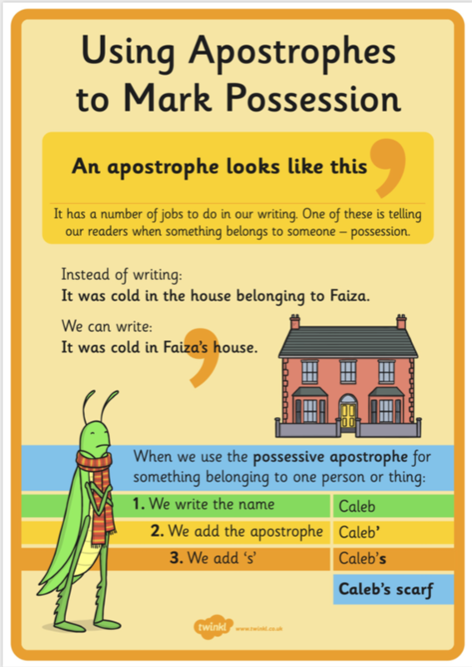  Year 1s: Write at least 2 sentences using an apostrophe for possession.  Year 2s: Write at least 3 sentences using an apostrophe for possession. | Year 1 Lesson 4:  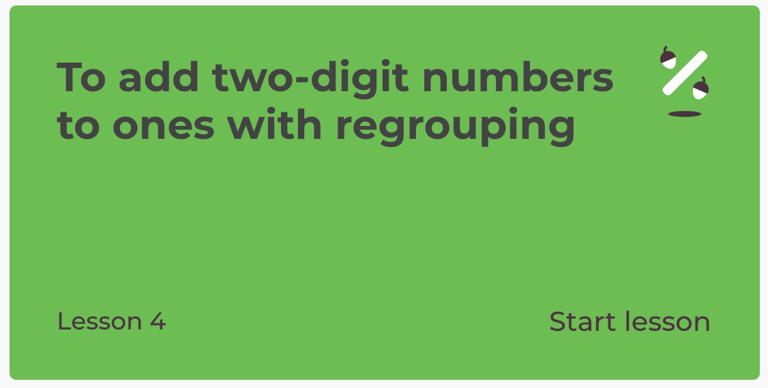  Year 2 Lesson 4:  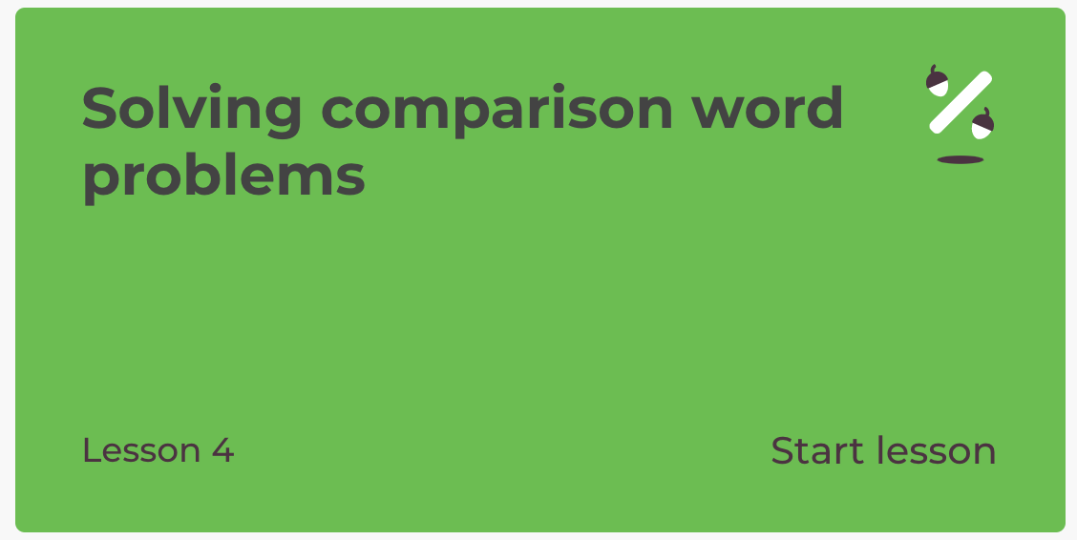  Extension: Choose one of the pirate themed Maths Challenge cards attached to the grid. | HISTORY/GEOG/PSHE/ART:  What is WRECKING and what does it have to do with Cornwall’s smuggling history?  Use these sites or research your own.  https://www.historic-uk.com/CultureUK/Smugglers-Wreckers/  http://www.smuggling.co.uk/gazetteer_sw.html  Activity: If you were a Wrecker, walking the beach looking for ‘booty’, what would you be excited to find?  EXAMPLE: A container, wrecked off the coast of Cornwall in 1997, was full of Lego which was still being washed up 10 years later.  https://www.bbc.co.uk/news/magazine-28367198  What would your treasure look like? Maybe it would be a bucket-full of Lego. Draw what your ‘perfect booty’ would look like. | Choose 1 activity:  - Joe Wicks (The Body Coach TV) Workout  - iMovers  PLUS:  Go Noodle – GoNoodle for Families https://family.gonoodle.com/channels/zumba-kids
S  E  S  S  I  O  N  5 | WRITING TASK  Write a wanted poster for your pirate captain. Remember to include a character description and a description of the crimes they have committed.  Success Criteria:  - Expanded noun phrases  - Capital letters and full stops  - Apostrophes for possession  - Pirate vocabulary  Check through your work afterwards and any corrections are your next steps in your writing. (Remember your punctuation!) | Play  Practise your fast recall of addition facts to play this game:  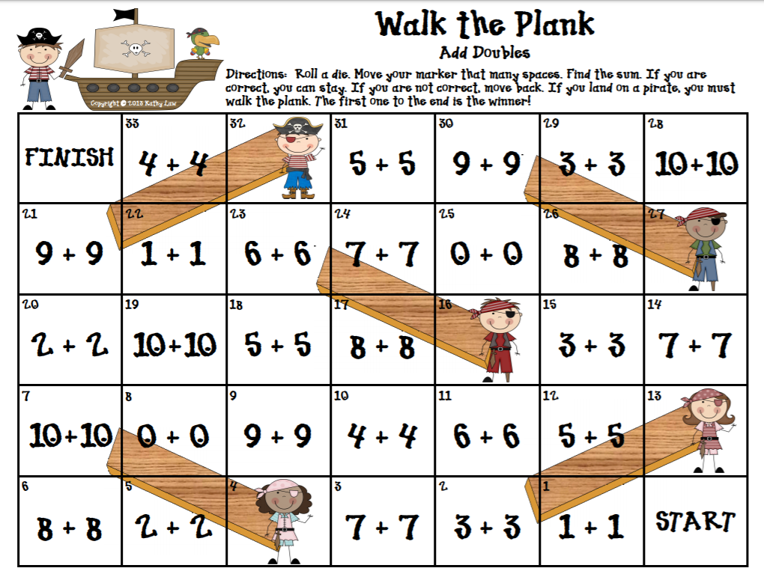  You just need a dice and two counters.  (Bigger version below grid)  Challenge: Can you design and make your own pirate themed addition board game? | DT: Food Preperation  Scurvy was a nasty disease which many pirates caught due to dark, damp and dirty living conditions and lack of Vitamin C. Thankfully, we don’t have to worry about catching Scurvy these days!  ACTIVITY: Make a plate of food fit for life at sea. One that is yummy but sure to keep the Scurvy away!  Suggestions: GROG: orange/apple/tomato juice or squash  GRUB: Chunks of cheese/apple/ orange/pineapple/grapes/peppers/ strawberries AND a tasty treat of course!  Send me a picture of your ‘pirate picnic’!  Or  Use your Co-ordinate knowledge to play Pirate Battleships!  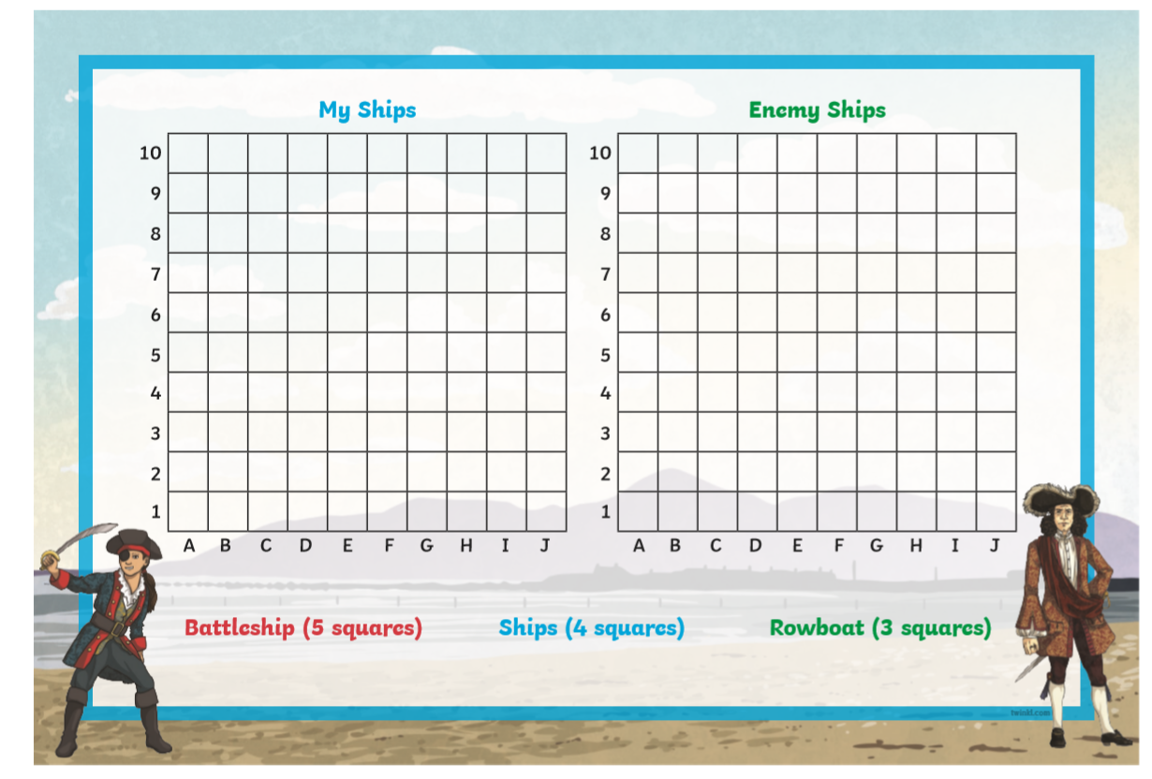  (Info attached to grid) | Choose 1 activity:  - Joe Wicks (The Body Coach TV) Workout  - iMovers  PLUS:  https://www.youthsporttrust.org/pe-home-learning  CHOOSE AN ACTIVITY AND DOWNLOAD A CHALLENGE CARD!
SESSION 1 ACTIVE

SESSION 5 ENQUIRY
