Famous Cornish Smugglers
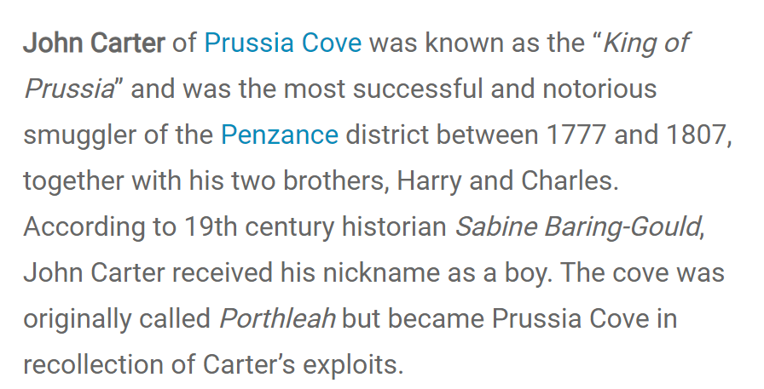
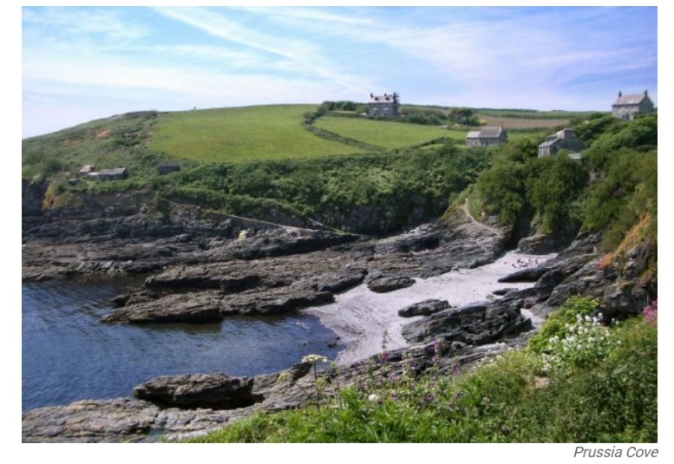
The brothers ran a profitable smuggling business for many years, hiding loot in three inlets (small landing places). Silks, teas, tobacco and brandy were goods which they often smuggled into Cornwall. These spots were sheltered and secluded – it was impossible to see what was going on unless you leant over the edge of the cliffs above. The caves in the inlets are said to connect to one of the houses above. Which one do think it could be?

Zephaniah Job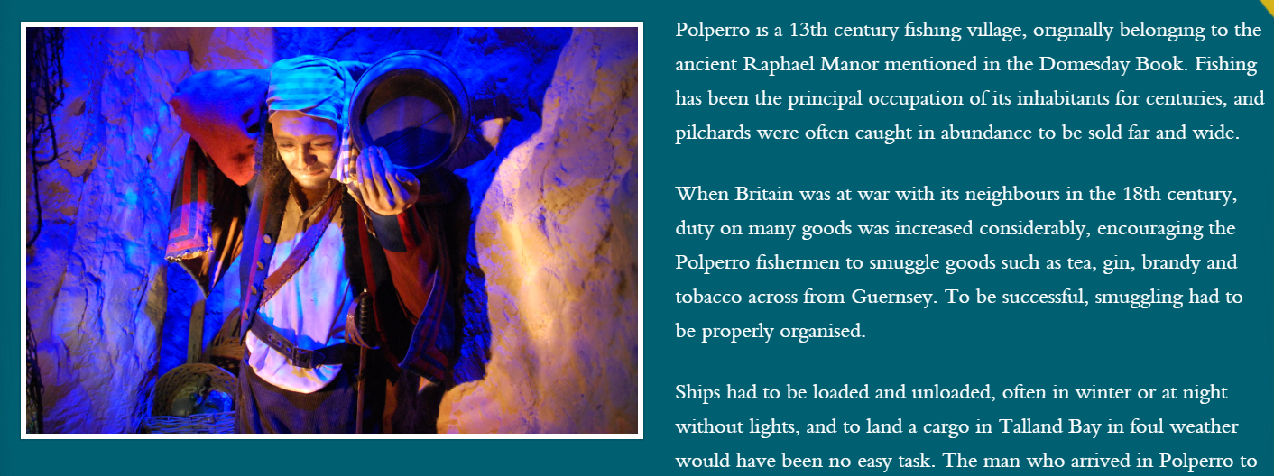
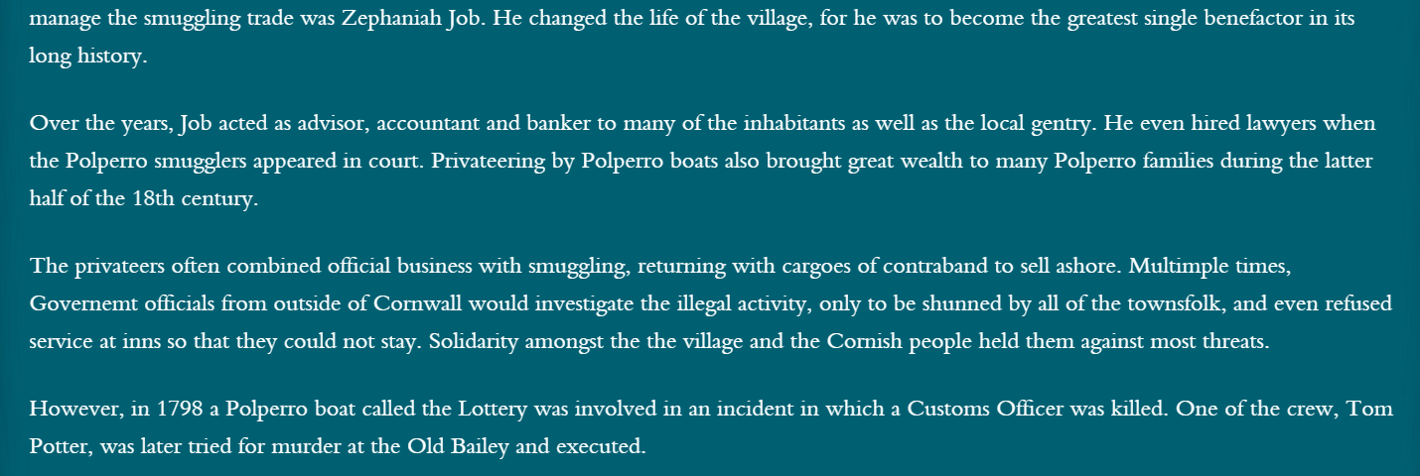
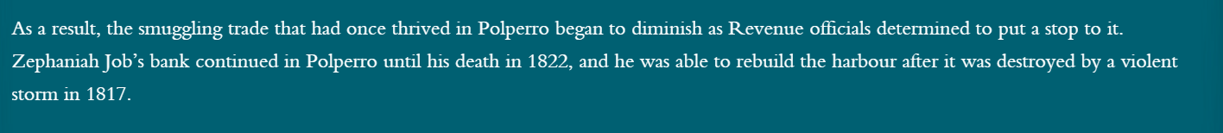

Cornwall is known for its smugglers but not so much for its pirates. All except for one…

Lady Mary Killigrew of Penryn
Known as a national beauty with long auburn hair, Lady Mary Killigrew was Cornwall’s own Scarlett Pimpernel. A Nobel aristocrat by day and a ruthless pirate by night. Her husband (Sir Henry Killgrew) was actually sent to sea with a fleet of men to stop illegal piracy in English waters! Being at sea for many months at a time meant that Lady Mary could continue her secret family business from home. For years she looted ships which docked (whilst the crew dined at her castle) and stole precious wealth from others until her demise one New Year’s Eve in 1583.
She knew there was treasure on board the Spanish ship Maria. She waited until most of the crew had gone on land to dine in Penryn town, jumped on deck, threw the remaining men overboard and sailed the Maria out to sea! However, Maria’s captain alerted the Queen and her men were lying in wait as she returned to shore. She was put on trial but surprisingly pardoned (let off) so long as she stopped her piracy and changed her ways. She did!
