6.7 | ENGLISH | MATHS | ENQUIRY |  | ACTIVE
S  E  S  S  I  O  N  1 | READING FOR INFORMATION  This week we are going to use the fantastic Smugglers of Mousehole series of books by Adam Sanders Clarke. We will read an extract from the first book and use this to write a smuggling story set in Cornwall.  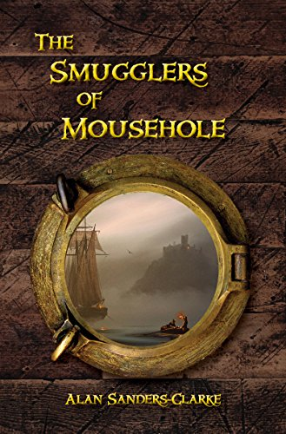  Read Chapter 1 of the story an answer the VIPERS.  Check your answers and use that as feedback for your next step. | This week, you are going to use Oak Academy to study properties of 2D and 3D shapes. There are no worksheets as you work from the video and jot down answers on paper. Form some of the activities you might need extra equipment like a ruler, this will be specified at the start of the lesson.  Year 4  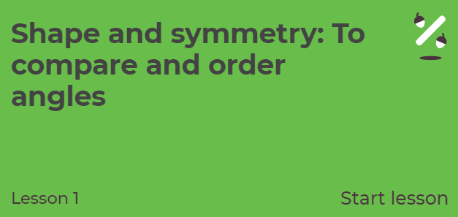  https://classroom.thenational.academy/lessons/shape-and-symmetry-to-compare-and-order-angles  Year 5  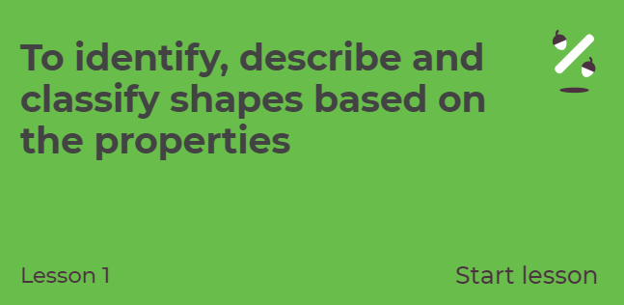  https://classroom.thenational.academy/lessons/to-identify-describe-and-classify-shapes-based-on-the-properties | HISTORY  We are looking into the history of Cornish piracy and smuggling this week. Why do you think people ‘smuggled’ and went ‘treasure seeking?’  Watch this intro: https://www.youtube.com/watch?v=kEMpm053eko  Now let’s read about two of the families mentioned - the aristocratic Killigrew’s and Polperro’s Zephania Job as well as a man nicknamed ‘The King of Prussia’ (SESSION 1 ENQUIRY attached to blog)  ACTIVITY: RESEARCH SOME FACTS AND CREATE A FACT SHEET ABOUT PIRATES AND SMUGGLERS! https://www.dkfindout.com/uk/history/pirates/  https://www.squizzes.com/pirate-facts/  Listen to a folk song about Polperro’s very own smuggler, Zephaniah Job https://www.youtube.com/watch?v=1cbBoI2kSuQ |  | 60 SECOND WEEKLY CHALLENGE  SOCKS IN A BOX  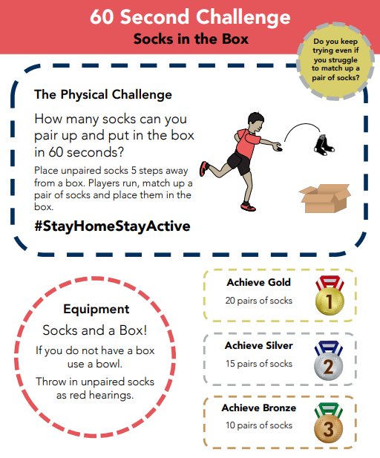
S  E  S  S  I  O  N  2 | COMPARING TEXTS  Today you are going to use your comparison skills. Read a bit of Chapter 2 and then compare this with another text (The Tunnel at Gurnick Street). Both the texts are attached below the Blog.  When you have read the texts, think about what is the same and what is different – use the comparison grid on page 7 of this document.  Do you think one of the authors has read the other person’s story?  If so, who has read whose?  What do you think the tunnel looks like? Have a go at drawing it. Think about your learning from last week about mines. | Year 4  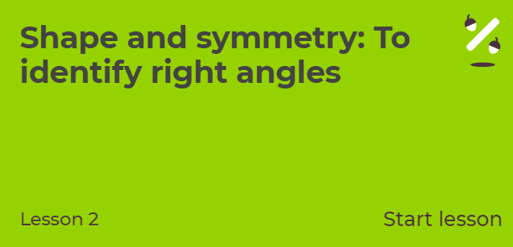https://classroom.thenational.academy/lessons/shape-and-symmetry-to-identify-right-angles  Year 5  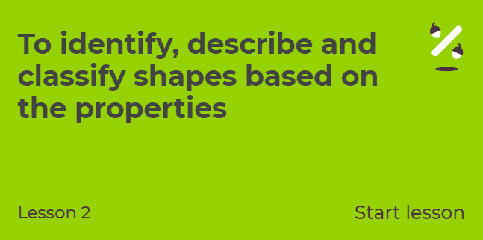  https://classroom.thenational.academy/lessons/to-identify-describe-and-classify-shapes-based-on-the-properties-6537fa | SCIENCE - MATERIALS  A PIRATE/SMUGGLER’S SHIP NEEDED TO BE SOLID, WATERTIGHT AND BOUYANT (ABLE TO FLOAT).  Some materials are perfect for the job whilst others do not have the correct properties to keep a vessel afloat.  ACTIVITY: Select various materials around your house (recycling bin is a good place to start) and investigate which would be the best to make a boat. Follow the instructions attached:  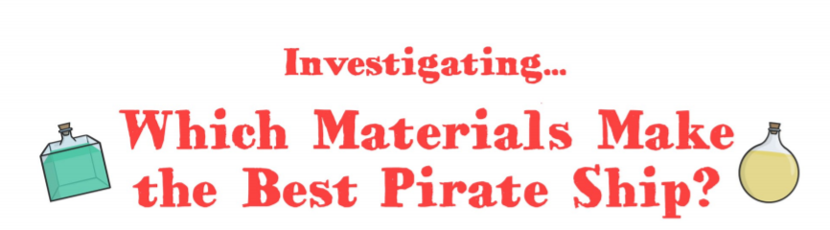  EXTENSION:  WHY NOT MAKE SOME PIRATE DOUBLOONS TO GO ON YOUR SHIP!  (both experiments attached to the blog) |  | Choose 1 activity:  - Super Movers  - iMovers  PLUS:  Let’s Dance! https://www.youtube.com/playlist?list=PLJnn5H8Y_tYE3LdXoJIG_azMC2l5TjCON
S  E  S  S  I  O  N  3 | DESCRIPTIVE WRITING  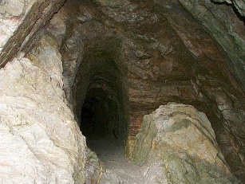  Imagine that you are in the tunnel, you get to the steep part and decide to climb up – where do you end up? What is at the end of the tunnel?  Write a piece of descriptive writing of what you see, feel, hear, and smell as you enter the tunnel and start to explore it. Is it wet underfoot, is the air stale, has the ceiling got rafters like a mine shaft, is it pitch black when you turn the light out?  Success Criteria  - Write your piece as a cliff hanger (perhaps there’s another door, or a portal, or someone waiting for you)  - You need to build the suspense and end it with … (ellipsis) | Year 4  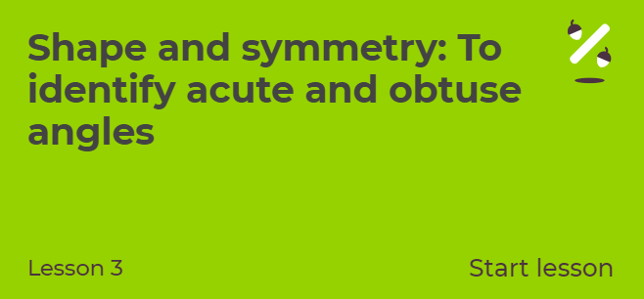  https://classroom.thenational.academy/lessons/shape-and-symmetry-to-identify-acute-and-obtuse-angles  Year 5  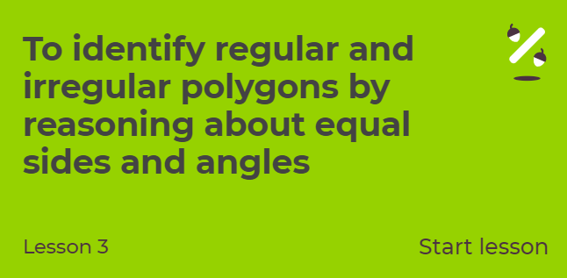  https://classroom.thenational.academy/lessons/to-identify-regular-and-irregular-polygons-by-reasoning-about-equal-side | ART/DT: The Jamaica Inn is a coaching inn on Bodmin Moor which is associated with smuggling. It is remote, isolated and a perfect hideaway for smugglers to stash their loot and pick up later. Click on the link to find out more: https://www.jamaicainn.co.uk/history  ACTIVITY: Imagine you are a famous smuggler. Draw/paint a picture of yourself and your crew approaching the mysterious Jamaica Inn with your booty.  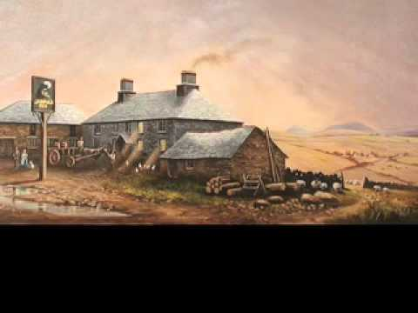  OR CREATE YOUR OWN PIRATE HOARD. Collect a few items which are important to you (favourite toy, jewel/pebble etc.) Put them in a ‘treasure chest’ then hide it in the house/garden. Then design your own pirate treasure map. Give the map to a person in your house to see if they can find your stash!  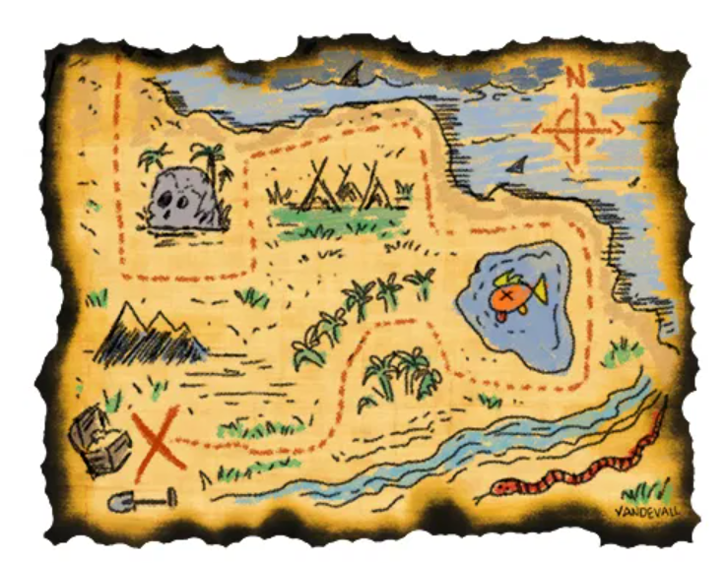 |  | Try some activities from  #ThisIsPE  https://www.youtube.com/playlist?list=PLYGRaluWWTojV3An2WEgsQ4qGFy_91jDL  You can choose from lots of different skills. How fast are you at Fast Feet?
S  E  S  S  I  O  N  4 | WRITING  In the book, Olivia and Georgia end up in smuggling days of the 1700s. Watch the clip of the film here  https://www.thesmugglersofmousehole.com/  Not it is time for you to decide what you think happens next when you get to end of the tunnel.  - Have you have found a time travel portal?  - Is it a portal to another world, one of smugglers – Cornish Pirates?  Write a description of what you see when you get to the end of the tunnel.  Success Criteria  Use a variety of sentence types  Use descriptive language devices (similes, metaphors, show not tell)  Strong verbs, adverbs and adjectives | Year 4  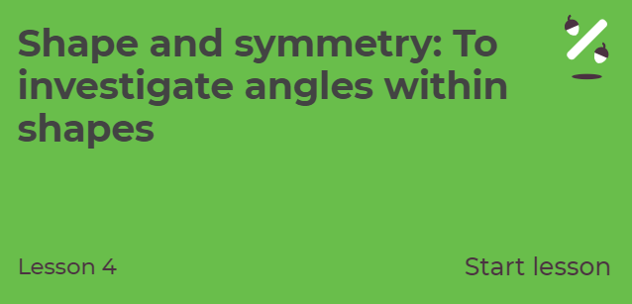  https://classroom.thenational.academy/lessons/shape-and-symmetry-to-investigate-angles-within-shapes  Year 5  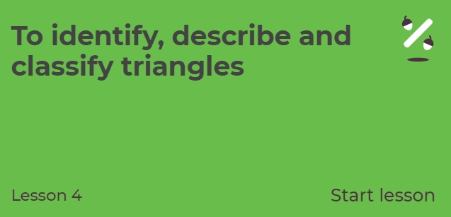  https://classroom.thenational.academy/lessons/to-identify-describe-and-classify-triangles | HISTORY/GEOG/PSHE/ART:  What is WRECKING and what does it have to do with Cornwall’s smuggling history?  Use these sites or research your own.  https://www.historic-uk.com/CultureUK/Smugglers-Wreckers/  http://www.smuggling.co.uk/gazetteer_sw.html  Activity: If you were a Wrecker, walking the beach looking for ‘booty’, what would you be excited to find?  EXAMPLE: A container, wrecked off the coast of Cornwall in 1997, was full of Lego which was still being washed up 10 years later. https://www.bbc.co.uk/news/magazine-28367198  What would your treasure look like? Maybe it would be a bucket-full of Lego. Draw what your ‘perfect booty’ would look like. |  | Choose 1 activity:  - Joe Wicks (The Body Coach TV) Workout  - iMovers  PLUS:  Go Noodle – GoNoodle for Families https://family.gonoodle.com/channels/zumba-kids
S  E  S  S  I  O  N  5 | ILLUSTRATING  Test your descriptive skills by using your writing to draw a picture of what you found at the end of the tunnel.  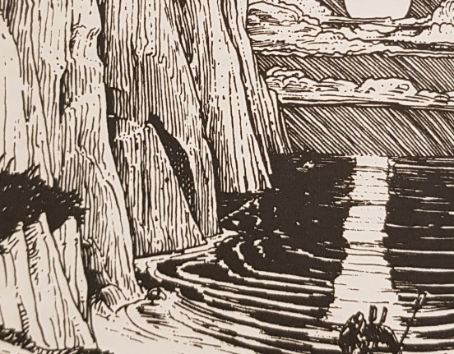  I would love to hear what you come up with, so please share your work. | FUN AND GAMES  ALL  Choose games from Topmarks to practise your skills learnt this week.  https://www.topmarks.co.uk/maths-games/7-11-years/shape-position-and-movement  Remind yourself of the angles you have learnt this week with this excellent song!  https://www.youtube.com/watch?v=NVuMULQjb3o  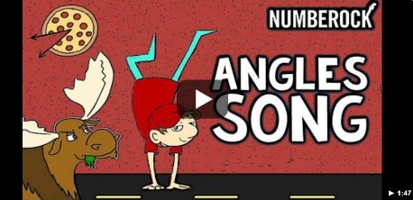  Don’t forget your times tables, have you mastered your targets? | DT: Food Preparation  Scurvy was a nasty disease which many pirates caught due to dark, damp and dirty living conditions and lack of Vitamin C. Thankfully, we don’t have to worry about catching Scurvy these days!  ACTIVITY: Make a plate of food fit for life at sea. One that is yummy but sure to keep the Scurvy away!  Suggestions: GROG: orange/apple/tomato juice or squash  GRUB: Chunks of cheese/apple/ orange/pineapple/grapes/peppers/ strawberries AND a tasty treat of course!  Or Use your Co-ordinate knowledge to play Pirate Battleships.  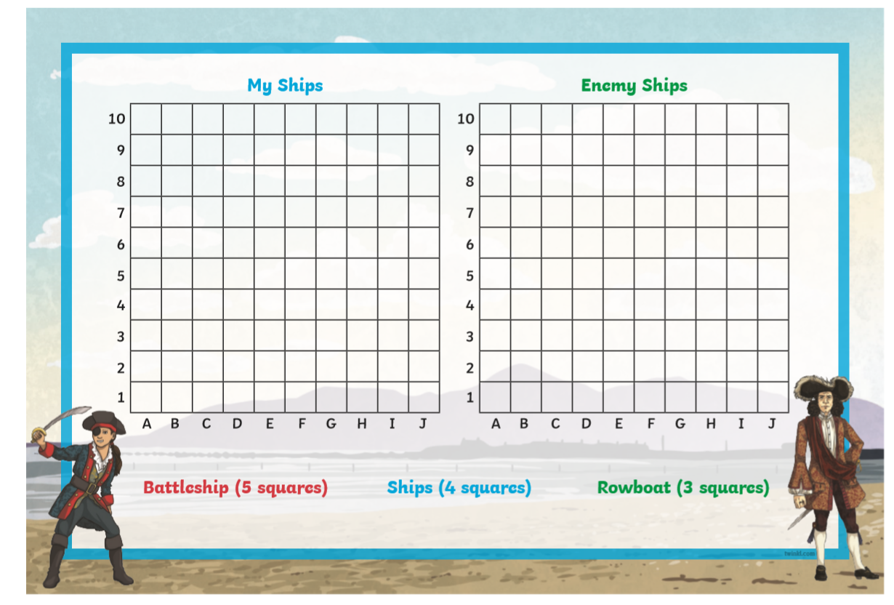  (Info attached to grid) | Choose 1 activity:  - Joe Wicks (The Body Coach TV) Workout  - iMovers  PLUS:  https://www.youthsporttrust.org/pe-home-learning  CHOOSE AN ACTIVITY AND DOWNLOAD A CHALLENGE CARD!

Scroll down below grid for resources

Comparison of texts

Similarities | Differences

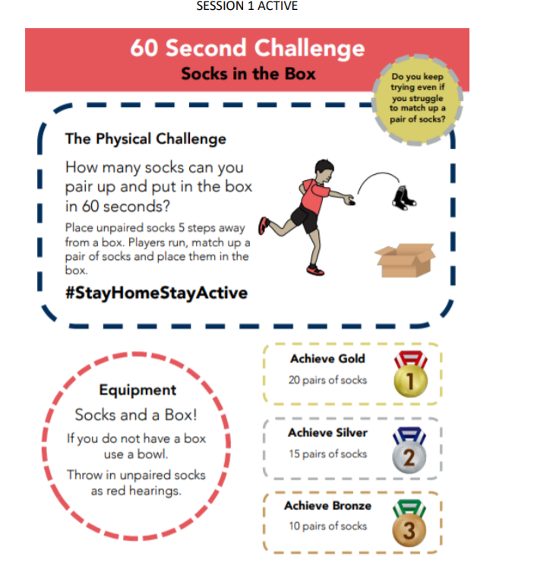

SESSION 5 ENQUIRY
