English | MATHS | ENQUIRY | Active
READING FOR INFORMATION  This week, you are going to create an information leaflet about mining. You will work on a new part each day and spend Friday finishing off. Your leaflet will have information about tin, the structure of mines, miners and the tools they used.  Today you are going to read for information to find out about mining. Watch the film:  https://www.nationaltrust.org.uk/features/what-is-the-tin-coast  READ the Tin Mining PowerPoint and take notes of information you think is useful for the front page to introduce your leaflet. Create an eye-catching front page with illustrations and relevant information. | https://wrm-13b48.kxcdn.com/wp-content/uploads/2020/06/Y6-Week-10-Alternative-Plan.pdf  Go to the above link and watch the video for Day 1 (The first quadrant)  Complete the worksheet attached to the blog for today. | HISTORY/SCIENCE:  Did you know that in the 1900s, half of the world’s tin came from Cornwall? Tin mining was an important industry in Cornwall up until the 1980s. Take a look at some Cornish tin mining facts: https://www.nationaltrust.org.uk/lists/ten-things-you-probably-didnt-know-about-cornish-mining  So what was it like inside a Tin Mine? https://www.youtube.com/watch?v=Tx9l0BPcrq8  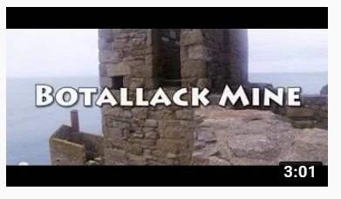  Would you have been a miner or a Bal Maiden? Have a go at drawing yourself back in the days of Cornish mining.  Use these links to help you:  Miner: https://www.youtube.com/watch?v=-47M6DDDE-I  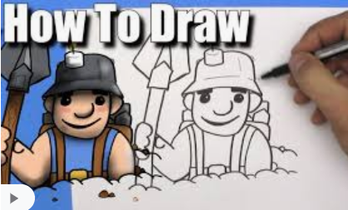  Bal Maiden: What does the word ‘Bal’ mean? http://www.balmaiden.co.uk/Balmaidens%20at%20Work.htm | 60 SECOND WEEKLY CHALLENGE – details attached to the blog.  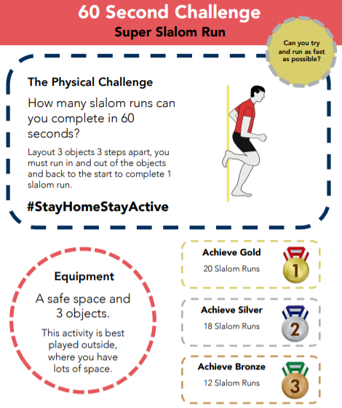
NOTE-TAKING/ WRITING  Today you are going to create the section about tin and why it was a valuable resource.  Like yesterday, use the PowerPoint and this link  https://classroom.ricksteves.com/videos/england-s-cornwall-and-its-former-tin-mining-industry  https://www.nationaltrust.org.uk/lists/ten-things-you-probably-didnt-know-about-cornish-mining  When you have enough information, write the next section for your leaflet.  Success Criteria:  - Include technical language  - Include only relevant information  - Include diagrams/pictures with labels (the label needs to explain what the picture shows)  - Use a variety of sentence types  - Check spellings | https://wrm-13b48.kxcdn.com/wp-content/uploads/2020/06/Y6-Week-10-Alternative-Plan.pdf  Go to the above link and watch the video for Day 2 (Four quadrants)  Complete the worksheet attached to the blog for today. | HISTORY/SCIENCE:  As we learned yesterday, many children were sent to work down a tin mine.  Have a go at ‘mining’ using a chocolate chip cookie by following the instructions attached to the blog.  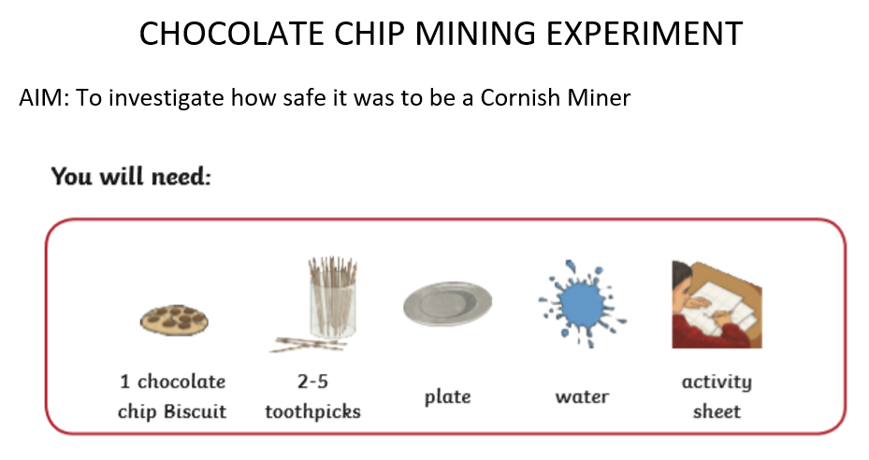  Find out about conditions for children in the tin mines. What jobs would they have done? Do you think it would be safe for you to go down a mine? | Choose 1 activity:  - Super Movers  - iMovers  PLUS:  Let’s Dance! https://www.youtube.com/playlist?list=PLJnn5H8Y_tYE3LdXoJIG_azMC2l5TjCON
NOTE-TAKING/ WRITING  Today you are going to create the section about mines and their structure.  Like yesterday, use the PowerPoint and this link: https://www.youtube.com/watch?v=Tx9l0BPcrq8  When you have enough information about the structure and what it is like inside a mine, write the next section for your leaflet.  Success Criteria  - Include technical language  - Include only relevant information  - Include diagrams/pictures with labels  - Use a variety of sentence types  - Check spellings | https://wrm-13b48.kxcdn.com/wp-content/uploads/2020/06/Y6-Week-10-Alternative-Plan.pdf  Go to the above link and watch the video for Day 3 (Translations)  Complete the worksheet attached to the blog for today. | HISTORY/ART China Clay is another material that Cornwall is famous for.  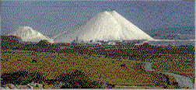  China Clay is another material that Cornwall is famous for. These are known as the Cornish Alps and sometimes the White Pyramids – find out where in Cornwall they are and why they have these nicknames! Let’s learn about them:  https://www.youtube.com/watch?v=wHXAHqnPKUg  Read some facts about China Clay. Why do you think the clay is called ‘China’ when its mined in Cornwall? https://www.cornwall-calling.co.uk/mines/clay/clay-mining.htm#:~:text=The%20china%20clay%20deposits%20in,at%20least%20another%20hundred%20years.  Draw the everyday items that are made from china clay. Are you surprised y any of them?  CHALLENGE: Can you find the answer to these questions?  Who first discovered China Clay or ‘Kaolin’ as it is often referred to?  What famous Cornish attraction is built on a disused China Clay site? | Try some activities from  #ThisIsPE  https://www.youtube.com/playlist?list=PLYGRaluWWTojV3An2WEgsQ4qGFy_91jDL  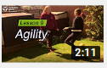  You can choose from lots of different skills. How fast are you at Fast Feet?
NOTE-TAKING/ WRITING  Today you are going to create the section about miners.  Like yesterday, use the PowerPoint and this clip to see what life was like for a child miner. Although it is coal mining and not tin (which Cornwall is most famous for), conditions were the same. https://www.bbc.co.uk/bitesize/clips/z73b4wx  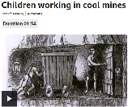  When you have enough information about miners and the tools they used, write the next section for your leaflet.  Success Criteria  - Include technical language  - Include only relevant information  - Include diagrams/pictures with labels  - Use a variety of sentence types  - Check spellings | https://wrm-13b48.kxcdn.com/wp-content/uploads/2020/06/Y6-Week-10-Alternative-Plan.pdf  Go to the above link and watch the video for Day 4 (Reflections)  Complete the worksheet attached to the blog for today. | ART/DT/ACTIVE: -  Using the instructions attached to the blog, can you make your own china clay cargo ship?  I’d love to see a picture of your finished ship. | Choose 1 activity:  - Joe Wicks (The Body Coach TV) Workout  - iMovers  PLUS:  Go Noodle – GoNoodle for Families https://family.gonoodle.com/channels/zumba-kids
FINISHING OFF, EDITING AND ILLUSTRATING  Finish off your leaflet with any missing information. When you have finished, have a go at editing.  Follow these four steps:  - Choose one sentence to improve.  - Improve the sentence by changing it into a different sentence type.  - Consider your adjectives, adverbs and verbs. Have you got interesting adjectives, strong verbs and said how these verbs are done?  - Check all the spellings and punctuation.  Now finish off any illustrations and labels/captions. Share your finished leaflet with others in your house and if you can, email me a copy please | Complete the arithmetic questions that are attached to the blog.  You do not have to time yourself – you can work through them at your own pace.  If you do want to time yourself then allow yourself 30 minutes to complete all the questions.  Use the answers to check it when you’ve finished. | MUSIC/DANCE:  What type of music do you like to listen to? Play your favourite tune and have a little dance! What music do you think Cornish miners’ children listened to?  Watch this clip from Wheal Martyn and see if you can think why the dance is called a ‘Snail’ Creep? https://www.youtube.com/watch?v=CCWWaVh_oO4  We are going to make an old-fashioned musical instrument and learn the traditional Cornish dance known as the Snail Creep. Choose to make either a maraca, rain stick, tambourine or drum and follow the instructions: https://www.youtube.com/watch?v=7sUNXA4NYKI  Then watch the Rescorla Snail Creep and practise the dance. https://www.youtube.com/watch?v=CCWWaVh_oO4  The Dance  One person leads and then the others follow in the same footsteps. The leader then moves in and out in a circular movement (like the shell of a snail) taking care not to bump into the others. March/dance to the beat of your instrument(s) | Choose 1 activity:  - Joe Wicks (The Body Coach TV) Workout  - iMovers  PLUS:  https://www.youthsporttrust.org/pe-home-learning  CHOOSE AN ACTIVITY AND DOWNLOAD A CHALLENGE CARD!

