CHOCOLATE CHIP MINING EXPERIMENT
AIM: To investigate how safe it was to be a Cornish Miner
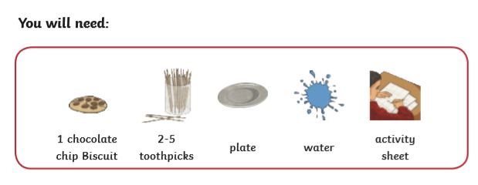
- Wash your hands.
- Next, place your biscuit on a plate.
- Then, draw your biscuit as it is before you begin your experiment. Count how many pieces of tin (chocolate chips) you have. The biscuit represents the dirt and bedrock below the ground and the choclate chips are the tin deposits that miners used to collect.
Biscuit before it had been mined  Tin (chocolate chips) amount in your biscuit : | Biscuit after it had been mined  Tin (chocolate chips) left on your biscuit now:

- After you have drawn your biscuit and counted the chocolate chips, use your toothpicks (spades) to remove (pick out) as many chips as you can in 3 minutes. Put them aside.
- Now draw your biscuit as it looks now (it may be broken) and count how many chips are left in the biscuit.
- Complete the questions below to analyse your findings
Questions:
- Could your biscuit return to its original state after it had been mined?
- Do you think it is stronger or weaker now?
- Your biscuit represented a mine, looking at your biscuit now, do you think mining was a safe or a dangerous job to do?
- Using your experiment to support your answer, explain why:

