 | ENGLISH | MATHS | ENQUIRY | ACTIVE
S  E  S  S  I  O  N  1 | COMPREHENSION  Read ‘History of Seaside Holidays’ (Year 1 or Year 2) attached to the blog and answer the questions underneath.  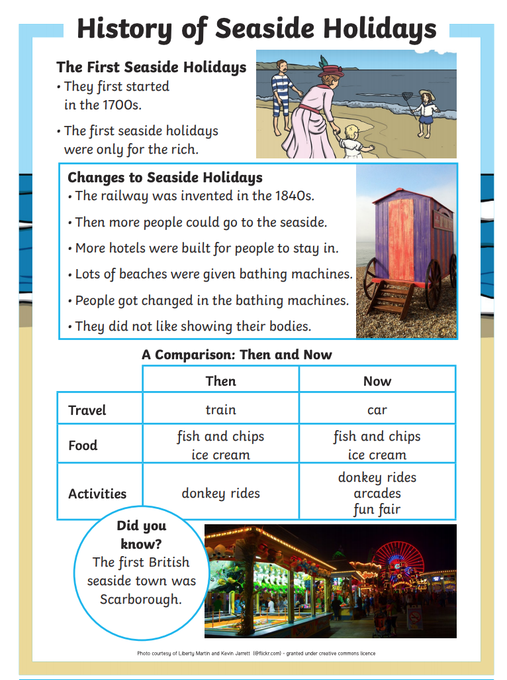 | Today, you will be comparing mass. Use the words ‘heavier’ and ‘lighter’.  First, pick two objects from your house. Hold one in each hand. Pretend you are human scales and hold the heavier item low and the lighter item high.  Record your results in a table and use the greater than, less than or equal to symbol to compare them (attached below or you could draw your own.)  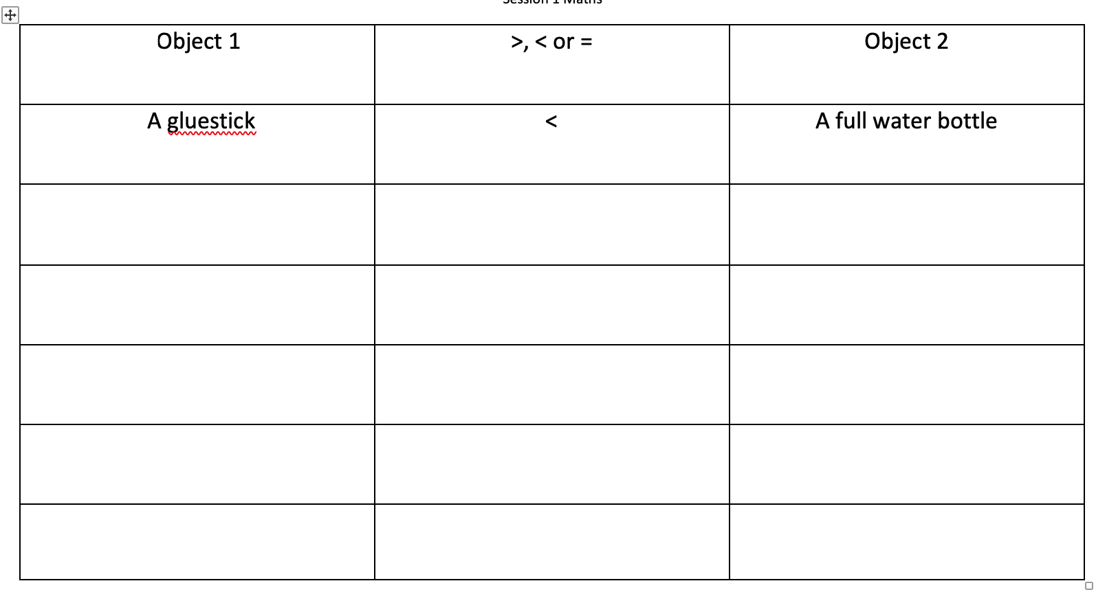 | HISTORY  Mining began in Cornwall in the Bronze age but by the 1900s, it was a huge industry with half of the world’s tin coming from Cornwall!  Let’s find out a bit more about what life was like. Between 1837-1901 was known as the Victorian Era.  Look through the powerpoint about Victorian toys (attached to the blog).  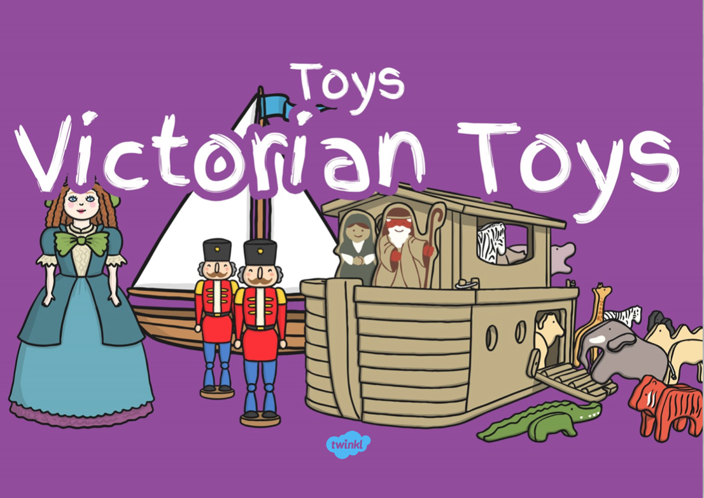 | Now that the Virtual School Games is complete – we are back to our normal Active grid.  60 SECOND WEEKLY CHALLENGE  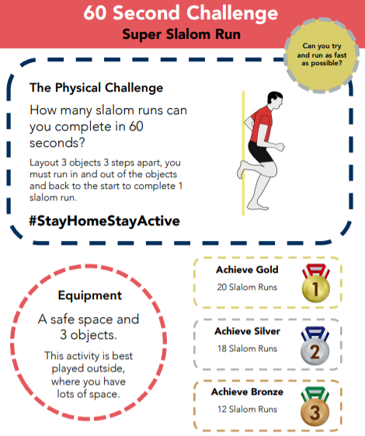
S  E  S  S  I  O  N  2 | SPaG  Watch this clip to recap when we use an exclamation mark:  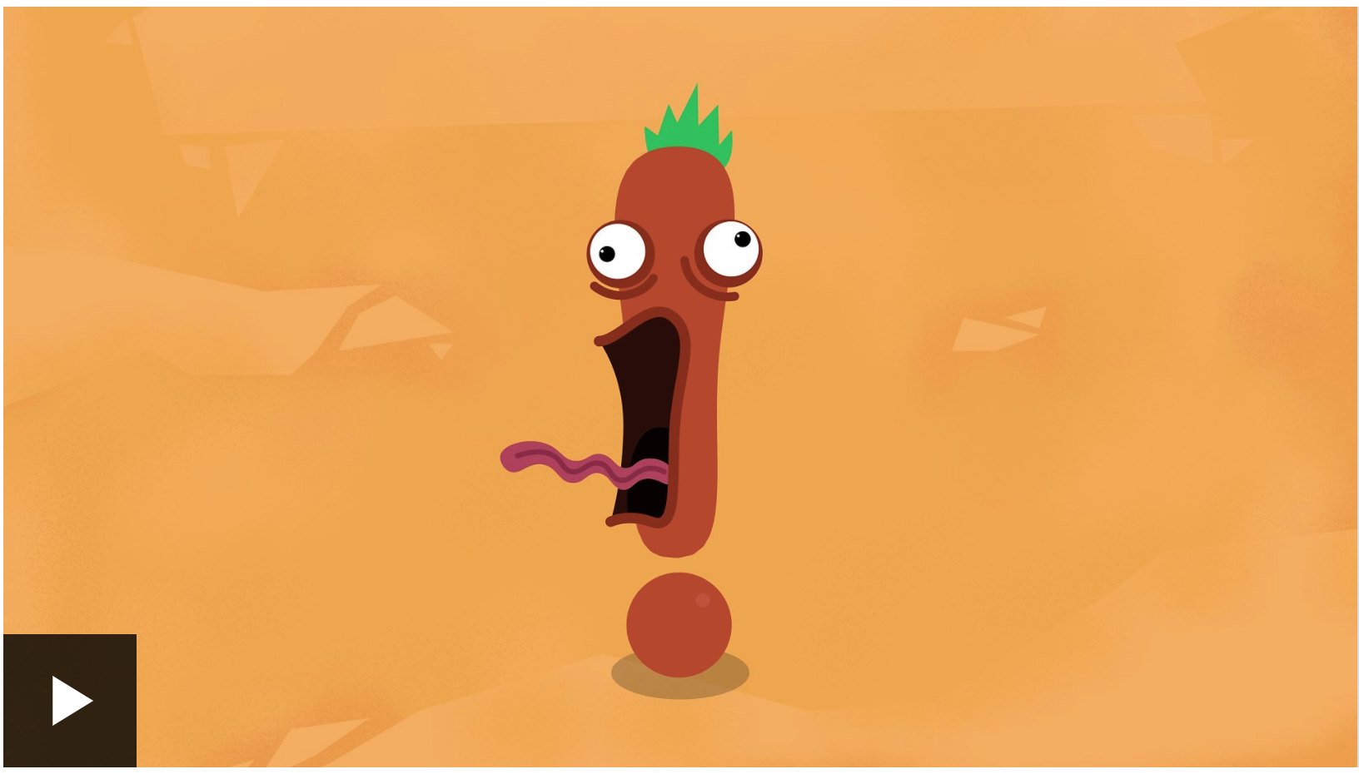https://www.bbc.co.uk/bitesize/topics/z8x6cj6/articles/z3dcmsg  Then answer the questions underneath.  Now, watch this clip to recap when to use a question mark:  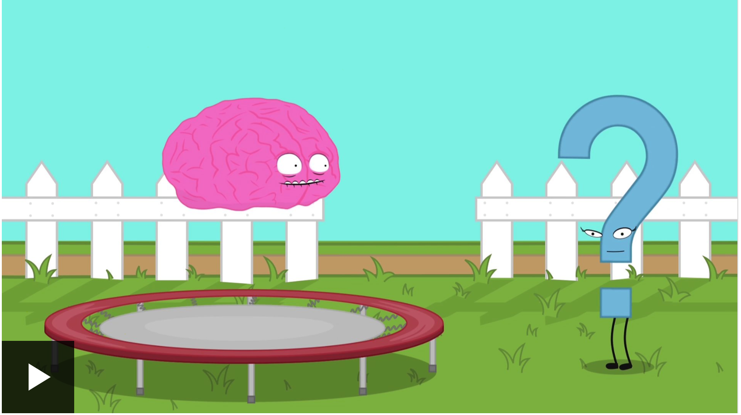  https://www.bbc.co.uk/bitesize/topics/z8x6cj6/articles/zcm3qhv  Now write a sentence with a question mark and one with an exclamation mark. | Use real scales, kitchen scales and real items or look at the pictures below. How much does each item weigh in grams?  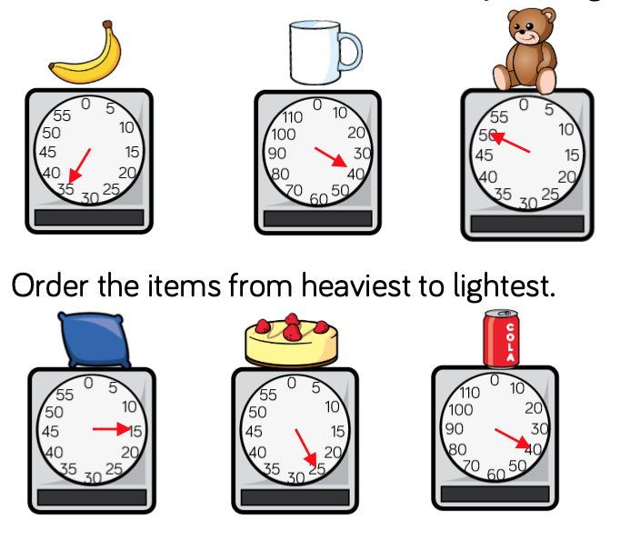  Put your items in order from lightest to heaviest. | ART/DT  Yesterday you learned all about Victorian toys. Today you are going to have a go at making your own!  https://thekidshouldseethis.com/post/17490881335  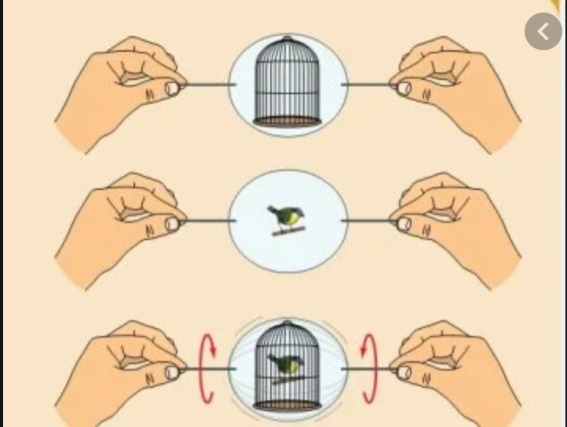 | Choose 1 activity:  - Super Movers  - iMovers  PLUS:  Let’s Dance! https://www.youtube.com/playlist?list=PLJnn5H8Y_tYE3LdXoJIG_azMC2l5TjCON
S  E  S  S  I  O  N  3 | DESCRIPTIVE WRITING  Imagine you could visit a beach from the Victorian times. What would you see, hear and smell? How would it be different from today?  Write a post card from your trip to the seaside.  Success Criteria:  . Full, punctuated sentences,  . Adjectives,  . Commas to separate a list  Challenge:  . An exclamation mark and question mark. | Have a go at the maths mastery cards below.  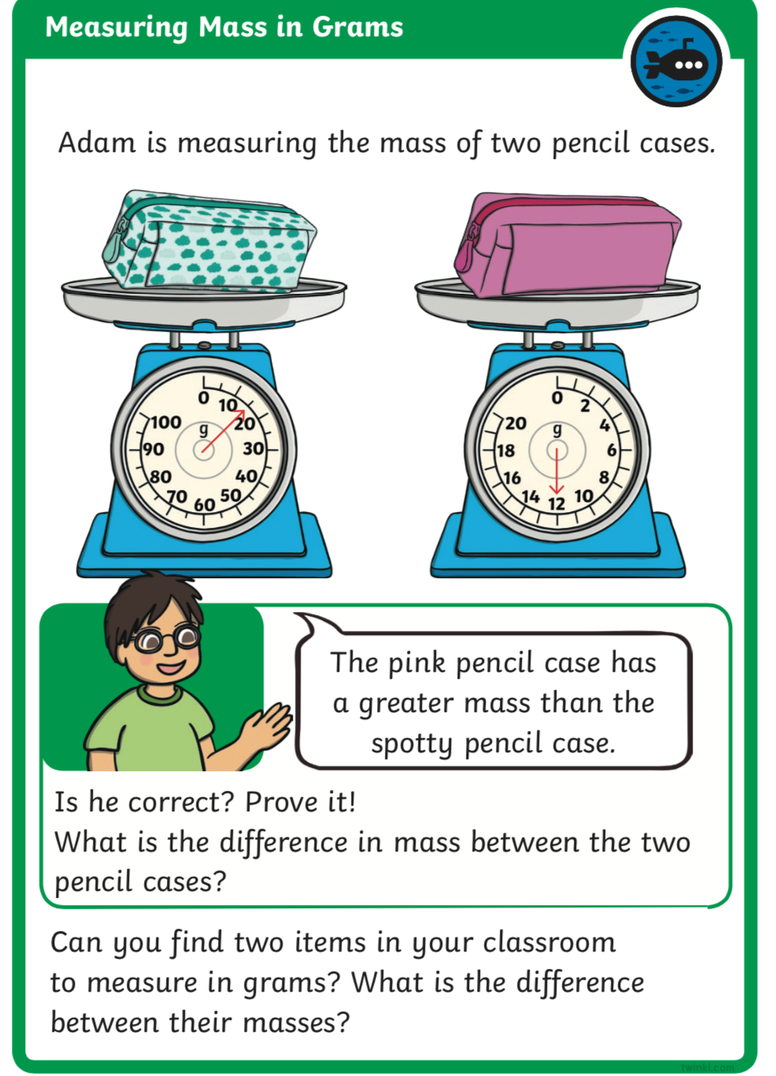  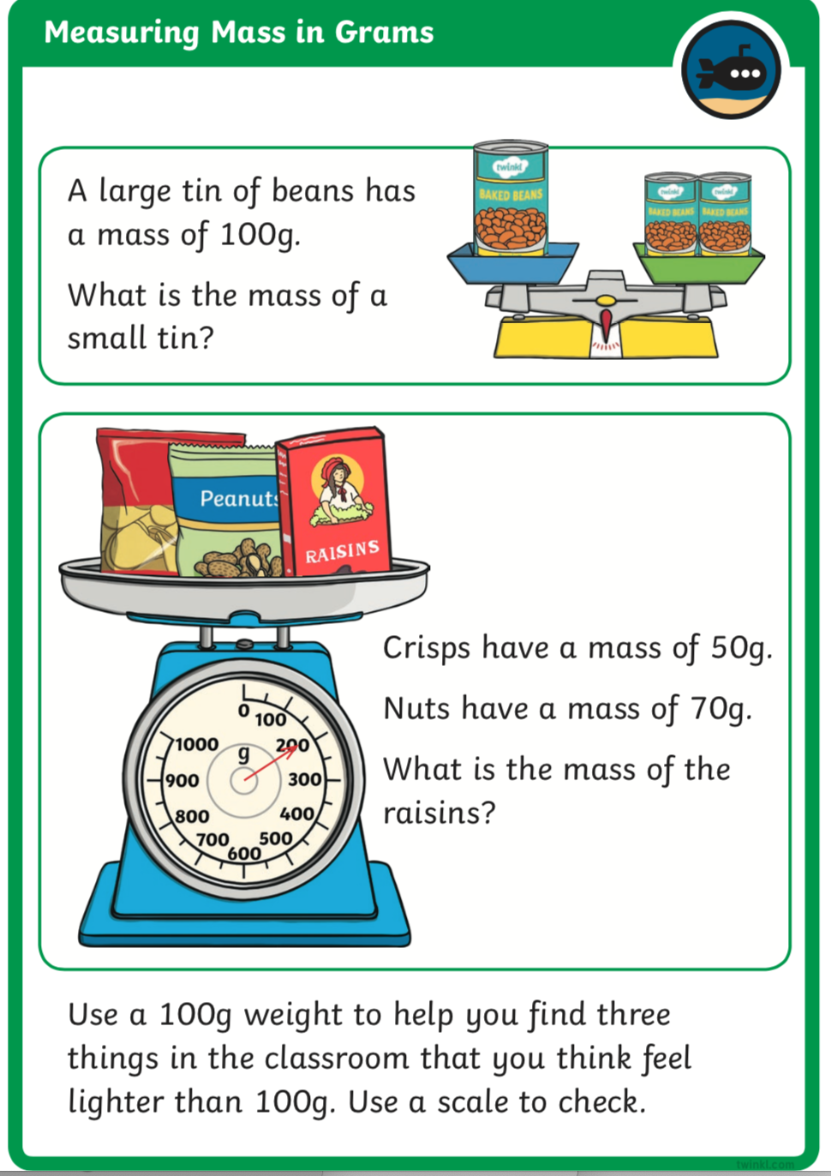 | HISTORY/SCIENCE:  Tin Mining in Cornwall Tin mining was an important industry in Cornwall up until the 1980s. Take a look at some Cornish tin mining facts: https://www.nationaltrust.org.uk/lists/ten-things-you-probably-didnt-know-about-cornish-mining  Look through the PowerPoint attached to the blog.  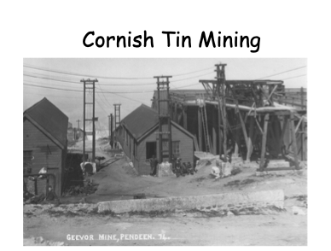  ACTIVITY: Label the miner (attached to the blog) | Try some activities from  #ThisIsPE  https://www.youtube.com/playlist?list=PLYGRaluWWTojV3An2WEgsQ4qGFy_91jDL  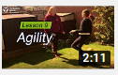  You can choose from lots of different skills. How fast are you at Fast Feet?
S  E  S  S  I  O  N  4 | SPaG  Watch this video about the past, present and future tense.  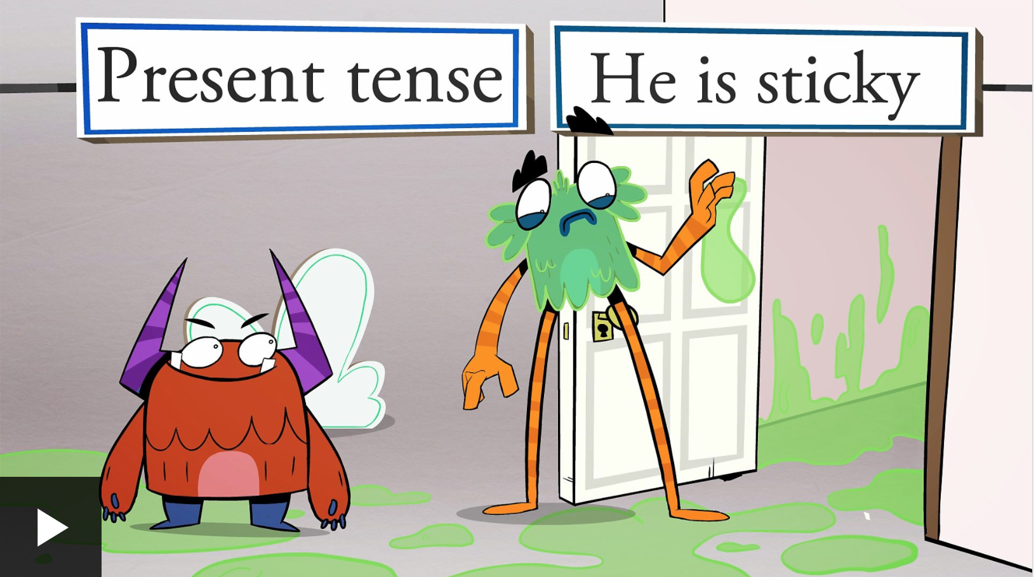  https://www.bbc.co.uk/bitesize/topics/zrqqtfr/articles/z3dbg82  Write a sentence in the present tense then write it in the past and future. | Which is heavier: one gram or one kilogram?  Watch this video all about grams and kilograms:  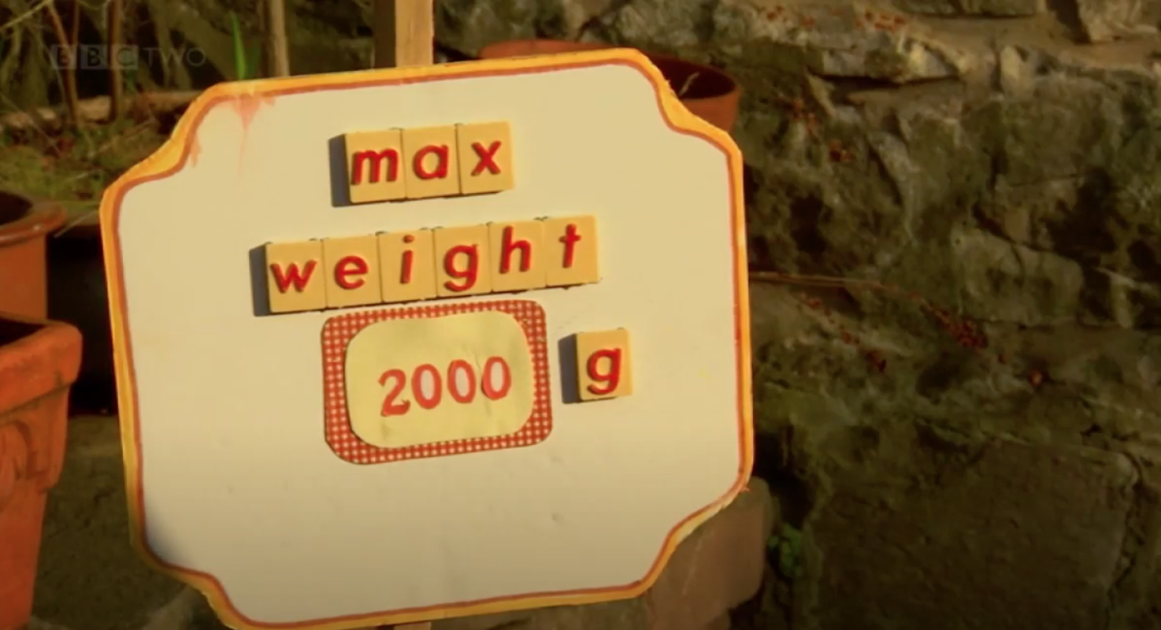  https://www.youtube.com/watch?v=M3BPlLt7OQ4  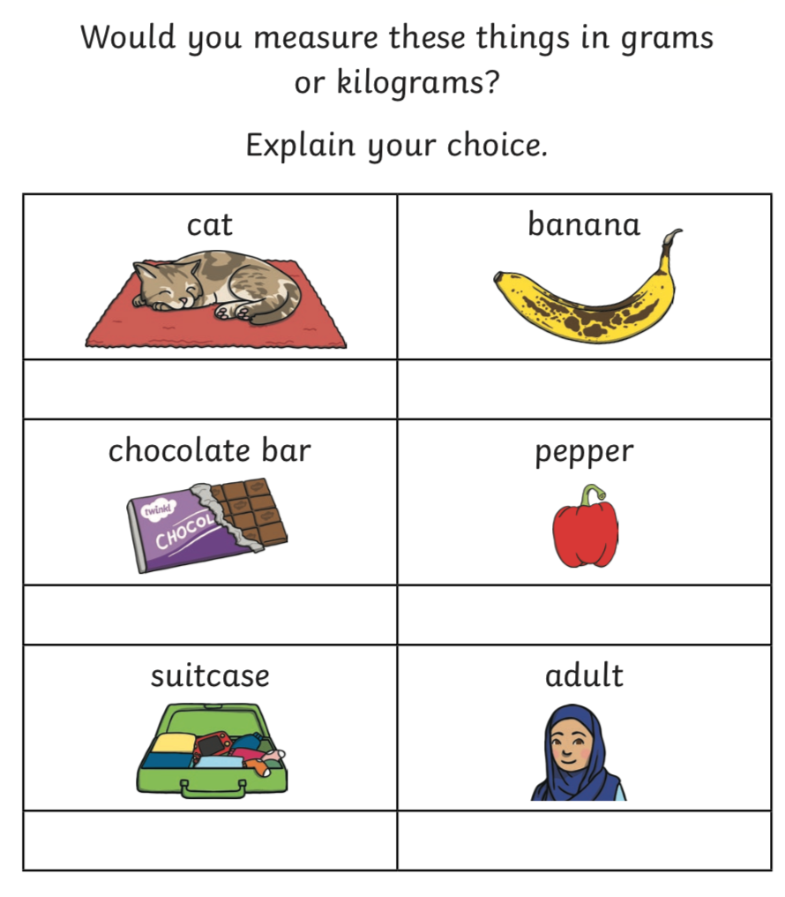  Find 5 things in your house that you would weigh in grams and 5 things that you would weigh in kilograms. | HISTORY/SCIENCE:  As we learnt from yesterday, many children were used to working down a mine tin. Do you think it would be safe for you to go down a mine?  ACTIVITY: LET’S DO A QUICK SCIENCE EXPERIMENT!  Have a go at ‘mining’ using a yummy chocolate chip cookie! Then, use the results and the questions on the sheet to think about the question in red.  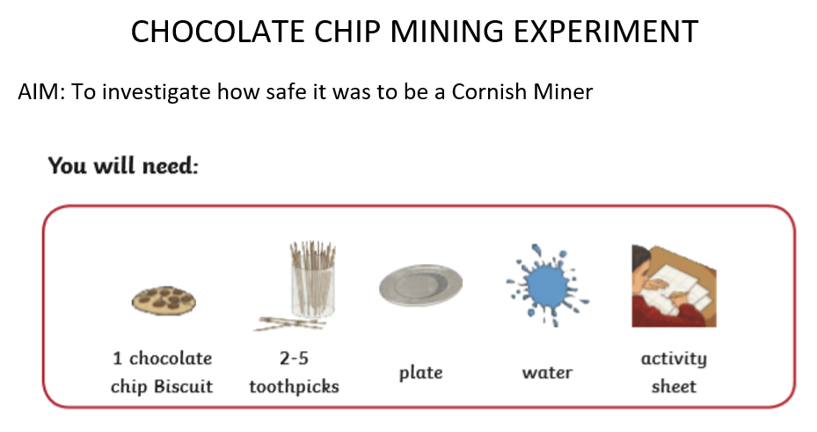 | Choose 1 activity:  - Joe Wicks (The Body Coach TV) Workout  - iMovers  PLUS:  Go Noodle – GoNoodle for Families https://family.gonoodle.com/channels/zumba-kids
S  E  S  S  I  O  N  5 | WRITING TASK  Imagine you were exploring the tin mine and found a diamond!  Write a diary entry of what you experienced. Use your senses to describe what you saw, heard, felt and smelled.  Success Criteria:  - Full, punctuated sentences  - First Person  - Past tense  - Time connectives (first, then, next)  You could choose one of the templates attached to the blog or make your own old looking paper!  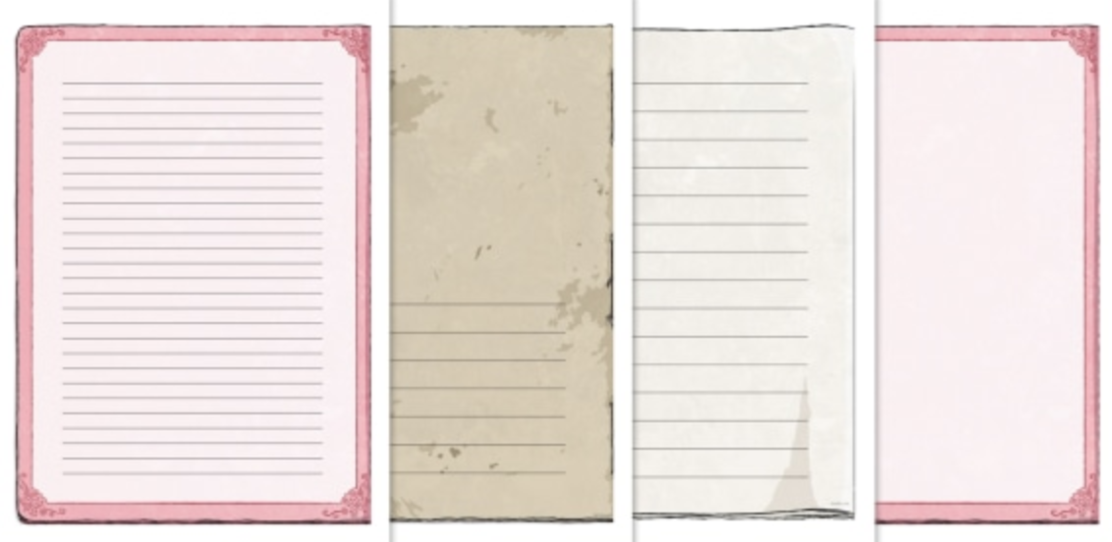 | Today is all about temperature.  What do you already know about temperature? How do we measure temperature in the UK?  Watch this video all about temperature:  https://www.bbc.co.uk/teach/skillswise/temperature/zh4ghbk  Have a look at the weather this week:  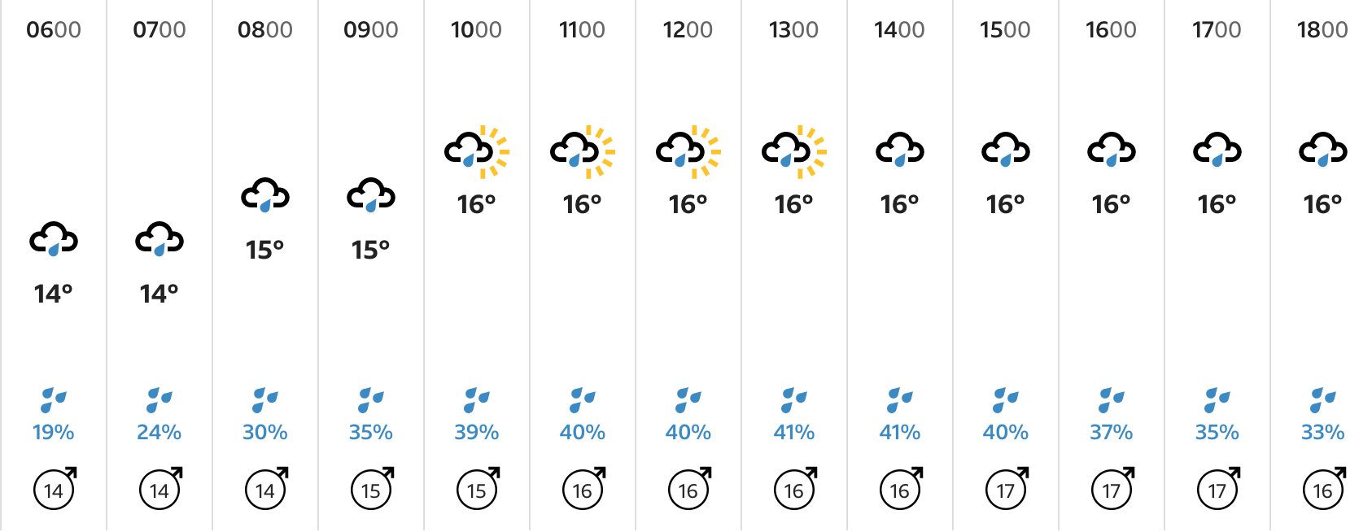  https://www.bbc.co.uk/weather/3345093  What do you notice? What is the temperature now? Which is the warmest day? Which is the coldest day?  Challenge: How many answers can you find to this question:  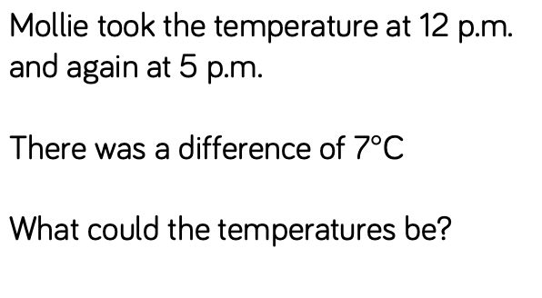 | MUSIC/DANCE: What type of music do you like to listen to? play your favourite tune and have a little dance! What music do you think Cornish miners’ children listened to?  Watch this clip from Wheal Martyn and see if you can think why the dance is called a ‘Snail’ Creep? https://www.youtube.com/watch?v=CCWWaVh_oO4  ACTIVITY: We are going to make an old-fashioned musical instrument and learn the traditional Cornish dance known as the Snail Creep. Choose to make either a maraca, rain stick, tambourine or drum and follow the instructions: https://www.youtube.com/watch?v=7sUNXA4NYKI  Then watch the Rescorla Snail Creep again so find out how to practise the dance.: https://www.youtube.com/watch?v=CCWWaVh_oO4  The Dance (it’s a bit like FOLLOW THE LEADER) One person leads and then the others follow in the same footsteps. The leader then moves in and out in a circular movement (like the shell of a snail) taking care not to bump into the others. March/dance to the beat of your instrument(s) A CORNISH CREAM TEA IS THE TRADITIONAL FOOD SO MAYBE HAVE A TRADITIONAL CORNISH AFTERNOON IN THE GARDEN OR OUT ON YOUR DAILY WALK! | Choose 1 activity:  - Joe Wicks (The Body Coach TV) Workout  - iMovers  PLUS:  https://www.youthsporttrust.org/pe-home-learning  CHOOSE AN ACTIVITY AND DOWNLOAD A CHALLENGE CARD!
SESSION 1 ACTIVE – 60 SECOND CHALLENGE

Session 1 Maths
Object 1 | >, < or = | Object 2
A gluestick | < | A full water bottle

