29.6 | ENGLISH | MATHS | ENQUIRY |  | ACTIVE
S  E  S  S  I  O  N  1 | READING FOR INFORMATION  This week, you are going to create an information leaflet about mining. You will work on a new part each day and spend Friday finishing off. Your leaflet will have information about tin, the structure of mines, miners and the tools they used.  Today you are going to read for information to find out about mining. Watch the film:  https://www.nationaltrust.org.uk/features/what-is-the-tin-coast  READ the Tin Mining PowerPoint and take notes of information you think is useful for the front page to introduce your leaflet. Create an eye-catching front page with illustrations and relevant information. | This week, you are going to use White Rose again. The worksheets are attached below the blog for you to print or work from on-screen.  Y4 SUBTRACTION  Subtract two 4-digit numbers - no exchange  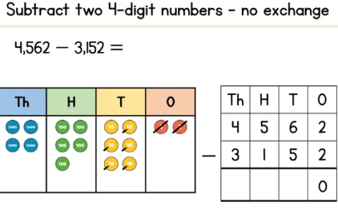  https://vimeo.com/427996624  Year 5  Practise your skills from last week  Multi-step addition and subtraction problems  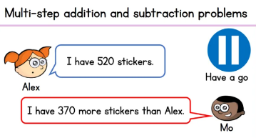  https://vimeo.com/428001969 | HISTORY/SCIENCE: Tin Mining in Cornwall Did you know that in the 1900s, half of the world’s tin came from Cornwall? Tin mining was an important industry in Cornwall up until the 1980s. Take a look at some Cornish tin mining facts: https://www.nationaltrust.org.uk/lists/ten-things-you-probably-didnt-know-about-cornish-mining So what was it like inside a Tin Mine? https://www.youtube.com/watch?v=Tx9l0BPcrq8  ACTIVITY: Would you have been a miner or a Bal Maiden? Have a go at drawing yourself back in the days of Cornish mining:  Miner: https://www.youtube.com/watch?v=-47M6DDDE-I  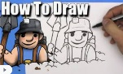  Bal Maiden: (What does the word ‘Bal’ mean? http://www.balmaiden.co.uk/Balmaidens%20at%20Work.htm (images only I’m afraid) |  | Now that the Virtual School Games are complete – we are back to our normal Active grid.  60 SECOND WEEKLY CHALLENGE  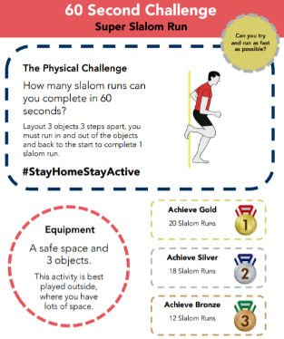
S  E  S  S  I  O  N  2 | NOTE-TAKING/ WRITING  Today you are going to create the section about tin and why it was a valuable resource.  Like yesterday, use the PowerPoint and this link  https://classroom.ricksteves.com/videos/england-s-cornwall-and-its-former-tin-mining-industry  https://www.nationaltrust.org.uk/lists/ten-things-you-probably-didnt-know-about-cornish-mining  When you have enough information, write the next section for your leaflet.  Success Criteria  Include technical language  Include only relevant information  Include diagrams/pictures with labels (the label needs to explain what the picture shows)  Use a variety of sentence types  Check spellings | Year 4  Subtract two 4-digit numbers - one exchange  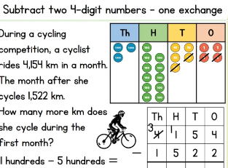  https://vimeo.com/428000196  Year 5  FOR the rest of the week, you are going to re-cap on line graphs.  Read and interpret line graphs  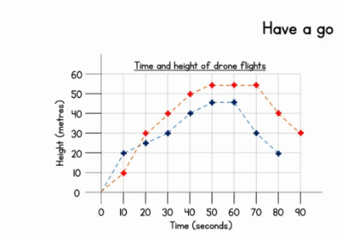  https://vimeo.com/428002041 | HISTORY/SCIENCE:  As we learnt from yesterday, many children were used to working down a tin mine. Do you think it would be safe for you to go down a mine?  ACTIVITY: LET’S DO A QUICK SCIENCE EXPERIMENT!  Have a go at ‘mining’ using a yummy chocolate chip cookie! Then, use the results and the questions on the sheet to think about the question in red.  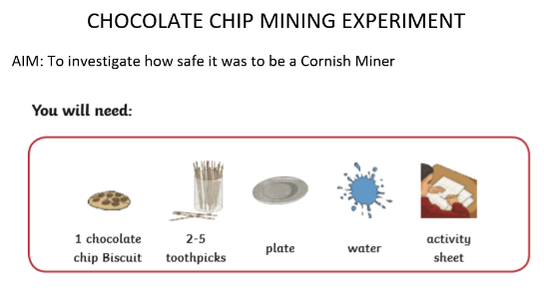 |  | Choose 1 activity:  - Super Movers  - iMovers  PLUS:  Let’s Dance! https://www.youtube.com/playlist?list=PLJnn5H8Y_tYE3LdXoJIG_azMC2l5TjCON
S  E  S  S  I  O  N  3 | NOTE-TAKING/ WRITING  Today you are going to create the section about mines and their structure.  Like yesterday, use the PowerPoint and this link  https://www.youtube.com/watch?v=Tx9l0BPcrq8  When you have enough information about the structure and what it is like inside a mine, write the next section for your leaflet.  Success Criteria  Include technical language  Include only relevant information  Include diagrams/pictures with labels  Use a variety of sentence types  Check spellings | Year 4  Subtract two 4-digit numbers - more than one exchange  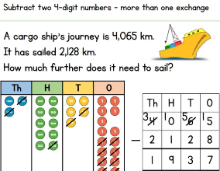  https://vimeo.com/428000367  Year 5  Draw line graphs  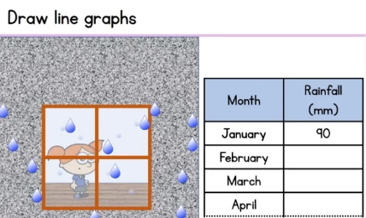  https://vimeo.com/428002106 | HISTORY/ART  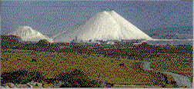  China Clay is another material that Cornwall is famous for. These are known as the Cornish Alps and sometimes the White Pyramids – find out where in Cornwall they are and why they have these nicknames! Let’s learn about them: https://www.youtube.com/watch?v=wHXAHqnPKUg  Read some facts about China Clay. Why do you think the clay is called ‘China’ when its mined in Cornwall? https://www.cornwall-calling.co.uk/mines/clay/clay-mining.htm#:~:text=The%20china%20clay%20deposits%20in,at%20least%20another%20hundred%20years.  ACTIVITY: USING THE GRID BELOW, DRAW ALL OF THE EVERYDAY THINGS THAT ARE MADE FROM CHINA CLAY – YOU WILL BE SURPRISED!  CHALLENGE: Who first discovered China Clay or ‘Kaolin’ as it is often referred to? What famous Cornish attraction is built on a disused China Clay site? https://www.cornwalls.co.uk/history/people/william_cookworthy.htm |  | Try some activities from  #ThisIsPE  https://www.youtube.com/playlist?list=PLYGRaluWWTojV3An2WEgsQ4qGFy_91jDL  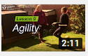  You can choose from lots of different skills. How fast are you at Fast Feet?
S  E  S  S  I  O  N  4 | NOTE-TAKING/ WRITING  Today you are going to create the section about miners.  Like yesterday, use the PowerPoint and this clip to see what life was like for a child miner. Although it is coal mining and not tin (what Cornwall is most famous for), conditions were the same. https://www.bbc.co.uk/bitesize/clips/z73b4wx  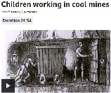  When you have enough information about miners and the tools they used, write the next section for your leaflet.  Success Criteria  Include technical language  Include only relevant information  Include diagrams/pictures with labels  Use a variety of sentence types  Check spellings | Year 4  Efficient Subtraction  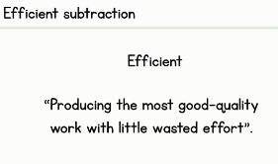  https://vimeo.com/428003455  Year 5  Use line graphs to solve problems  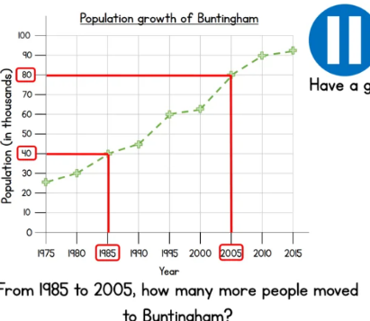  https://vimeo.com/428002182 | ART/DT/ACTIVE: -  Make a China Clay Cargo Ship  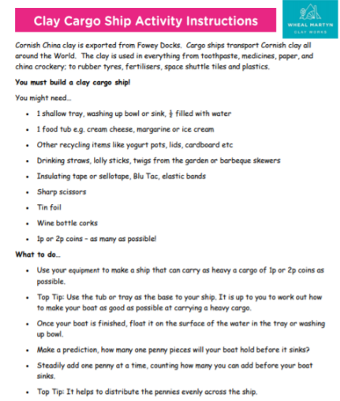  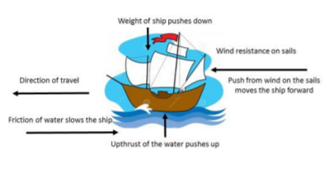  (attached to the blog) |  | Choose 1 activity:  - Joe Wicks (The Body Coach TV) Workout  - iMovers  PLUS:  Go Noodle – GoNoodle for Families https://family.gonoodle.com/channels/zumba-kids
S  E  S  S  I  O  N  5 | FINISHING OFF, EDITING AND ILLUSTRATING  Finish off your leaflet with any missing information. When you have finished, have a go at editing.  Follow these four steps:  - Choose one sentence to improve.  - Improve the sentence by changing it into a different sentence type.  - Consider your adjectives, adverbs and verbs. Have you got interesting adjectives, strong verbs and said how these verbs are done?  - Check all the spellings and punctuation.  Now finish off any illustrations and labels/captions. Share your finished leaflet with others in your house and if you can, email me a copy please | FUN AND GAMES  Year 4  Choose games from Topmarks to practise your skills learnt this week.  https://www.topmarks.co.uk/maths-games/7-11-years/addition-and-subtraction  Year 5  Test your skills with this interactive game  https://uk.ixl.com/math/year-5/interpret-line-graphs  Don’t forget your times tables, have you mastered your targets?  Scroll down below grid for resources | MUSIC/DANCE: What music do you think Cornish miners’ children listened to?  Watch this clip from Wheal Martyn and see if you can think why the dance is called a ‘Snail’ Creep? https://www.youtube.com/watch?v=CCWWaVh_oO4  ACTIVITY: We are going to make an old-fashioned musical instrument and learn the traditional Cornish dance known as the Snail Creep. Choose to make either a maraca, rain stick, tambourine or drum and follow the instructions: https://www.youtube.com/watch?v=7sUNXA4NYKI  Then watch the Rescorla Snail Creep again so find out how to practise the dance.: https://www.youtube.com/watch?v=CCWWaVh_oO4  The Dance One person leads and then the others follow in the same footsteps. The leader moves in and out in a circular movement (like the shell of a snail) taking care not to bump into the others to the beat of your instrument. | Choose 1 activity:  - Joe Wicks (The Body Coach TV) Workout  - iMovers  PLUS:  https://www.youthsporttrust.org/pe-home-learning  CHOOSE AN ACTIVITY AND DOWNLOAD A CHALLENGE CARD!

Scroll down below grid for resources

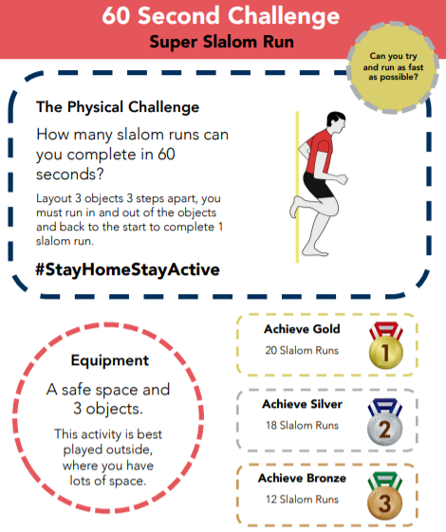

SESSION 3 ENQUIRY – CHINA CLAY OBJECTS

WHAT OBJECTS HAVE YOU USED WHICH ARE MADE FROM CHINA CLAY?

