Here is the vocabulary you will need for today’s lesson. A property of a shape is a description of how it is made. Take a look at the properties of a rectangle.
The words: straight/sides/long/short and corners have been used. REMEMBER a corner is where two straight lines meet! Also, you need to give as much information as possible when describing a shape and its properties. If you just tell somebody “A rectangle has 4 sides” then they won’t know that all sides are straight and that two sides are longer than the other AND they may confuse it with a square.
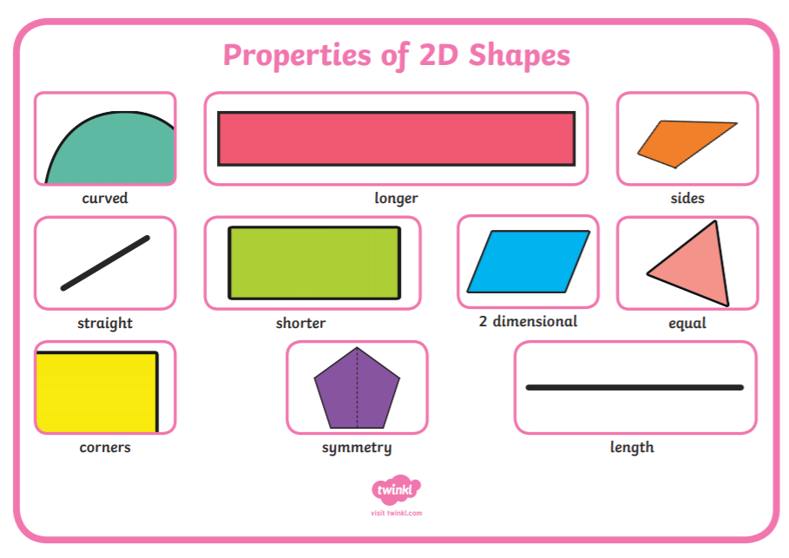
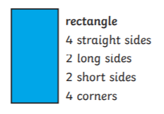
ACTIVITY: Using the vocabulary above, write properties for these shapes – think about using ‘equal length’ for some of them!
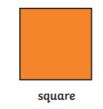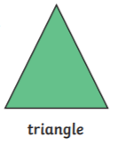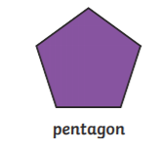

IF YOU CAN’T REMEMBER HOW TO WORK OUT THE LINES OF SYMMETRY – DON’T WORRY – WE WILL DO A SESSION ON IT THIS WEEK!

