Killigarth Class - Home Learning Weekly Planner
Summer Term Enquiry – Where and what in the world is Cornwall? Week beginning: 22nd June 2020

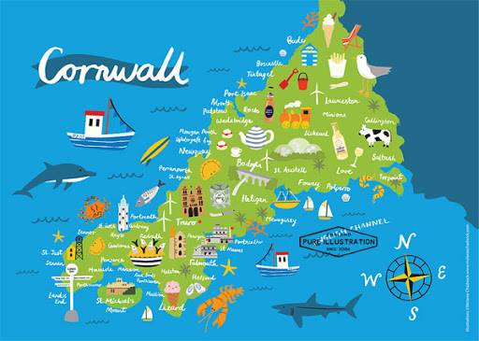
See page 2 & 3 for maths & phonics and spelling learning for this week

Personal, Social and Emotional Development | Communication and Language |  |  |  | Physical Development
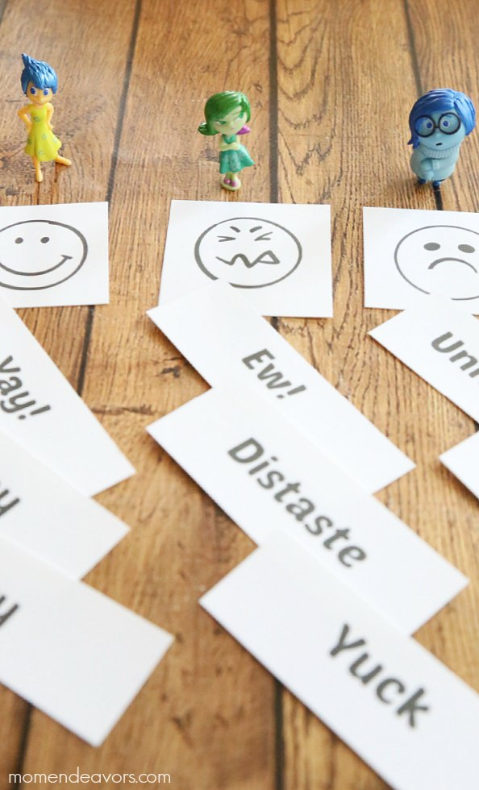  Print out these cards or write them out and draw the faces. Then you can sit down with the kids for a fun sorting activity. Have all the cards out, face down & have each child pick one card at a time and decide which emotion it goes with. It opens up the opportunity for lots of discussion about emotions and then things that they associate with each emotion. It’s such a simple & fun way to open up some dialogue.  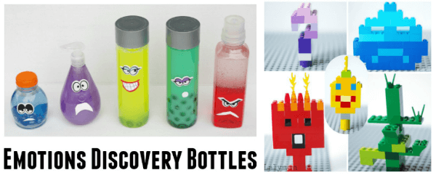  You could also have a look at making some emotions bottles or Lego creatures to go with each word choosing the colours carefully relate to each emotion. | Ahoy Jim Lad!  Follow this link to find out your Pirate name!  https://mamateaches.com/find-your-pirate-name-for-talk-like-a-pirate-day-pirate-name-list/  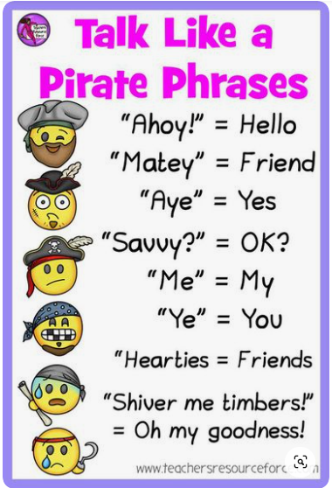  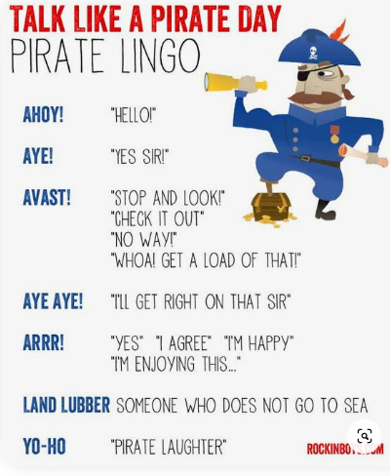  Can you have a go at putting some of these pirate phrases together to make a sentence and record yourself saying it?  We’d love to see it in school if you email it to us. |  |  |  | Make a hull of a pirate ship. Can you name it? Try to learn the different parts then go outside and draw or outline a large pirate on the floor. Can you remember and write down the 4 parts of the pirate ship? Have a go at practising these actions too… Scrub the Deck - Children crouch down and pretend to clean the floor with their hand, Climb the rigging – children pretend to climb a rope ladder, Captains coming - Children salute and shout Aye Aye Captain, Walk the plank – Children walk carefully in a straight line, Shark Attack – Children put their hand on their back to make a fin and run around like a shark.  Then get a grown up or older sibling to shout out one of the commands or places on the pirate ship and the children have to run to it or complete the command. Can you think of any other pirate commands? Here are some other suggestions https://www.teachingideas.co.uk/warm-up-ideas/pirate-ship  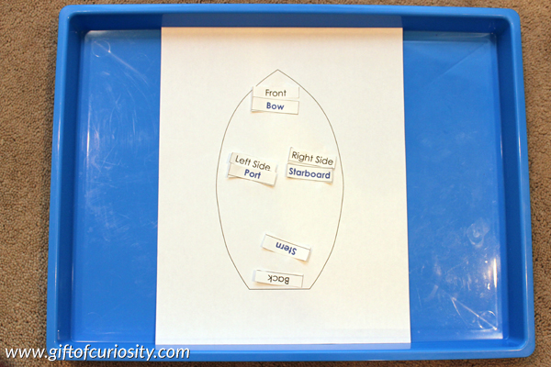  As in previous weeks take some time to maybe do a different Cosmic Yoga or PE with Joe Wicks.  https://www.youtube.com/watch?v=LhYtcadR9nw  https://www.youtube.com/watch?v=sX05HHni9Wk
Literacy |  | Mathematics | Understanding the World | Expressive Arts and Design
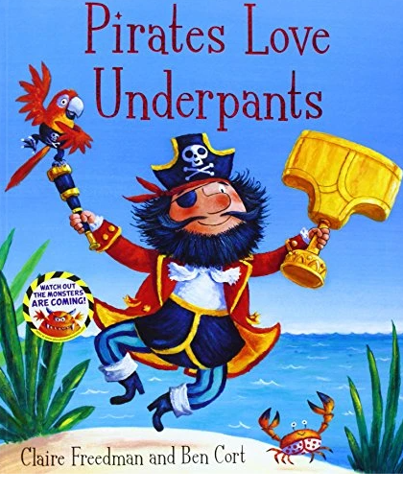  Ahoy me hearties! Join the Pants Pirates on a special treasure hunt. Grab your cutlass and sail on the Pirate Ship Black Bloomer past angry crocs, sharks in fancy pants and through gurgling swamps on a quest to find...the Pants of Gold! You'll be yo-ho-ho-ing until the sails come down!  We’re learning about the same story in Class at the moment.  Session 1: Can you write a message in a bottle to email to us in school? (template attached or you can make your own at home.)  Session 2: Write a sentence to go with the pirate pictures (attached at the bottom of the blog). Don’t forget finger spaces, capital letters and full stops.  Session 3: Follow this link to the Powerpoint ‘All About Pirates’ look through it with an adult. Can you write down one fact about pirates and email it to Mrs Counsell.  https://www.twinkl.co.uk/resource/t-tp-1314-all-about-pirates-powerpoint |  | See below for plans. | Oh no! There’s a storm coming! You need to keep your treasure safe.  Follow this link and have a go at the waterproofing science experiment to protect your treasure.  https://www.science-sparks.com/protect-the-pirate-coins-waterproofing-activity/  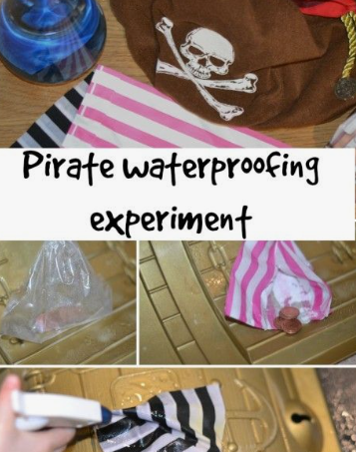 | Can you design and create your own pirate ship? Take some time to draw a picture of all the things you want to put on your pirate ship and label them. Then work out the best material to make from depending on if it needs to be waterproof or not etc. Will it sink or float? Is it made from natural materials or junk modelling? Can you fit a toy pirate in it or not? Can you fit in it?  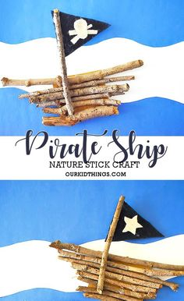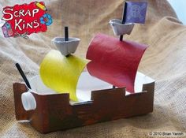  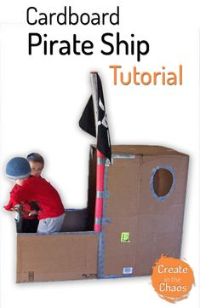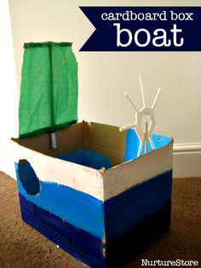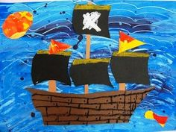

Maths
We have decided to do our weekly planning slightly differently for the rest of term as we have found some fantastic resources.

For the rest of term we will have a number a week until we reach 20 very similar to what you have been doing with numbers 10-15 so that you can have a go at understanding each number completely. This might be done outside on walks when looking for the number or finding objects.
We then also want you to have a look at this link and you will see the different weekly plans. Look for the relevant weeks planning. I have chosen specific weeks to suit what we are looking at and also the areas we have not yet covered.
https://whiterosemaths.com/homelearning/early-years/

On a Monday have a read of the book. If you don’t have it then get the children to have watch of the video of someone reading the story to them.
Then each day click on the link and complete the relevant activities. You can see in this overview what they should be looking at each day with their learning objective.

Number 16 & Time
Monday 22nd June | Tuesday 23rd June | Wednesday 24th June | Thursday 25th June | Friday 26th June
Monday - Watch Numberblocks – Sixteen  https://www.bbc.co.uk/iplayer/episode/m0005yfs/numberblocks-series-4-sixteen  When Teaching 16 remind children its 10 and 6 just like 13 is 10 and 3 etc. Take a look at the place value layout attached to the planning. When children make piles of 16 get them to place them in 10s and ones columns. Go around your house or garden and make 16 piles of 16 things e.g. sticks, spoons, a tower of 16 bricks etc. Can you have a go at doing 16 things e.g 16 star jumps? Run between 2 markers 16 times?  Lesson 1 –  Give the children 6 pieces of paper and ask them to draw 6 things they do in their day e.g. brush their teeth, read a book, get dressed etc.  Children then need to sequence them from what they do first to what they do last. Get them to discuss their day using language such as first, then, next finally etc. | Tuesday  Go around your house and garden and see if you can see the number 16 on anything, if you can’t how can you make the number 16? 16 times Using string? Straws? Bricks? What unusual things can you think of to make the number 16?  Lesson 2 –  Watch the days of the week song.  https://www.youtube.com/watch?v=HtQcnZ2JWsY  Cut out strips of paper and write the days of the week on each one, can you link them together to make paper chains?  Then write out a set on card. Can you order them? Then hide them and place them around the room or garden. Discuss if today is Tuesday what day will it be tomorrow? Children run to that sign, What day was it yesterday? What days are the weekend? Can you run to one of them? Etc. | Wednesday  Have 2 signs on the table 16 and not 16. Give the children a number of items e.g. pencils, a piece of paper with dots on, some Lego bricks etc. Ask them to place them in the correct piles.  Lesson 3 –  I can make a clock.  Children make a clock with hands that move. Pinterest has loads of ideas! But something like these…  https://www.pinterest.co.uk/search/pins/?rs=ac&len=2&q=homemade%20clock%20for%20kids&eq=homemade%20clock&etslf=5463&term_meta[]=homemade%20clock%20for%20kids%7Cautocomplete%7C0  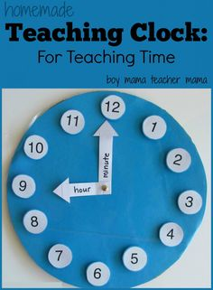 | Thursday  Children throw up 16 counters/balls/bricks etc in to a tray and see where they land, how many obvious piles are there? Can they make that into a partitioning model e.g. 3 and 3 and 6 and 4 make 16 or even simpler 9 and 7 make 16 too. Complete discussing ways of making 16.  Lesson 4 –  Discuss how when the big hand is at the 12 and the small hand is on another number that makes o’clock. Model this on the clock and test them on a few until they are secure. Can you show me 5 o’clock? 9o’clock etc.  Then watch this video and see if they can tell the time.  https://www.youtube.com/watch?v=EIxaxnageTo  Children could have a go at this interactive game for o’clock  https://mathsframe.co.uk/en/resources/resource/116/telling-the-time  You could also match the times to the clock see resources. | Friday  Give your child ten counters (Lego bricks, past shapes, buttons, sweets) and ask them questions such as: What do you add to 3 to make 16? Using your adding and subtracting skills can you come up with some ways to add and subtract totalling 16? I would love to see some of your number sentences.  Lesson 5 –  Label on your clock half past. Discuss where each hand should go when its half past. Ask them some questions e.g. show me half past 4 show me 6 o’clock mixing them up as you go.  If you feel they are confident then have a go at quarter past and quarter to.  Then watch this video and see if they can tell the time.  https://www.bbc.co.uk/bitesize/topics/zhk82hv/articles/zcmdwxs  Children could have a go at this interactive game for o’clock  https://mathsframe.co.uk/en/resources/resource/116/telling-the-time  You could also match the times to the clock see resources.

Phonics
We have come to the end of Phase 3 Letters and sounds and having had a good re-cap we thought we would go back to the letters and sounds videos which help the children learn to read and write longer words and look at a number of different things we are wanting to now focus on.

We have also provided a suggested more practical idea you could have a go at too.

Remember the phonics play website. It is free to sign up using the Username: march20 and Password: home
And the ‘Teach Your Monster To Read’ app or website which again is free to download and sign up and has lots of fun games and activities to help your children with sounds and tricky words. https://www.teachyourmonstertoread.com/

Monday 22nd June | Tuesday 23rd June | Wednesday 24th June | Thursday 25th June | Friday 26th June
Lesson 21 – Multi-Syllable words https://www.youtube.com/watch?v=JUBnHk_BRlg&feature=youtu.be  Optional extra activity – Phonics Sort – Choose 2 or 3 sounds and place a number of pictures or objects or tell the children what those objects are and they have to go and find them and place them in the correct pile depending on the sound. Can the children write down what each object is and make up a sentence with that word in. | Lesson 22 – Multi-Syllable words https://www.youtube.com/watch?v=waeQE-tK7ZA&feature=youtu.be  Optional extra activity – Phonics Hunt – Write on pieces of paper or sticky notes tricky words, sounds or words. Hide them around the house and ask the children to use their telescope to find them and tell you what they are. | Rec Lesson 23 – Compound Words https://www.youtube.com/watch?v=T0tEhcgBBRU&feature=youtu.be  Optional extra activity – Use your phonics sounds to jumble them up and make words. What words can you make? | Lesson 24 –Compound and Multi-Syllable words https://www.youtube.com/watch?v=iXdE-JtYuGo&feature=youtu.be  Optional extra activity – Find an interesting picture or object or photograph and write a sentence about it. | Lesson 25 – Compound and Multi-Syllable words https://www.youtube.com/watch?v=vEXXQ4pPrXY&feature=youtu.be  Optional extra activity – Ask an adult to write a sentence using your sounds can you read it? Or find a recipe, craft or game with instructions and read them to an adult.

