 | ENGLISH | MATHS | ENQUIRY | ACTIVE
S  E  S  S  I  O  N  1 | READING COMPREHENSION  This week’s learning is all about the food that Cornwall is famous for! So let’s familiarise ourselves with the five food groups so that we can identify which groups are in the foods that we eat.  Read through the fact file on healthy eating and answer the questions attached.  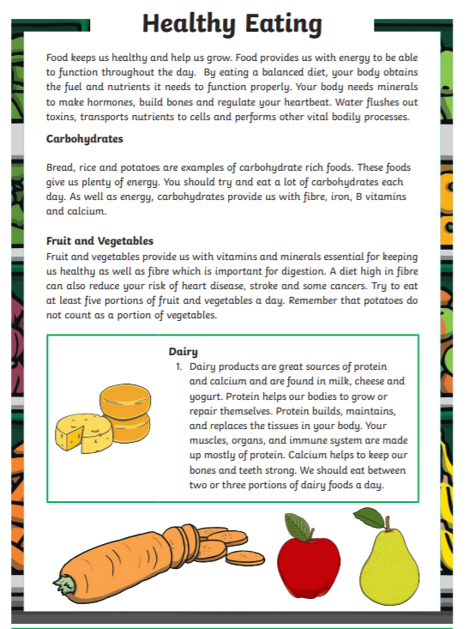  (attached to blog) | We are going to have a go at writing Roman numerals this week. Watches and clocks sometimes use them, the Queen is known as Elizabeth II and books can have chapters using letters instead of numbers. So what do they mean?  Go through the power point up to slide three today:  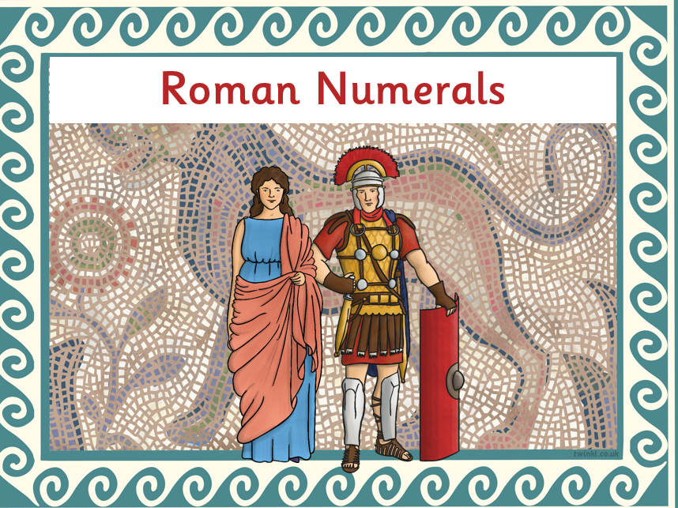  ACTIVITY: Let’s just focus on numerals to 20 so use sticks from the garden, a flour tray or pencils/pens to practise writing these.  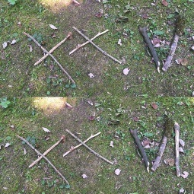 | HISTORY/DT  Let’s begin this ‘delicious’ week by learning about the history of our most famous Cornish food – the pasty.  Watch: https://www.youtube.com/watch?v=88NJg9cXiVU  “Oggie, Oggie, Oggie!” “Oi, Oi, Oi!”  Go through this fact page (with a grown up) and find some ‘tasty facts’, the relationship between pasties and The Knockers and what this old Cornish saying really means. https://www.historic-uk.com/CultureUK/The-Cornish-Pasty/  ACTIVITY: DESIGN A NEW CORNSH PASTY FILLING. Remember, it needs to be savoury first and then something sweet and yummy!  Write a paragraph beside it to explain what ingredients you have chosen.  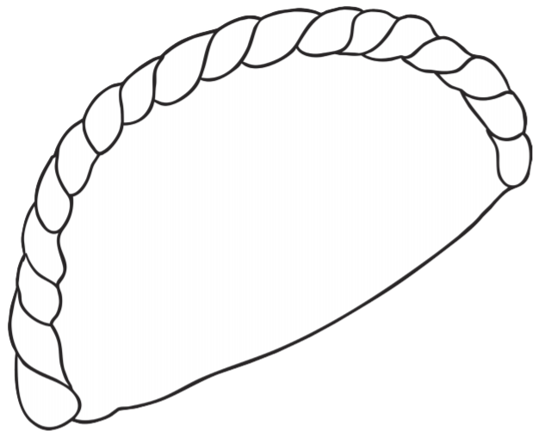 | Complete your School Games challenge and record your entry online before 4pm  Today’s event  ATHLETICS:  Here is the link to all of the Activity Cards:  http://www.activecornwall.org/cornwallschoolgames/the-virtual-games
S  E  S  S  I  O  N  2 | COMPREHENSION WE LEARNT ABOUT THE HISTORY BEHIND THE PASTY YESTERDAY - WHAT DO YOU THINK THIS CORNISH DELICACY IS?  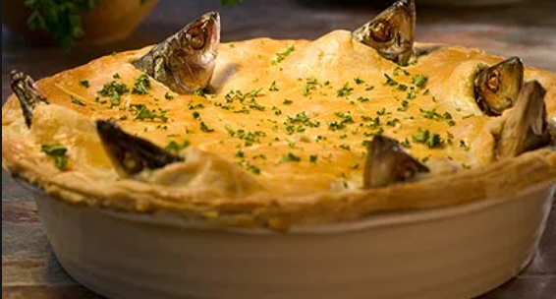  Read (if you have the book) or Watch a puppet version of the Mousehole Cat  https://www.youtube.com/watch?v=htJFkZQ7w0U  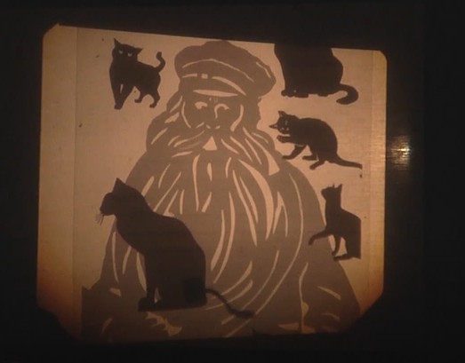  ACTIVITY: CREATE A POSTER INVITING PEOPLE TO COME TO MOUSEHOLE AND CELEBRATE ‘TOM BAWCOCK’S EVE’ ON DECEMBER 23RD! | Today, we will link reading time with Roman numerals. Match up numbers 1-12 with their Roman numerals first. (below grid)  Then,  ACTIVITY:  Create a paper plate clock using Roman numerals. Make the times on the worksheet.  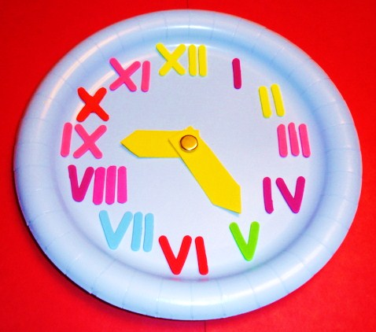  (If you get stuck – use your clocks from last week with our numbers on to help you!) | DT- Create your favourite Cornish food.  “You will need to build up your calorie intake so that you have enough energy to take part in the Virtual School Games this week.”  LET’S MAKE SOME SCRUMMY CORNISH FOOD!  ACTIVITY: I’ve attached a recipe for pasties, Cornish fairings and a link to make a Cornish Cream Tea. Take your pick or try them all!  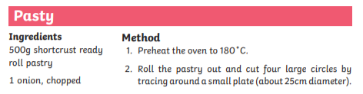  Link to Cornish Cream Tea: https://www.bbc.co.uk/cbbc/joinin/matilda-and-the-ramsay-bunch-blog-2018-recipe-cornish-cream-tea | Complete your School Games challenge and record your entry online before 4pm  Today’s event  BOWLS/BOCCIA:  AIM: Knock down all your ‘skittles’ in one go.  AIM: Get close to a target as possible.
S  E  S  S  I  O  N  3 | DESCRIPTIVE WRITING  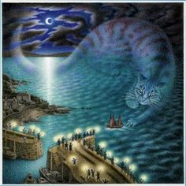  This is a picture from the Cornish tale, The Mousehole Cat. (Bigger version on blog)  Write a descriptive paragraph describing what you see in the picture. Why do you think the author has used a cat to represent the storm? Use some of the language in the story from yesterday. | Go back to the power point and go through the rest of the slides.  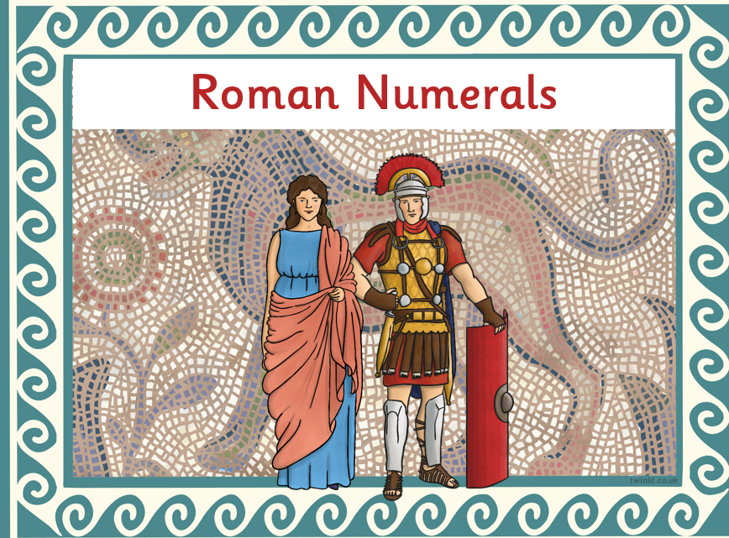  Complete the activities on the power point and then go the bottom of this grid to complete the sheet.  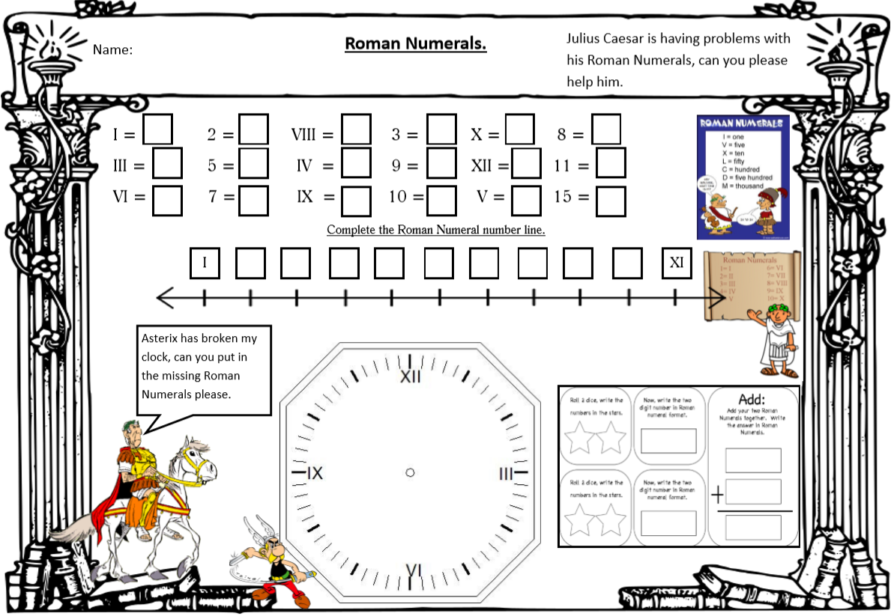 | ART – CREATE A STARGAZEY PIE! Watch (Tom Bawcock’s Eve celebrations in Mousehole) https://www.youtube.com/watch?v=FMnIdV8dfss  This is the song they chant – can you learn it? (bigger version below)  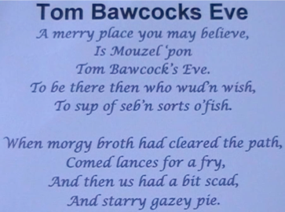  ACTIVITY: Stargazy Pie was made with Herrings, Pilchards and Mackerel. CREATE THIS USING SALT DOUGH AND PAINT IT! (not edible) https://www.bbcgoodfood.com/howto/guide/how-make-salt-dough-recipe  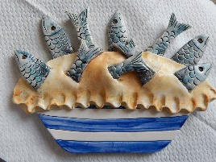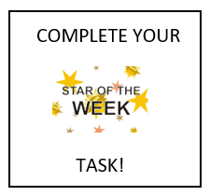 | Complete your School Games challenge and record your entry online before 4pm  Today’s event  DANCE/GYMNASTICS:  AIM: Perform a Hip Hop routine of your choice  AIM: Perform a sequence using a variety of skills.
S  E  S  S  I  O  N  4 | SPaG  We are going to write a set of instructions for a recipe, tomorrow. Watch this chef making a delicious chocolaty treat and make a note of the ‘bossy’ imperative verbs he uses (the words that appear in blue!)  https://www.bbc.co.uk/teach/class-clips-video/english-ks1-ks2-how-to-write-instructions/zrvtscw  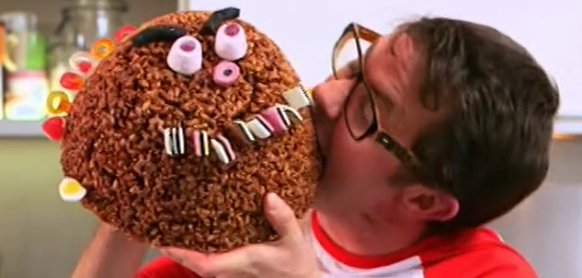  ACTIVITY: PLAN THE LANGUAGE YOU WILL USE IN YOUR RECIPE. YOU CAN USE THE WORDS YOU WROTE DOWN OR USE THE WORD MAT (TASK BELOW GRID) TO FIND YOUR OWN!  SUCCESS CRITERIA: Make a note of  - EQUIPMENT YOU WILL NEED  - INGREDIENTS  - TIME CONJUNCTIONS  - IMPERATIVE ‘BOSSY’ VERBS (ACTIONS LIST ON WORD MAT) | Crack the Roman numeral code!  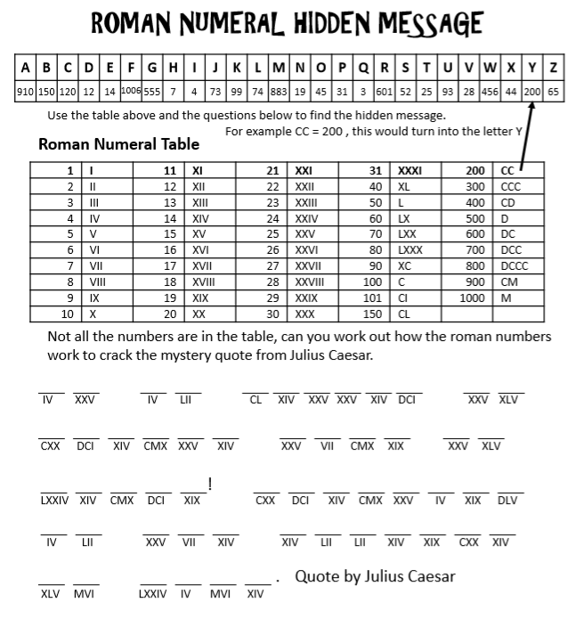  (BIGGER VERSION BELOW)  Remember the rules: If a smaller number comes before a bigger one, you need to subtract it.  If a bigger number comes before a smaller one, or both numbers are the same, you add them. | SCIENCE – NUTRITION So for the Science behind what we eat! Let’s learn about the food pyramid Intro: https://www.youtube.com/watch?v=mMHVEFWNLMc  Now let’s sort these groups into a food pyramid. Think about which ones are the most important when you watch the video https://www.youtube.com/watch?v=0KbA8pFW3tg  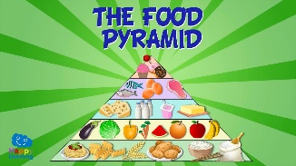  “Why do you think carbohydrates is at the bottom and sweets/fats are the smallest section at the top?”  ACTIVITY: CREATE A PERSONAL FOOD PYRAMID WITH ALL THE YUMMY FOODS YOU LIKE TO EAT (Attached below with an example)  CHALLENGE: Look at the ingredients for a Cornish Pasty – which ingredient goes in which food group? Is it healthy? (Recipe on blog) | Complete your School Games challenge and record your entry online befOre 4pm  Today’s event  VOLLEYBALL:  AIM: Serve the ball into a desginated area in 2 minutes.  AIM: Keep the ball off the ground using different parts of your body.  AIM: Get as many balls over your head and catch in 2 minutes.
S  E  S  S  I  O  N  5 | WRITING TASK  Write a set of instructions for the Cornish treat you made this week.  Instructions must have Success Criteria:  - Title  - List of equipment  - List of ingredients  - Numbered steps  - Imperative ‘bossy’ verbs  - Picture to show the finished product  (SEE SESSION 5 ENGLISH ATTACHMENT FOR WRITING FRAME)  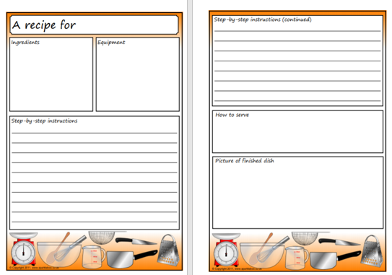 | Next week we are going to focus on  The properites of 2D and 3D shapes  A favourite area of Maths for most of you.  To get you warmed up, click on the BBC Bitesize link and revisit properties of 2D shapes and do the activities suggested online.  https://www.bbc.co.uk/bitesize/articles/zq6p7yc  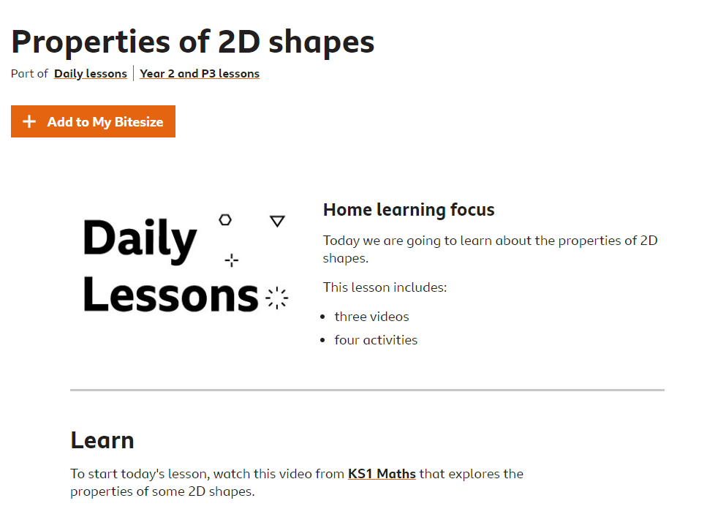 | ART  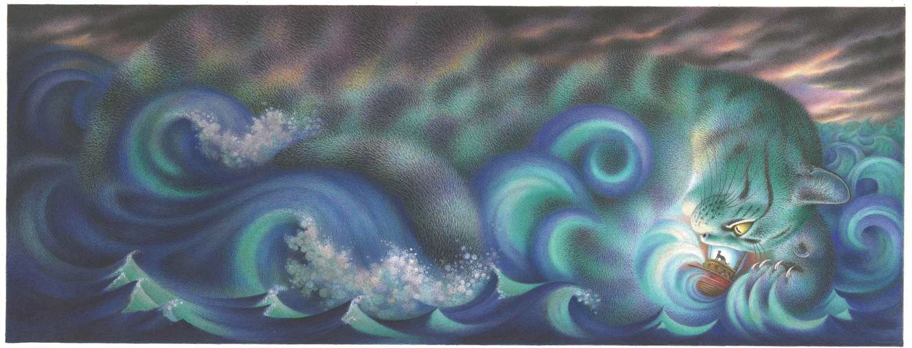  In the tale of the Mousehole Cat, the storm itself is referred to as Storm Cat. (Bigger image below)  Think of your favourite animal and use your imagination to create a Storm (animal) seascape using your skills at mixing and blending colours. How about a Storm Tiger and blend orange/yellow and browns together?  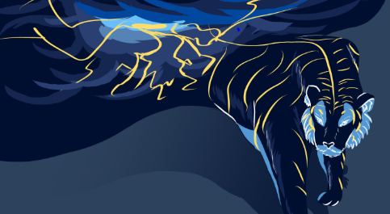  (Look at this Storm Tiger by Dinah Conteh – she used blues and oranges) | Complete your School Games challenge and record your entry online before 4pm  Today’s event  TENNIS:  AIM: Get as many balls into a target in 60 seconds as you can  AIM: As many continuous shots as possible in a rally in 2 minutes.  AIM: As many continuous volleys as possible in 2 minutes.

SESSION 1 MATHS – ROMAN NUMERALS TO 20 (HOW DO THEY WORK THEM OUT?)
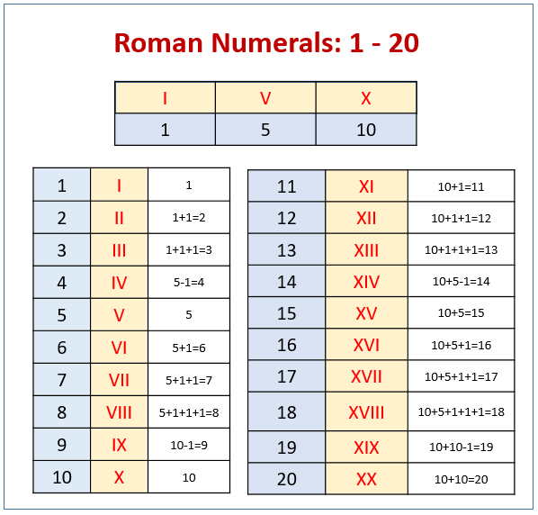
SESSION 1 ENQUIRY – CREATE A PASTY FILLING
SESSION 2 – MATHS
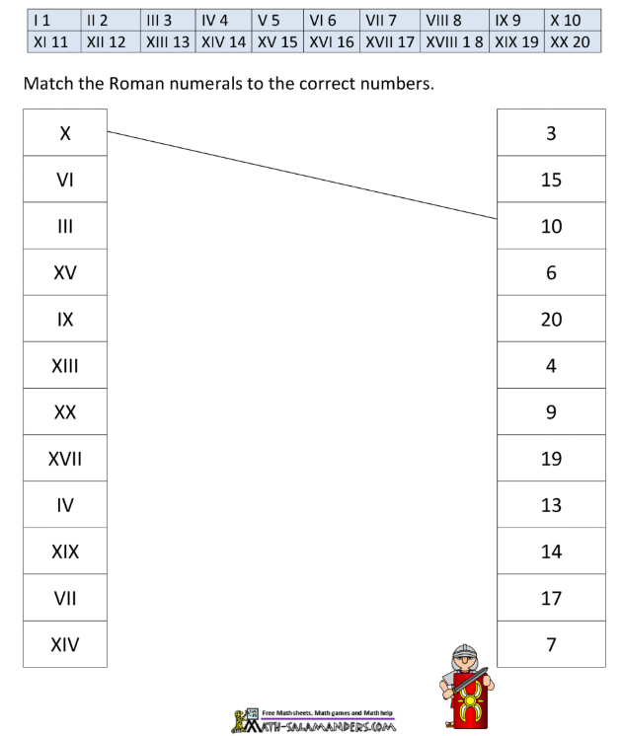
Now have a go at making these times using your Roman Numeral clock.
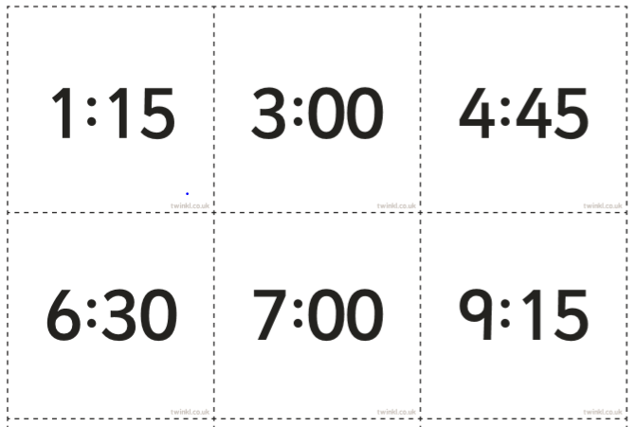
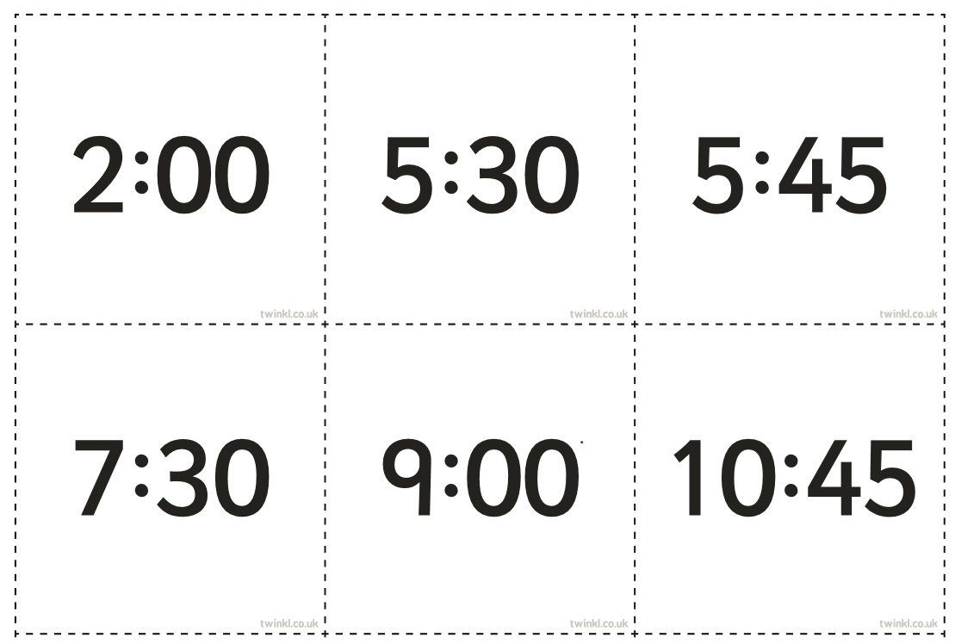

SESSION 3 – TOM BAWCOCK’S SONG
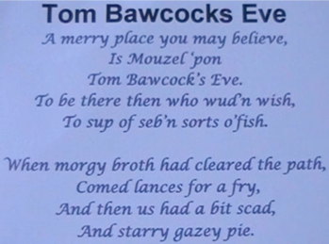

SESSION 3 MATHS – ROMAN NUMERALS

SESSION 4 ENGLISH – INSTRUCTION PLANNING
EQUIPMENT LIST | INGREDIENTS LIST

TIME CONJUNCTION I WILL USE | IMPERATIVE VERBS TO USE IN MY RECIPE
(example) first | chop

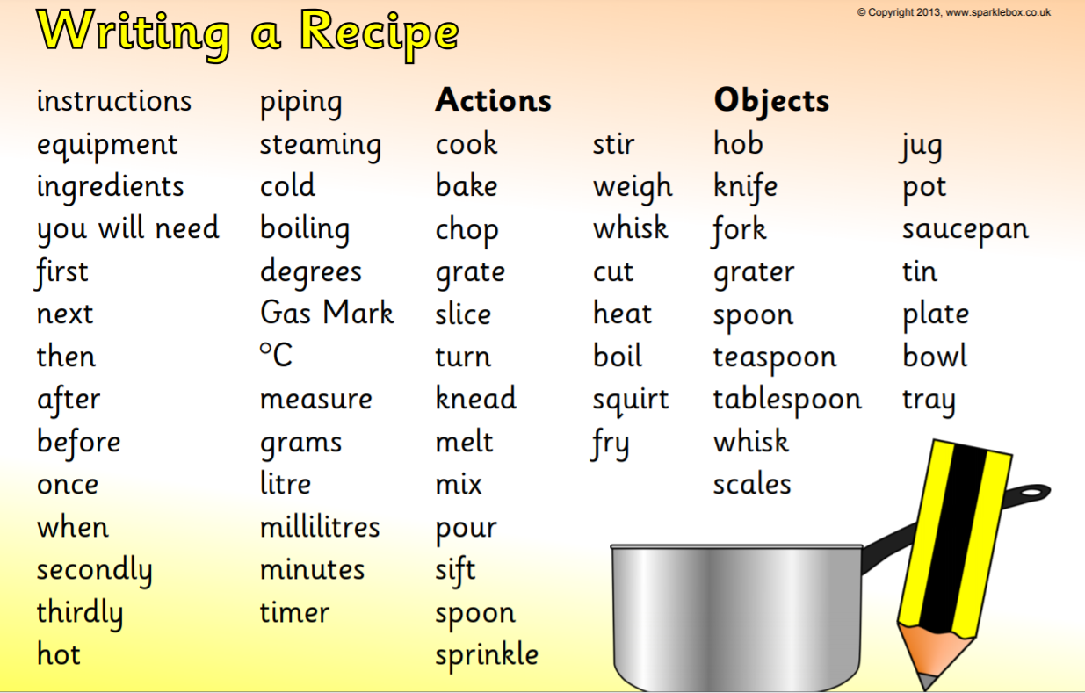
SESSION 4 FOOD PYRAMID
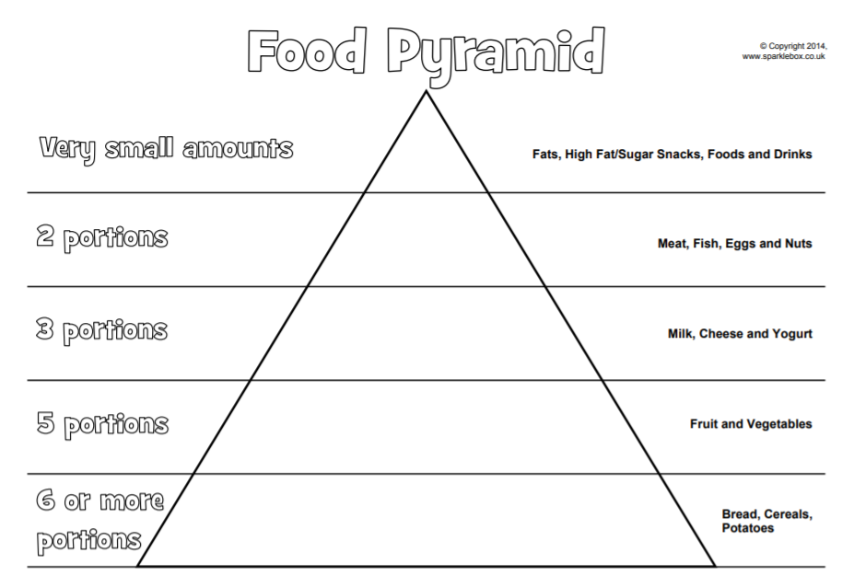
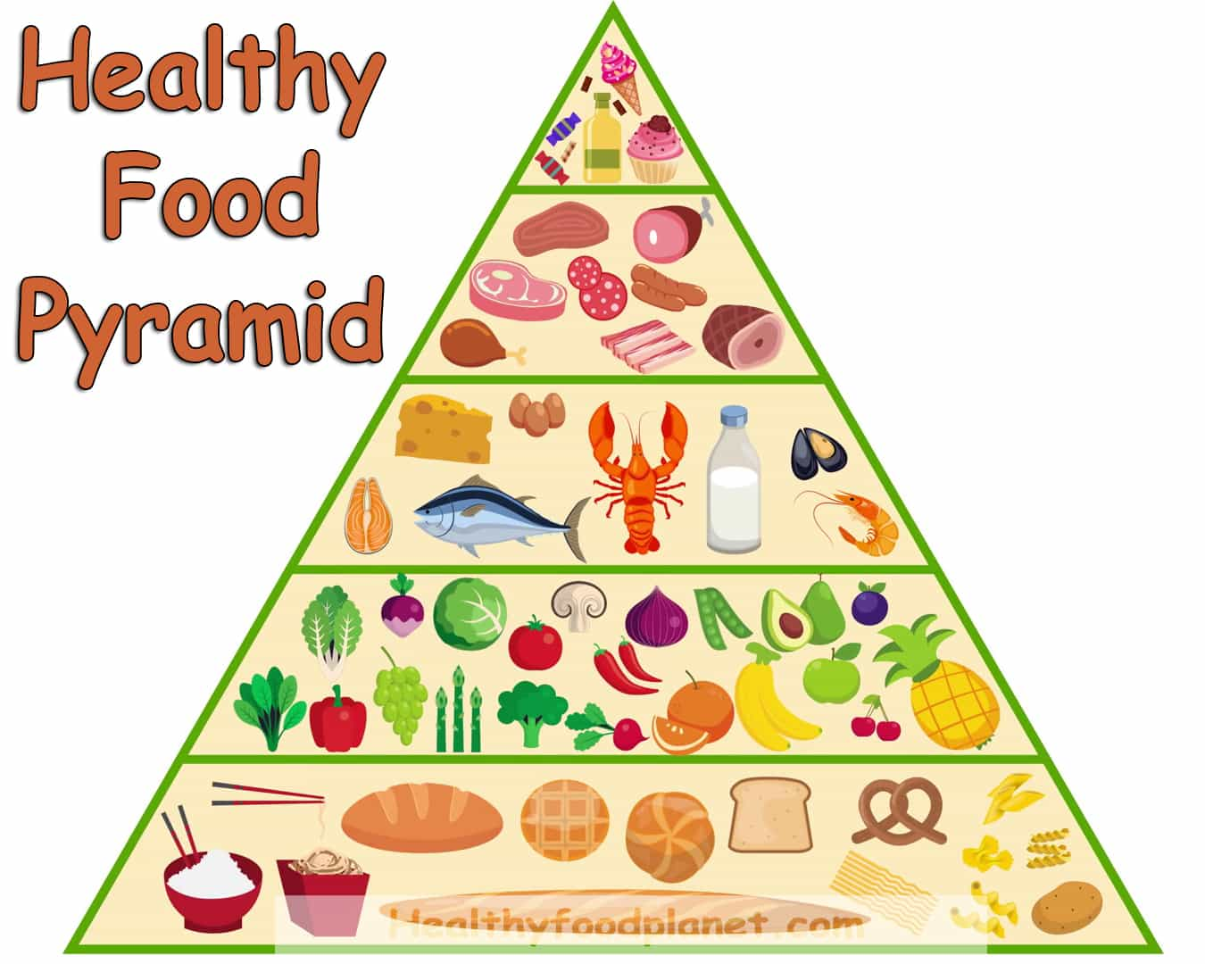
Here is an example
SESSION 5 ENQUIRY – SEASCAPE PAINTING
Think of your favourite animal and turn it into a Storm Animal like the one below.

SESSION 5 MATHS – ROMAN NUMERAL CODE CRACKING TASK
ANSWERS
