English | MATHS | ENQUIRY | Active
COMPREHENSION  Watch the film of the fantastic story about the Mousehole Cat  https://www.youtube.com/watch?v=htJFkZQ7w0U  Answer the VIPERS questions.  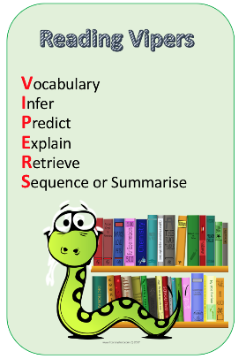  Check your answers.  Think about which VIPERS you didn’t get right, this is your feedback and your next steps for learning. | https://whiterosemaths.com/homelearning/year-6/  Go to the above link and watch the video for Summer Term Week 8, Lesson 3 (Convert Metric Measures)  Complete the worksheet attached to the blog for today. | HISTORY/DT  Let’s begin this ‘delicious’ week by learning about the history of our most famous Cornish food – the pasty.  Watch: https://www.youtube.com/watch?v=88NJg9cXiVU  “Oggie, Oggie, Oggie!” “Oi, Oi, Oi!”  Go through this fact page and find some ‘tasty facts’, the relationship between pasties and The Knockers and what this old Cornish saying really means. https://www.historic-uk.com/CultureUK/The-Cornish-Pasty/  DESIGN A NEW CORNSH PASTY FILLING. Remember, it needs to be savoury first and then something sweet and yummy!  Write a paragraph to explain what you have chosen and why. | Complete your School Games challenge and record your entry online before 4pm  Today’s event  ATHLETICS:  Here is the link to all of the Activity Cards:  http://www.activecornwall.org/cornwallschoolgames/the-virtual-games
Yesterday you designed a new Cornish pasty. Today you will be making an advert for your pasty.  You will need to include persuasive features in your advert to encourage people to buy it.  Look at the ‘persuasive features in advertising’ powerpoint to find out about the different techniques that you might want to use.  Design an advert for your pasty.  Success criteria:  - Include alliteration in your slogan  - Include a quote about the product  - Include an imperative verb to command the customer to do something. Remind yourself of what an imperative verb is here: https://www.youtube.com/watch?v=oApd0goKJDM  - Include a picture of the product to grab the customer’s attention | https://whiterosemaths.com/homelearning/year-6/  Go to the above link and watch the video for Summer Term Week 8, Lesson 4 (Miles and kilometres)  Complete the worksheet attached to the blog for today. | DT- Create your favourite Cornish food.  You will need to build up your calorie intake so that you have enough energy to take part in the Virtual School Games this week so let’s make some delicious Cornish food.  Choose one of the recipes that are attached to the blog and create your favourite Cornish treat. I’ve attached a recipe for pasties, Cornish fairings and a link to make a Cornish Cream Tea.  Take your pick or try them all!  Link to Cornish Cream Tea: https://www.bbc.co.uk/cbbc/joinin/matilda-and-the-ramsay-bunch-blog-2018-recipe-cornish-cream-tea | Complete your School Games challenge and record your entry online before 4pm  Today’s event  BOWLS/BOCCIA:  AIM: Knock down all your ‘skittles’ in one go.  AIM: Get close to a target as possible.
FEATURES  This week we are going to be writing a recipe. A recipe is really just a set of instructions, so first we need to remind ourselves of the features of instructions.  Read the recipe for Stargazey Pie that is attached to the blog. How many different features of instructions can you find?  Check the features you have found against the ‘Features of Instruction Writing’ document. Did you find them all?  Use this checklist to create a key and colour code the different features within the recipe. | https://whiterosemaths.com/homelearning/year-6/  Go to the above link and watch the video for Summer Term Week 9, Lesson 1 (Area and Perimeter)  Complete the worksheet attached to the blog for today. | ART – CREATE A STARGAZEY PIE!  Go to the following link to find out about stargazey pie a traditional pie that comes from the Cornish village of Mousehole. https://www.lovefood.com/news/57659/the-history-of-stargazey-pie  Mousehole celebrates Tom Bawcock on 23rd December every year. Go to the following link to watch the Tom Bawcock’s Eve celebrations:  https://www.youtube.com/watch?v=FMnIdV8dfss  This is the song the Mousehole villagers chant during the festivities – can you learn it? (there’s a bigger version attached to the blog)  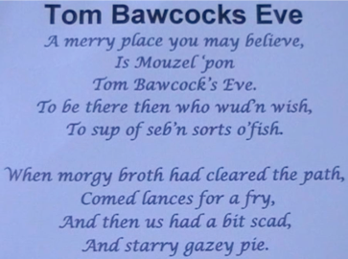  Make your own stargazey pie like the one in the picture below using saltdough and paint it?  There is a recipe for saltdough here: https://www.bbcgoodfood.com/howto/guide/how-make-salt-dough-recipe  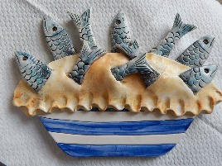  NB: Saltdough is not edible! | Complete your School Games challenge and record your entry online before 4pm  Today’s event  DANCE/GYMNASTICS:  AIM: Perform a Hip Hop routine of your choice  AIM: Perform a sequence using a variety of skills.
WRITING  Today you are going to design a new Cornish Stargazey Pie.  Will yours be filled with mackerel and potatoes like the original or will you make it a sweet pie full of luscious Cornish berries?  When you have decided on your ingredients, you need to write the recipe.  Use the ‘Features of Instruction Writing’ document as your success criteria. Try to include as many of these features as you can. | https://whiterosemaths.com/homelearning/year-6/  Go to the above link and watch the video for Summer Term Week 9, Lesson 2 (Area of a triangle)  Complete the worksheet attached to the blog for today. | SCIENCE – NUTRITION  So for the Science behind what we eat! Let’s learn about the food pyramid: https://www.youtube.com/watch?v=mMHVEFWNLMc  Now let’s sort these groups into a food pyramid. Think about which ones are the most important when you watch the video https://www.youtube.com/watch?v=0KbA8pFW3tg  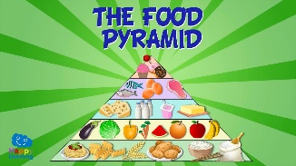  Why do you think carbohydrates is at the bottom and sweets/fats are the smallest section at the top?  Think about all of the different foods that you like to eat and use them to create your own personal food pyramid.  CHALLENGE: Look at Cornish Pasty recipe that is attached to the blog – which ingredient goes in which food group? Is it healthy? | Complete your School Games challenge and record your entry online before 4pm  Today’s event  VOLLEYBALL:  AIM: Serve the ball into a desginated area in 2 minutes.  AIM: Keep the ball off the ground using different parts of your body.  AIM: Get as many balls over your head and catch in 2 minutes.
EDITING  When you have finished writing your recipe, have a go at editing.  Follow these four steps:  - Check that you have used a variety of different fronted adverbials  - Check that each step of your instructions contains an imperative verb  - Consider your adjectives, adverbs and verbs. Have you got interesting adjectives, strong verbs and said how these verbs are done?  - Check all the spellings and punctuation.  Share your recipe with an adult and try to decide if the recipe would actually work. | Complete the arithmetic questions that are attached to the blog.  You do not have to time yourself – you can work through them at your own pace.  If you do want to time yourself then allow yourself 30 minutes to complete all the questions.  Use the answers to check it when you’ve finished. | ART:  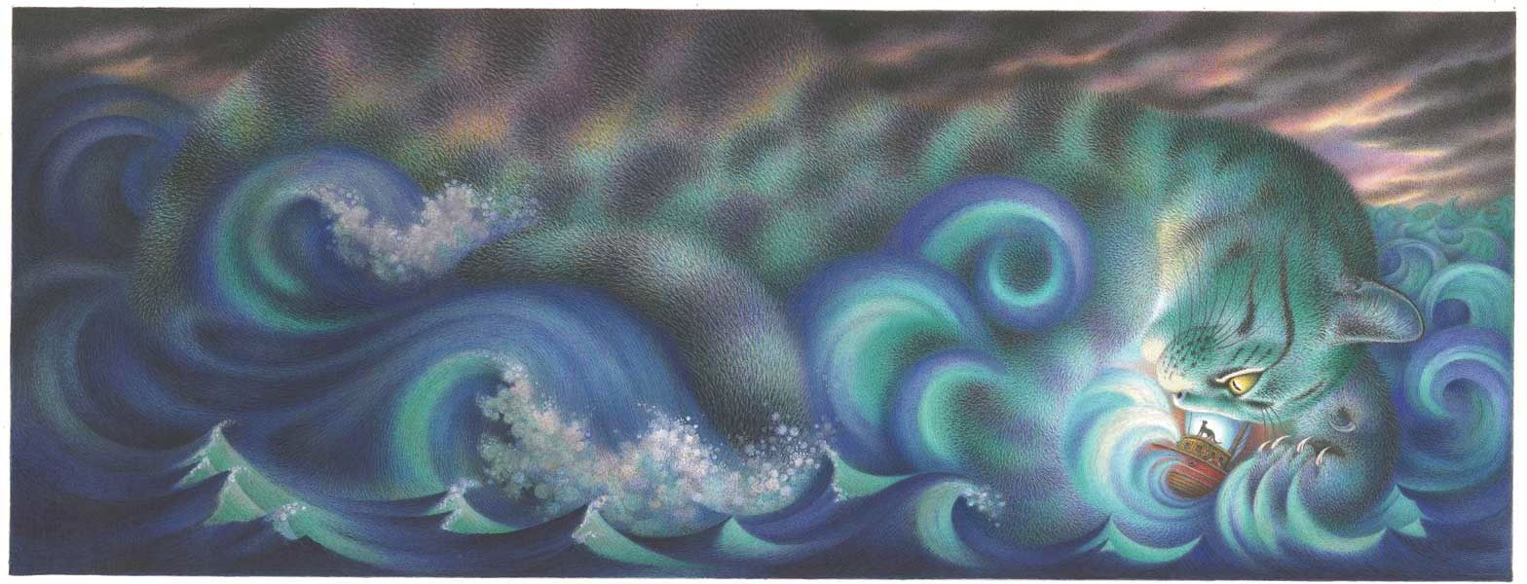  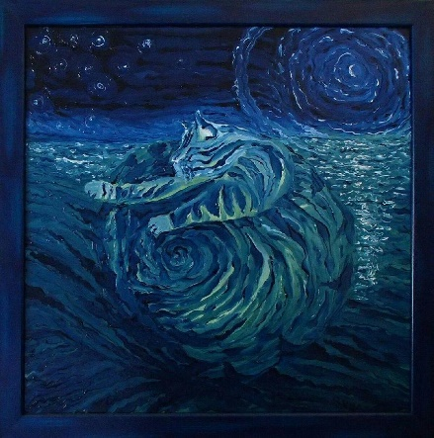  In the tale of the Mousehole Cat, the storm itself is referred to as Storm Cat.  Think of your favourite animal and use your imagination to create a Storm seascape like the ones above, where an animal emerges from the storm. Use your skills in mixing and blending colours to make the animal blend into the storm.  Why not blend orange/yellow and browns together and make a Storm Tiger? | Complete your School Games challenge and record your entry online before 4pm  Today’s event  TENNIS:  AIM: Get as many balls into a target in 60 seconds as you can  AIM: As many continuous shots as possible in a rally in 2 minutes.  AIM: As many continuous volleys as possible in 2 minutes.

