 | ENGLISH | MATHS | ENQUIRY | ACTIVE
S  E  S  S  I  O  N  1 | READING COMPREHENSION  This week’s learning is all about the food that Cornwall is famous for!  Read through the instructions (attached to the blog) on how to make a healthy greek salad and answer the questions attached.  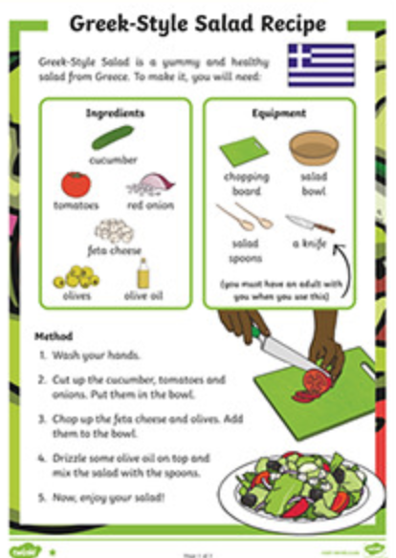 | First, recap coins from last week. Can you choose the right coins to make the total?  https://natwest.mymoneysense.com/students/students-5-8/coin-cruncher/  Compare money  Can you find two different answers to this question:  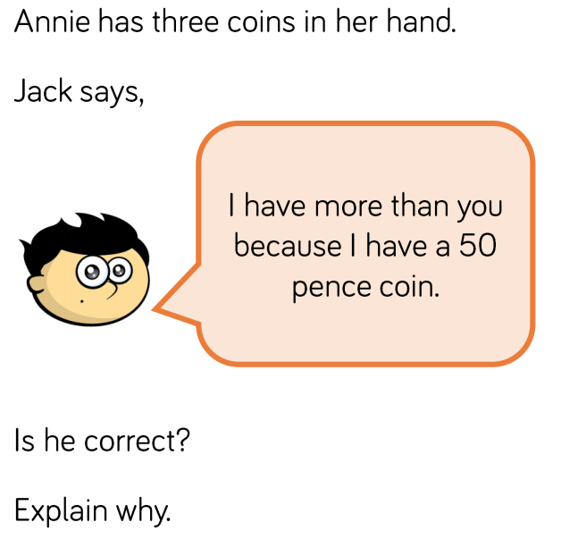 | HISTORY/DT  Let’s begin this ‘delicious’ week by learning about the history of our most famous Cornish food – the pasty.  Watch: https://www.youtube.com/watch?v=88NJg9cXiVU  ACTIVITY: DESIGN A NEW CORNSH PASTY FILLING. Remember, it needs to be savoury first and then something sweet and yummy!  Challenge: Write a paragraph beside it to explain what ingredients you have chosen.  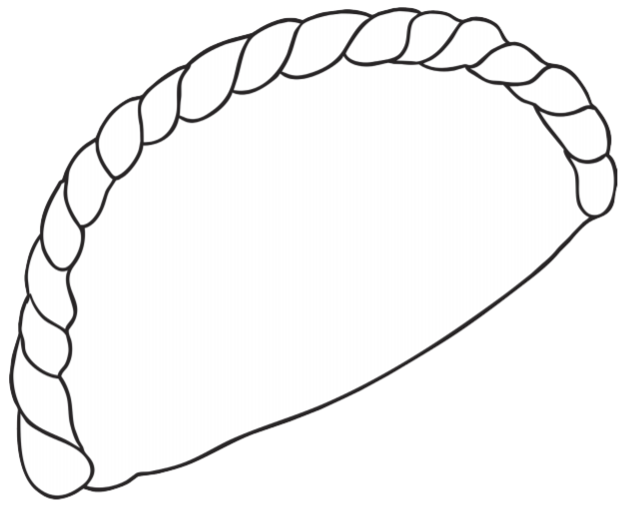 | Complete your School Games challenge and record your entry online before 4pm  Today’s event  ATHLETICS:  Here is the link to all of the Activity Cards:  http://www.activecornwall.org/cornwallschoolgames/the-virtual-games
S  E  S  S  I  O  N  2 | COMPREHENSION  We learnt about the Cornish pasty yesterday. What do you think this meal is?  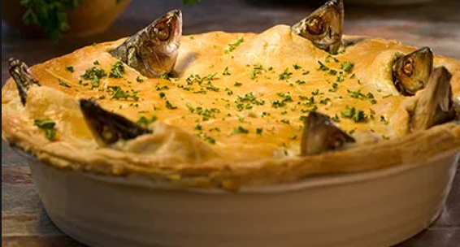  Read (if you have the book) or Watch a puppet version of the Mousehole Cat  https://www.youtube.com/watch?v=htJFkZQ7w0U  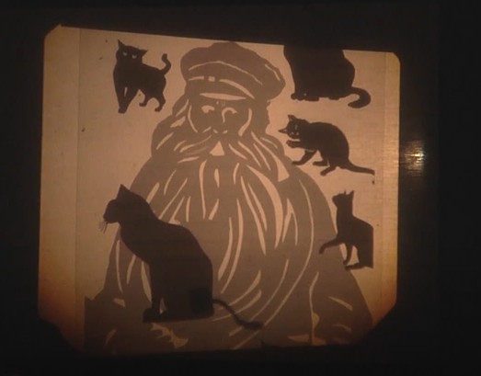  ACTIVITY:  Create a poster inviting people to come to mousehole and celebrate ‘Tom Bawcock’s eve’ on December 23rd! | Today, you will be finding the total of two coins. That means adding them together.  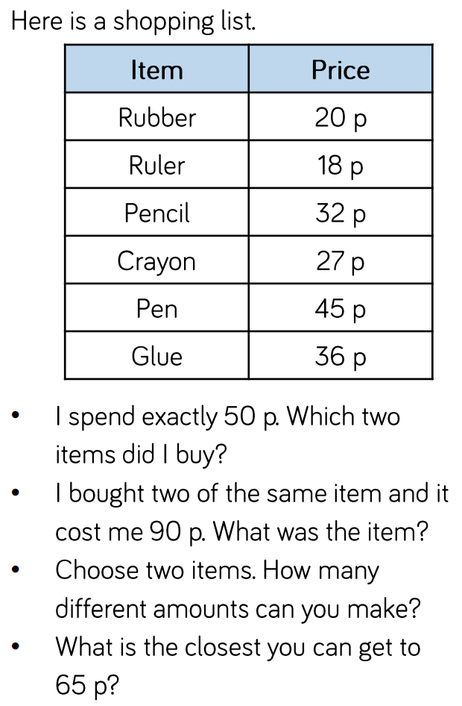 | DT- Create your favourite Cornish food.  You will need to build up your calorie intake so that you have enough energy to take part in the Virtual School Games this week.  Let’s make some scrummy Cornish food!  ACTIVITY: choose a recipe (attached to the blog) and create your favourite Cornish treat. I’ve attached a recipe for pasties, Cornish fairings and a link to make a Cornish Cream Tea. Take your pick or try them all!  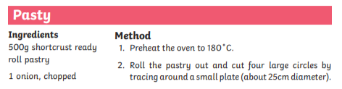  Link to Cornish Cream Tea: https://www.bbc.co.uk/cbbc/joinin/matilda-and-the-ramsay-bunch-blog-2018-recipe-cornish-cream-tea | Complete your School Games challenge and record your entry online before 4pm  Today’s event  BOWLS/BOCCIA:  AIM: Knock down all your ‘skittles’ in one go.  AIM: Get close to a target as possible.
S  E  S  S  I  O  N  3 | DESCRIPTIVE WRITING  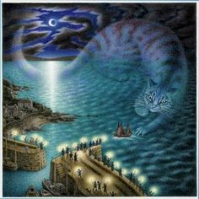  This is a picture from the Cornish tale, The Mousehole Cat.  Write a descriptive paragraph describing what you see in the picture. Why do you think the author has used a cat to represent the storm? Use some of the language in the story from yesterday. | Today we are finding the difference between two coins.  How much more does a pencil cost than a rubber?  What is the difference between a glue and a pen?  How much more would two rubbers cost than one a crayon? | ART – CREATE A STARGAZEY PIE! Watch (Tom Bawcock’s Eve celebrations in Mousehole) https://www.youtube.com/watch?v=FMnIdV8dfss  This is the song they chant – can you learn it? (bigger version below)  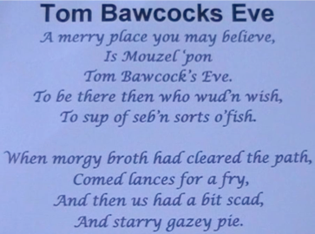  ACTIVITY: Stargazy Pie was made with Herrings, Pilchards and Mackerel. Create this using salt dough and paint it! (not edible!) https://www.bbcgoodfood.com/howto/guide/how-make-salt-dough-recipe  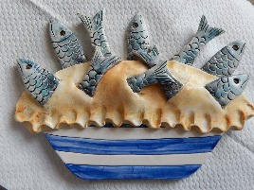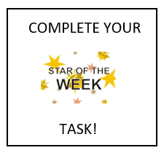 | Complete your School Games challenge and record your entry online before 4pm  Today’s event  DANCE/GYMNASTICS:  AIM: Perform a Hip Hop routine of your choice  AIM: Perform a sequence using a variety of skills.
S  E  S  S  I  O  N  4 | SPaG  We are going to write a set of instructions for a recipe, tomorrow. Watch this chef making a delicious chocolaty recipe and make a note of the ‘bossy’ imperative verbs he uses (the words that appear in blue!)  https://www.bbc.co.uk/teach/class-clips-video/english-ks1-ks2-how-to-write-instructions/zrvtscw  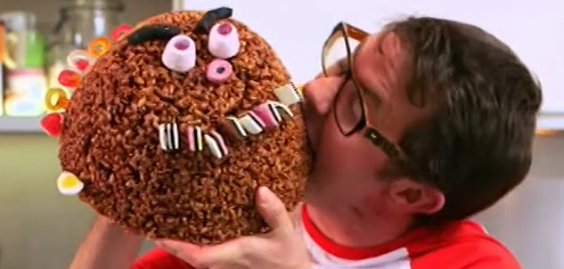  ACTIVITY: Plan the language you will use for your instructions. You can use the words you have written or the word mat below.  Success Criteria:  - List of equipment  - List of ingredients  - Imperative ‘bossy’ verbs | Today you will learn how to find change.  Watch the video on BBC bitesize about finding change and have a go at the activities underneath:  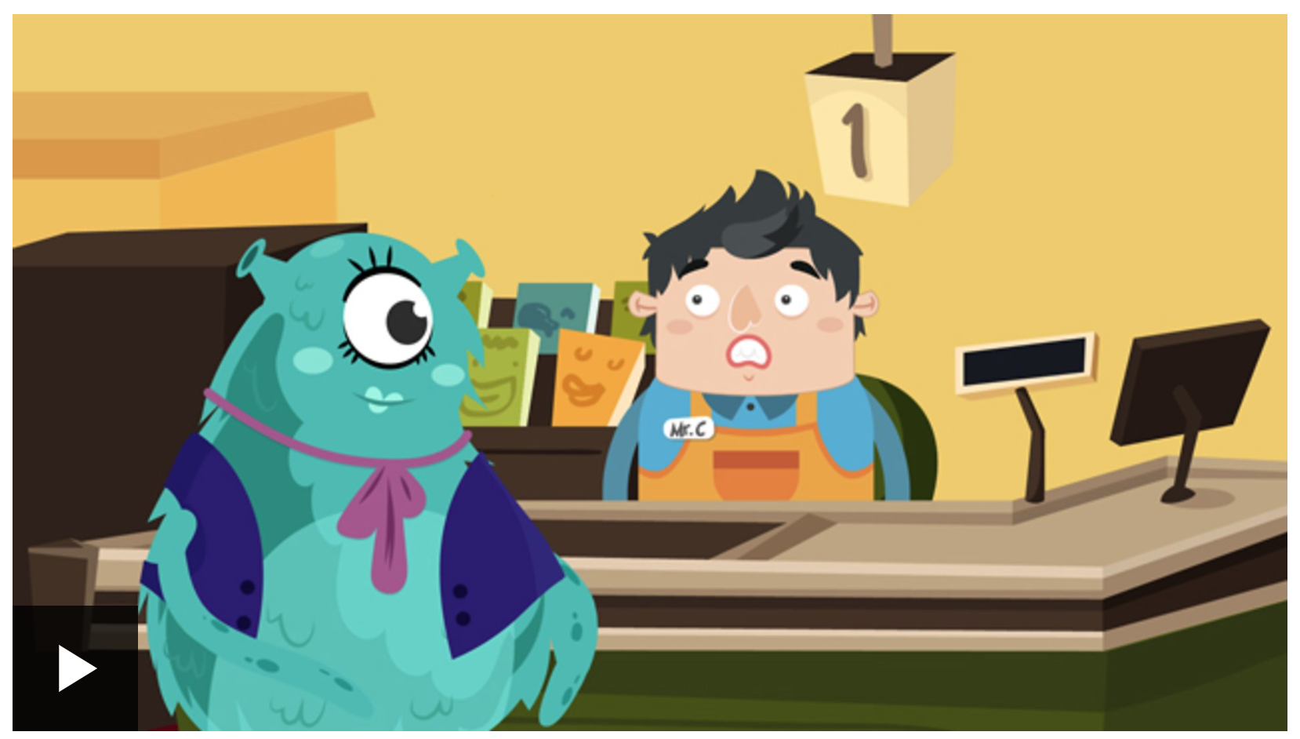  https://www.bbc.co.uk/bitesize/topics/zp8dmp3/articles/z2s6hv4 | SCIENCE – NUTRITION  So for the Science behind what we eat! Let’s learn about the food pyramid Intro: https://www.youtube.com/watch?v=mMHVEFWNLMc  Now let’s sort these groups into a food pyramid. Think about which ones are the most important when you watch the video https://www.youtube.com/watch?v=0KbA8pFW3tg  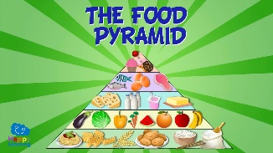  “Why do you think carbohydrates is at the bottom and sweets/fats are the smallest section at the top?”  ACTIVITY: Create a personal food pyramid with all the yummy foods you like to eat  (Attached below with an example)  CHALLENGE: Look at the ingredients for a Cornish Pasty – which ingredient goes in which food group? Is it healthy?  (Recipe on blog) | Complete your School Games challenge and record your entry online befOre 4pm  Today’s event  VOLLEYBALL:  AIM: Serve the ball into a desginated area in 2 minutes.  AIM: Keep the ball off the ground using different parts of your body.  AIM: Get as many balls over your head and catch in 2 minutes.
S  E  S  S  I  O  N  5 | WRITING TASK  Write a set of instructions for the Cornish treat you made this week.  You could use the writing frame attached to the grid.  Success Criteria:  - Title  - List of equipment  - List of ingredients  - Numbered steps  - Imperative ‘bossy’ verbs  - Picture to show the finished product | Word problems  Have a go at answering these word problems:  - Lollipops cost 5p each. How much would 4 lollipops cost?  - Bob had a 20p coin. He spent 6p. How much did he have left?  - An orange costs 32p. What coins could you use to pay for it?  - If a ball costs £1.50, how many could I buy with a £5 note?  - Annie has four 20p coins. Can she buy an apple for £1?  Challenge: Now write two of your own. | ART  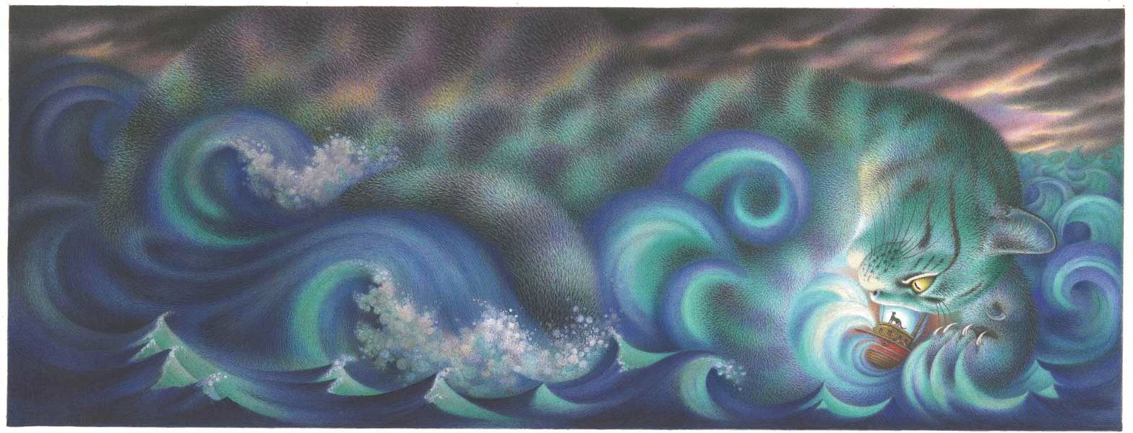  In the tale of the Mousehole Cat, the storm itself is referred to as Storm Cat. (Bigger image below)  Think of your favourite animal and use your imagination to create a Storm (animal) seascape using your skills at mixing and blending colours. How about a Storm Tiger and blend orange/yellow and browns together?  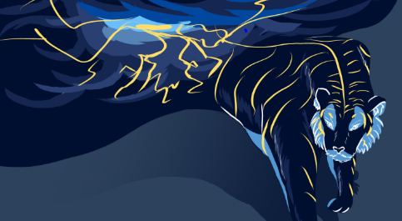  (Look at this Storm Tiger by Dinah Conteh – she used blues and oranges) | Complete your School Games challenge and record your entry online before 4pm  Today’s event  TENNIS:  AIM: Get as many balls into a target in 60 seconds as you can  AIM: As many continuous shots as possible in a rally in 2 minutes.  AIM: As many continuous volleys as possible in 2 minutes.

SESSION 1 ENQUIRY – CREATE A PASTY FILLING
SESSION 3 – TOM BAWCOCK’S SONG
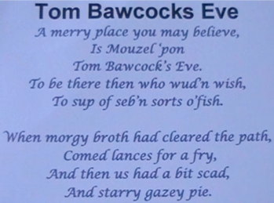

SESSION 4 ENGLISH – INSTRUCTION PLANNING
Equipment list | Ingredients list

Time conjunction I will use | Imperative verbs to use in my recipe
(example) first | chop

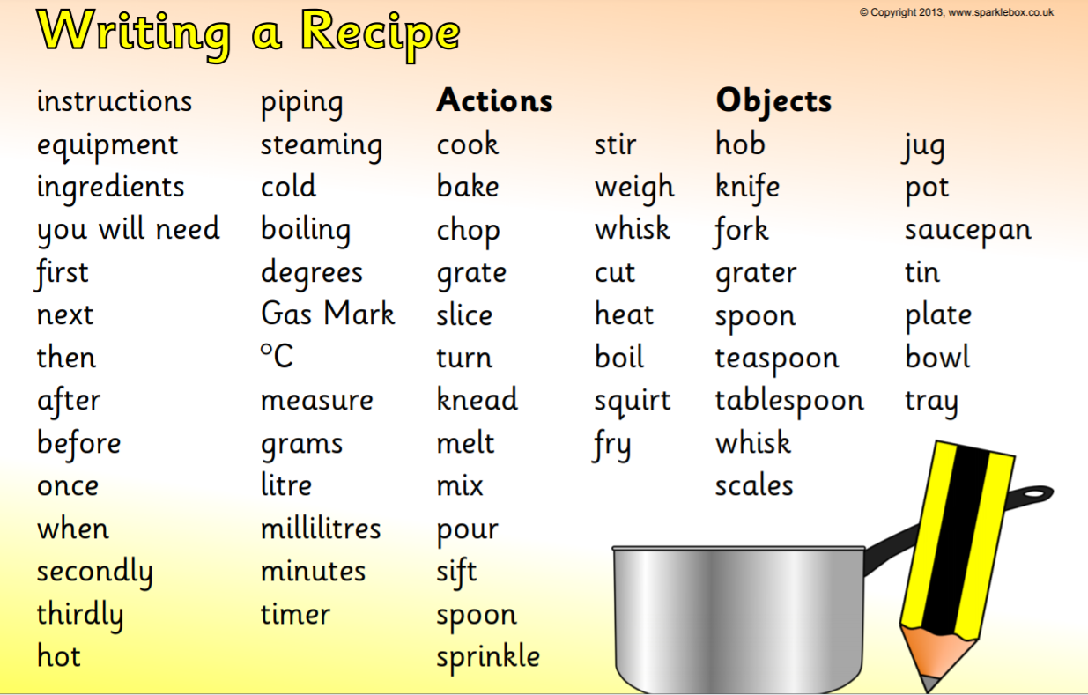
SESSION 4 FOOD PYRAMID
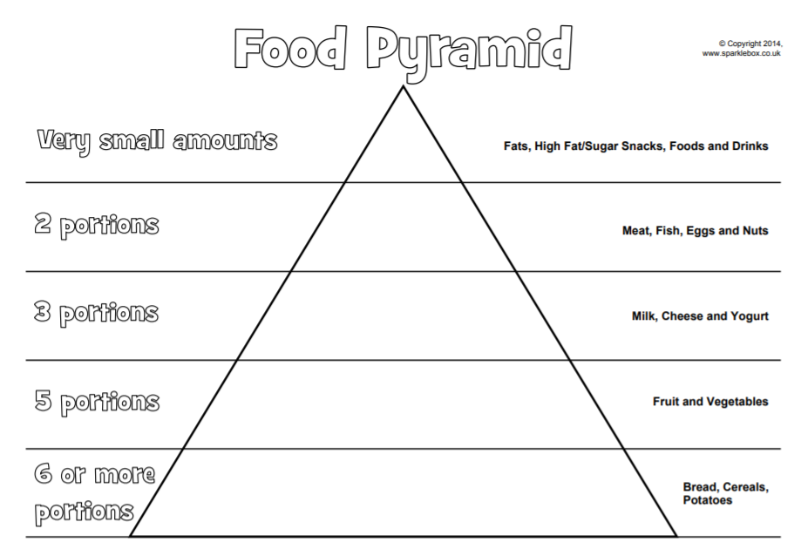
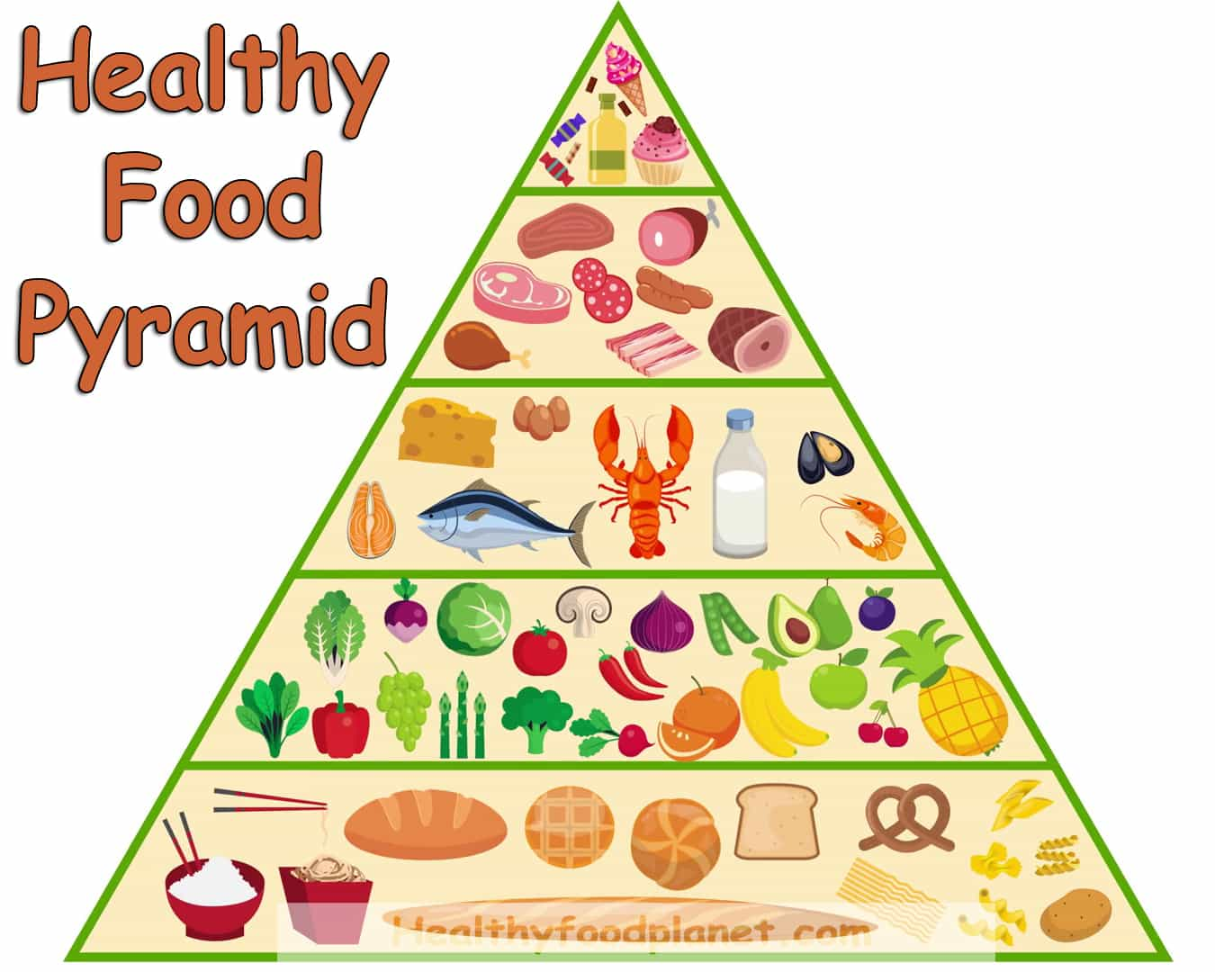
Here is an example
SESSION 5 ENQUIRY – SEASCAPE PAINTING

