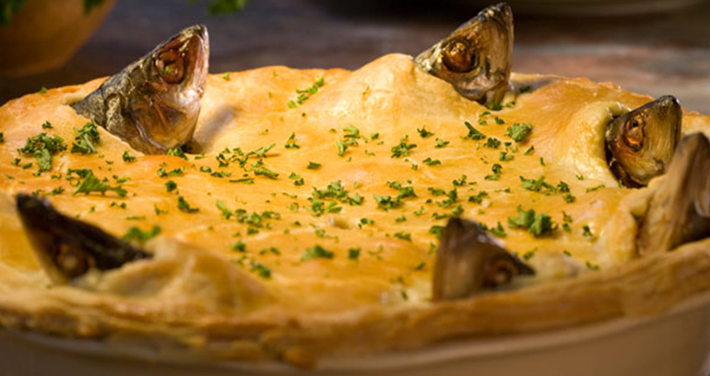

Stargazy pie
(serves 6)
shortcrust pastry made with 285g plain flour
8 pilchards, sardines or small herrings
salt, pepper
1 large chopped onion
approx. 3 tbsps chopped parsley
3 hard-boiled eggs
3 rashers streaky bacon
beaten egg to glaze

Roll out the pastry for double-crust plate pie. Cover the plate, brush the rim with water and roll out another piece for the lid. Keep it aside. Preheat the oven to gas 6, 200C (400F). Clean and bone the fish, leaving their heads in place. Season inside and stuff with finely chopped onion and parsley. Fold back into shape. Lay the fish on the pastry like the spokes of a wheel with their heads on the rim so that they can gaze upwards. Fill the gaps in between with chopped bacon and hard-boiled eggs. Put the pastry lid in place, pressing down between the fish heads so that it meets the pastry of the lower rim, making a wavy effect. Brush with beaten egg. Bake for 30 minutes, though if the fish are on the large side give them 15 minutes more at the reduced heat of gas 4, 180C (350F). Serve hot.

